UNIV 392 INTERNATIONAL EXPERIENCE COURSE PROPOSAL

California State University Channel Islands

Course Name & Number: UNIV 392: Mathematics, Science, Music, Art and Culture of Australia

Instructors: Dr. Jesse Elliott (Mathematics) and Dr. Ivona Grzegorczyk (Mathematics)

Country & Dates of Trip: Australia, March 13-22, 2015

SYLLABUS

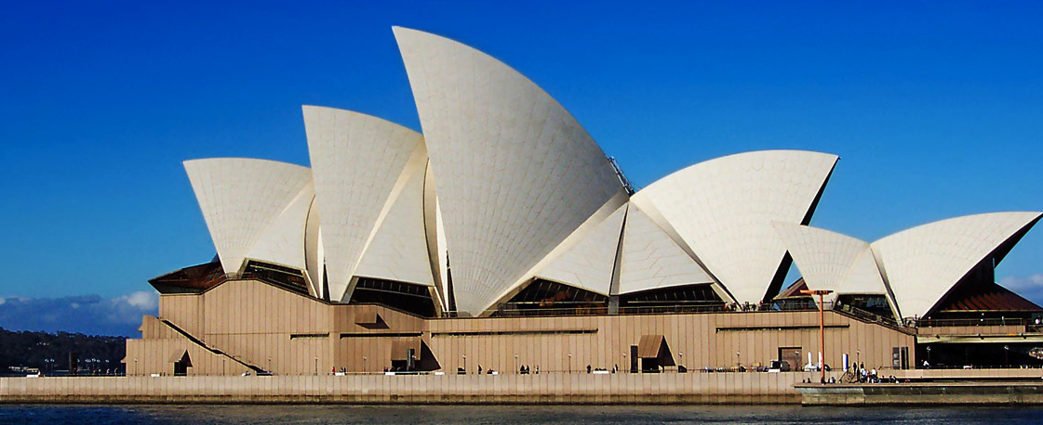

Sydney Opera House

Course: UNIV 392 Mathematics, Science, Music, Art and Culture of Australia

Description: This multicultural and interdisciplinary course combines the STEM disciplines with the culture, art, music, and architecture of Australia. The objective of this course is to give students exposure to the culture of Australia and some of the continent’s world contributions and accomplishments in mathematics, engineering, art, and music, as well as to provide students with practical and historical knowledge of the interdisciplinary applications. The instructors are experts, respectively, in connections between the STEM disciplines and art/architecture (Dr. Ivona Grzegorczyk) and music (Dr. Jesse Elliott). The course has no prerequisites and invites all students to apply. The instructors will select students though an application process on the basis of the students’ maturity and dependability, on their interest in mathematics, science, art, and music, and on recommendation letters from faculty.

The connections between mathematics, science, art, and music, are very deep and span many cultures and times. Australia’s architecture is very modern and mathematically sophisticated and includes iconic structures like the Sydney Opera House, the Sydney Harbor Bridge, and the Parliament House in Canberra, the nation’s capital city. Both Sydney and Canberra have many famous museums. Their modernism includes the works of the famous Australian artists Sidney Nolan, Arthur Boyd, and Albert Tucker.

Our travel will begin by visiting Sydney and its incredible museums, the Sydney Opera House, the Aboriginal Museum, the Harbor Bridge, the Botanical Garden, and other cultural landmarks. From there we will visit the nation’s capital city, Canberra, where we will be hosted by faculty from the Centre for Mathematics and its Applications, of the Mathematical Sciences Institute of the Australian National University (ANU). Students will have the unique opportunity of visiting ANU and interacting with its faculty and students in the mathematical sciences. As with similar programs organized by Drs. Elliott and Grzegorczyk in Italy and in the Benelux countries, there will be an organized daylong conference on mathematics where students and faculty of both CSUCI and ANU will present their studies and research on topics related to the course themes. The program will have cultural, artistic and scientific value and will be suitable for an undergraduate audience.

Early in the semester, students will be assigned the project of researching an interdisciplinary application of one or more STEM disciplines to art, culture or music that is relevant to the travel program. For example, a student may choose to research information on algebraic surfaces that describe the Sydney Opera House, to provide an analysis of the acoustical properties of the didgeridoo, or to study the geometry of Aboriginal art patterns. Several possible topics for the projects will be distributed to the students by the instructors, who themselves are experts in interdisciplinary applications of STEM disciplines. There will be several class sessions prior to the trip during which students will be given guidance on a) their projects and presentations, b) the history and culture of the regions, and c) preparation and orientation for the trip. The students will present their projects in the mathematics seminar MATH 499 before the trip. There will also be one post-trip presentation for the entire university population with a poster and project session. This class will be limited to 20 CSUCI students.

Learning Objectives:

This is a unique course designed to enhance the interdisciplinary, multicultural, and international perspectives of the student and stimulate interest in applications of mathematics to art, music, architecture and culture. Through this course students will learn to:
- Recognize and appreciate the beauty, design, and engineering of many artistic, architectural, and scientific works, especially those from the regions visited (including modern architecture such as the Sydney Opera House and the Parliament House in Canberra).
- Describe some historical and modern mathematical and/or scientific influences on art and music around the world.
- Choose one of the following:
  - Identify the mathematical background of compositions in the arts, apply rules of harmony, such as the ‘golden ratio’ proportion, in those compositions, and identify some aspect of patterns and symmetry in works of art and/or music.
  - Design modern artistic and/or musical projects following mathematical rules.
  - Discuss a concept in the STEM disciplines, and its connection to art, music, or culture.
- Discuss scientific and artistic ideas in an international forum.
- Recognize some artistic and musical accomplishments of Australia and the role of the STEM disciplines in those accomplishments.
- Present mathematical ideas in an oral and written form using technology.

Course outline:

In this course students will:
- Obtain exposure to major international and historical accomplishments in art, music, architecture, engineering, and culture of Australia.
- Obtain practical, cultural, and historical knowledge of the interdisciplinary applications of the STEM disciplines to art, music, and architecture.
- Research, prepare, and present on at least one application of STEM disciplines to art, music, or architecture.
- Participate in a daylong conference at the Mathematical Sciences Institute of the Australian National University in Canberra.
- Become familiar with the cultures and peoples of Australia.

Instructors: Jesse Elliott BTE 2758 437-2768 jesse.elliott@csuci.edu
Ivona Grzegorczyk BTE 2756 437-8868 ivona.grze@csuci.edu

Dr. Grzegorczyk is an expert on mathematics and science in art and architecture, and Dr. Elliott is an expert on mathematics and science in music. The instructors have travelled the world, have visited Australia on several occasions, and are very familiar with the region’s history and culture. Dr. Elliott spent time in Australia during a recent sabbatical and has a close colleague, Dr. James Borger, at the Mathematical Sciences Institute at the Australian National University. As an integral part of the class, before, during, and after the trip, Drs. Grzegorczyk and Elliott will provide students with instruction regarding various interdisciplinary applications of STEM disciplines to art, music, and architecture, and they will also provide students with cultural background and a cultural program that will help the students to attain international perspectives and to understand Australia’s international contributions to these areas. Both faculty offer unique qualifications that will allow the course to meet these objectives.

Prerequisites: Consent of instructors and CIA

Texts: An electronic course-pack with all course information will be provided. Readings will be selected from:

Australia's Planning Heritage, by Robert Freestone

Guide to Sydney Architecture, by Graham Jahn

History of Australia and New Zealand, by Alexander Sutherland

Language and Culture in Aboriginal Australia, by Michael Walsh and Colin Yallop

Lonely Planet Australia, by Meg Worby and Charles Rawlings-Way

Course Credit and Contact Hours: Students will receive 1 unit of credit for this course. Contact hours will include 12-15 hours on the CSUCI campus, on student projects and orientations, and 10-16 contact hours per day during the trip. All activities and meetings are mandatory.

Course Dates and Locations: There will be several class meetings before the trip. All class sessions will be on campus at CSUCI. We will meet for the first orientation session on February 2, 2015 to organize the group and advise students on passports, travel advisories, etc. We will then meet once a week starting on February 9 (6 meetings total) to prepare for the trip and to complete the student projects. Students will work on their projects in special sessions, and seminar presentations will be held prior to trip. Poster presentations will be prepared after the trip and scheduled for April or early May Travel will be on March 13 to Sydney, and we will return to LAX from Sydney on March 22 (with Roadrunner Shuttle and/or carpooling to and from LAX). Travel by bus or train from Sydney to Canberra and back to Sydney will be on March 17 and March 20, respectively.

Class Schedule (subject to change)

Mon Feb 2 Pre-trip Orientation I (including passport and travel advisories)
Mon Feb 9 Group Projects and Assignments
Mon Feb 16 Group Projects Session
Mon Feb 23 Pre-trip Orientation II
Mon Feb 28 Group Presentations on history, culture, traditions, etc.
Mon Mar 2 Group Project Presentations
Mon Mar 9 Pre-trip Orientation III
Fri Mar 13 Travel to Australia
Sun Mar 22 Return to LAX
April/May Poster Presentations

Assignments and Grading: Assessment will be based on the following.

Project and Presentation (20 points). Students will be assigned into small groups. Each group will prepare an interdisciplinary presentation related to Australian architecture, art, music, or culture. Examples of possible projects include: Mathematics of the Sydney Opera House (see http://ideastations.org/science-matters/sites-and-wonders/sydney-opera-house-its-all-about-math), Mathematical Patterns in Aboriginal Art, Mathematics of the Sydney Harbour Bridge (see http://passyworldofmathematics.com/sydney-harbour-bridge-mathematics/), Mathematics of the Didgeridoo (see http://www.didjshop.com/physicsDidjDreamtime.html), Modern Architecture in Sydney and Canberra, Traditional Music of Australia, and History of Science in Australia. Student projects will be presented prior to the trip to the other UNIV 392 students and to attendees of the mathematics seminar. Math-related talks will also be presented at the conference at ANU.

Attendance and Good Citizenship at Activities and Cultural Events (50 points). Students will be evaluated on their attendance, citizenship, cooperation, and collaboration. Most of the activities for the trip, as laid out in the itinerary, will be required. Each missed required activity will result in a deduction of points (in inverse proportion to the total number of required activities). The students will be hosted for two days by students from ANU. This part of the grade will also reflect students’ respect to their hosts.

Pre-Trip Presentation and Activities (15 points). Students are required to attend six pre-trip sessions. Students (in small groups) will research the culture, traditions, and history of Australia and present their findings to the class. Each student will also have tasks assigned related to trip organization, such as locating information items about attractions of interest, checking on hours of museums and events, language requirements, tickets, etc.

Final Poster Presentation (15 points). After the trip students will prepare posters related to culture, arts, and architecture of Australia and related mathematics and deliver a poster presentation on campus. The presentations in Australia and the post-trip posters will be scored via rubrics (to be distributed).

The final grade for the course will be calculated according to the following scheme.

Project and Presentation 20 points
Attendance and Citizenship 50 points
Pre-Trip Presentation and Activities 15 points
Final Poster Presentation 15 points

A+ 97-100 B+ 87-89 C+ 77-79 D+ 65-70
A 93-96 B 83-86 C 73-76 D 60-64
A- 90-92 B- 80-82 C- 70-72 F 0-59

Participation: Students are expected to present a project involving an interdisciplinary application of STEM disciplines to architecture, art, or music, with a focus on Australian culture. Students will be required to listen to and provide feedback on other students’ projects and talks, to participate in discussions with foreign scientists and students, and to attend excursions to art museums, music events, and excursions to architectural and cultural sites. The student projects will be prepared prior to the trip under the supervision of the instructors. After the trip students will present their projects to the university community, discuss the insights they gained from their travels, and attend the talks and exhibitions of their peers.

Communication: We will use e-mail, the math website, Blackboard, and class meetings to communicate.

Orientation and meetings: An initial orientation meeting for the students will include a briefing on the security of the country to be visited. International Travel Warnings on the State Department’s website at wwww.travel.state.gov will be consulted. Australia is a highly developed nation and very safe to visit, and the two instructors are very familiar with the region. Millions of U.S. citizens visit there every year and many Americans reside there year-round. Medical care in Australia is universal and is available at the high standard level. The orientation will include detailed information about health, safety, and emergency contacts and procedures. Wallet-sized cards including faculty contact and important embassy numbers will be provided. The syllabus will be distributed, along with possible presentation topics for the students. The orientation and syllabus will clearly delineate expectations and responsibilities of both the students and faculty before, during, and after the trip.

Travel Itinerary:

Fri Mar 13 LAX Sydney 14 hours direct by plane
Tue Mar 17 Sydney Canberra 3 hours by train
Fri Mar 20 Canberra Sydney 3 hours by train
Sun Mar 22 Sydney LAX 14 hours direct by plane

Day-by-day travel itinerary:

Fri Mar 13 LAX Sydney (14 hours direct by plane)
Sat Mar 14 Downtown Sydney, Botanical Gardens
Sun Mar 15 Sydney Opera House tour
Mon Mar 16 Sydney Tower and Harbor Bridge
Tue Mar 17 Sydney Canberra (3 hours by train)
Meet students from ANU Mathematics Department
Wed Mar 18 Joint ANU/CSUCI Conference
Thu Mar 19 Parliament House and museums (esp. National Museum of Australia)
Fri Mar 20 Canberra Sydney (3 hours by train)
Sydney Opera House concert
Sat Mar 21 Aboriginal Museum and Bondi Beach
Sun Mar 22 Sydney LAX (14 hours direct by plane)

Students with Disabilities: CSU Channel Islands is committed to equal educational opportunities for qualified students with disabilities in compliance with Section 504 of the Federal Rehabilitation Act of 1973 and the Americans with Disabilities Act (ADA) of 1990. The mission of Disability Resource Programs is to assist students with disabilities to realize their academic and personal potential. Students with physical, learning, or other disabilities are encouraged to contact Disability Resource Programs at (805) 437-3331 for personal assistance and accommodations.

Academic Honesty: Cheating and plagiarism will not be tolerated and may result in a failing grade for the course. For information on the University's policy on academic honesty, please consult the University Catalog.

Cost of Trip (per student): At a 66% funding rate the projected out-of-pocket cost for each student is $918.50. See the budget section below. To lower the costs we will try to use ANU’s dorms in Canberra and/or inexpensive hotels in Sydney, which, based on Expedia prices, we expect to average about $150 per night per double room (two students per room). Transportation will be by bus and train.

Student Recruitment: If approved the course will be advertised in Fall 2014 with fliers and e-mails. The course will be advertised across the entire university and an effort will be made to attract students across varying majors, cultures, and economic statuses. Students will submit an application with the following information: two faculty recommendations; GPA; mathematics and science courses; interests in art, music, mathematics, and science; student contribution to CI and/or CI STEM programs; and prior projects and presentations. Students will be selected, by Dr. Grzegorczyk (art and architecture) and Dr. Elliott (music), on the basis of their interdisciplinary interests in accordance with the CIA and IRA guidelines. Priority will be given to students majoring or minoring in a STEM discipline.

Notes: Students will buy their health insurance through the CSU system. Students will obtain their passports and sign all required forms. Students will know the cost of the trip ahead of time.

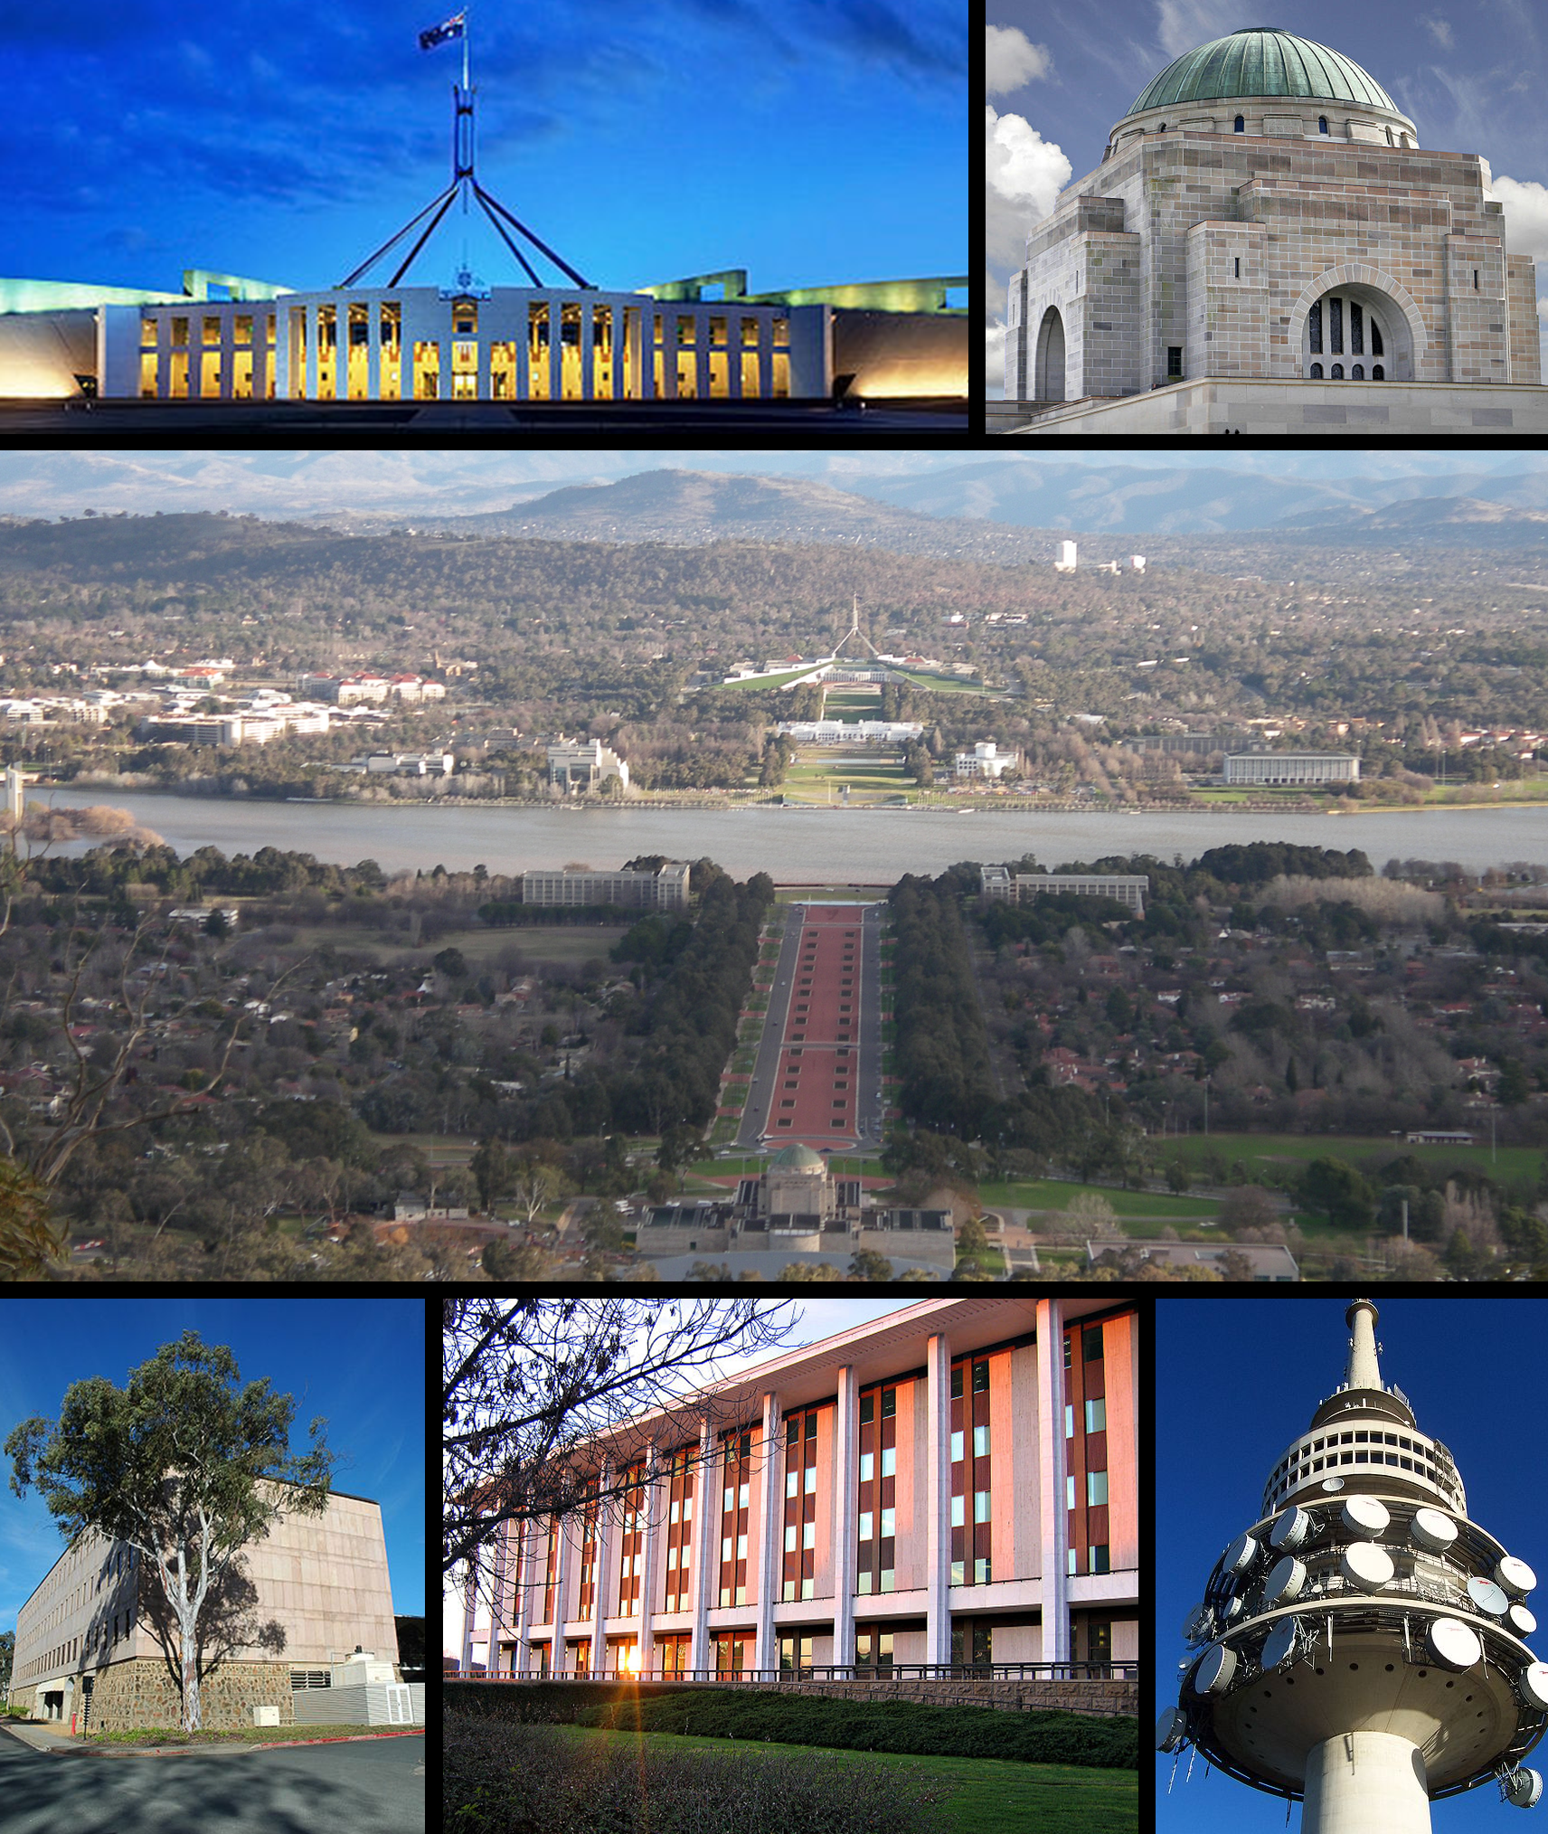

Canberra

BUDGET

Cost of Trip (20 students, estimated)

Air Fare (20 students) $28,000
Ground Transportation $ 2,500
Accommodation (9 nights x 20 students) $13,500
Meals (9 days x 20 students) $ 6,000
Travel Insurance $ 1,000
Cultural Events/concerts $ 2,000
Museum/exhibitions $ 2,000
TOTAL for 20 students $55,000

Student funding requested $36,630 (66% of projected student cost)

Projected cost per student $ 918.50 (($55,000-$36,630)/20)

Two Faculty

Air Fare 2 x $1,400 $ 2,800
Ground Transportation $ 250
Accommodation 2 x $900 $ 1,800
Meals $ 600
Travel Insurance $ 100
Cultural Events/concerts $ 100
Museum/exhibitions $ 100
TOTAL for two faculty $ 5,950

--------------------------------------------------------------------------------------------
TOTAL FUNDING REQUESTED $ 42,580 ($36,630 +$5,950)

