Finance Data Warehouse
Quick Reference Guide
This Quick Reference Guide provides concise steps for using the basic features of the Finance Data Warehouse. An electronic copy of this Quick Reference Guide on the CMS website at: http://cms.calstate.edu/T4_DocumentTemplates.asp

THE FINANCE DATA WAREHOUSE
The Common Financial Reporting environment (hereafter referred to as the Finance Data Warehouse) contains reporting capabilities that provide campuses with a set of interactive dashboards containing the first set of common, core reporting capabilities required by campuses and the Chancellor’s Office.
Log in to the Data Warehouse
The Finance Data Warehouse is accessed through the CSU Portal.
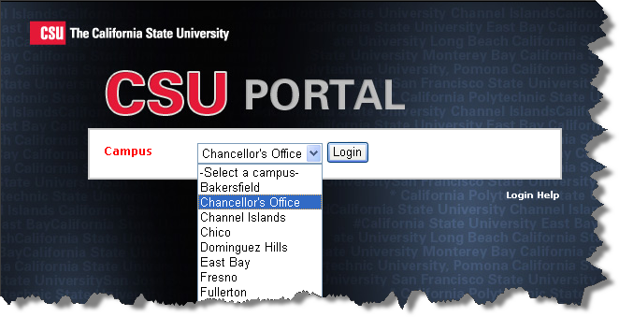
1 Navigate to the CSU Portal; select your campus using the drop-down list. Click Login.
2 Click Financial Reports. In the Report Login section, click Login to start the data warehouse.
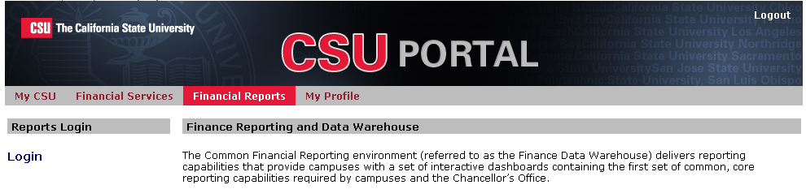

DATA WAREHOUSE DASHBOARDS
As of the current Finance data warehouse release, there are four delivered dashboards (report portals):
- Auxiliaries
- Manage My Budget
- Operations
- Sponsored Programs

Manage My Budget Dashboard and Reports
The Manage My Budget dashboard is designed for ease of use by the end user responsible for managing budget against one or more departments. This dashboard shows Revenue and Expense Accounts in a variety of report formats.

Operations Dashboards and Reports
The Operations dashboard is geared toward the Finance power user and includes Ledger and Trial Balance reporting. All chartfields, CSU funds and SCO funds are options on most pages. Unlike the Manage My Budget dashboard, the Operations dashboard is not limited to Revenue and Expense categories; all account categories are available.

Auxiliaries
The Auxiliaries dashboard contains pages and reports based on the AAT and FNAT key attributes connected to the chartfields.

Sponsored Programs
This dashboard contains reports formatted for Administration, management, and general grant managers.

Dashboard settings on the home page
Dashboard settings are filters that will apply to ALL pages within a dashboard. Dashboard settings must be set for each available dashboard. You can also designate settings to be the default for the associated dashboard.
1 Click on the name of any dashboard to go to that dashboard’s Home page.
2 In the Default Settings for this Dashboard section, select your campus values, as appropriate.
Primary  business unit | 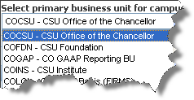
Primary budget | Choose your primary budget ledger
Budget scenario | Choose your original budget scenario (optional)

3 Click Go to execute your selection.
Save your Settings as Default
1 From the Page Options menu, choose Save Current Selections > For Me
You can choose the default name or enter a name of your choice.
2 Choose Make this my default for this page.
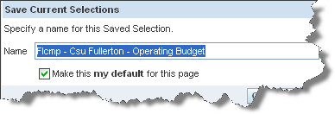
3 Click OK.
You have saved the selected settings as your dashboard default.
The first four dashboards are sourced from the campus ledger summary only. If you try to report on Legal or GAAP business units from this dashboard you will not get any results.
Data for Legal and GAAP business units will be reported in a separate dashboard targeted for implementation in second quarter 2011.

FIVE STEPS TO REPORT RESULTS
After you establish your dashboard defaults, you are ready to generate a report. There are five main activities involved with report production:
- Select the report
- Set the report filters
- Set the report format
- Drill through report data
- Capture report results (print / download)

Step ONE: Select the report
Each dashboard is divided into content areas organized by “pages.” Click on the Page (tab) at the top of any dashboard to go the associated page. Some pages will present a list of hyperlinks that allow you to select from a series of reports. Other pages will display one main report and will list links to other available reports at the bottom of the page.

STEP TWO: set report filters
Every dashboard page has a report filters section where you can set the report filters (the report search criteria) that will be used to generate the report(s) on that page. The report filters section will contain different fields depending on the active dashboard page.
DROP DOWN
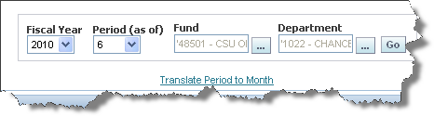
MULTI-SELECT

- Click on the down arrow to choose a value from a dropdown field
- Click on the ellipsis to choose value(s)
from a multi-select field.
1 Click the multi-select icon to search for report criteria in a specific field (for example, Department).
2 In the Match field, select the appropriate Match operator. The two choices you will probably use most often are begins with and contains.
3 Enter your search criteria in the box to the right of Match. For example, you could do a search for a value containing the search string renewal. Hit Go to start the match process.
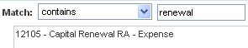.
If your search criteria produces more than 256 results, hit the More… button to display the next group of 256 choices.
Selection Buttons
1 Use the buttons described below to move items from the Choices Returned box into the Selected box.
Select all items listed
Select highlighted item(s)
De-select highlighted item(s)
De-select all items
- Double-click on any value to move it into or out of the Selected box
- Hold down the Shift key and click on the first and last values to select a continuous range of items
- Hold down the Ctrl key and click to select on non-continuous items.
2 When you are done setting all report filters, hit OK to return to the report page.
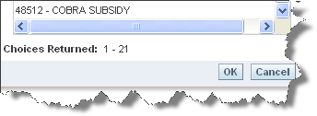
3 When all your report filters are selected, click Go to generate the report.
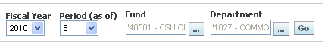

step three: format YOUR REPORT
Report results are delivered to your screen based on your report filters.
Report View
Report view selectors present report results in different ways or with different formats to display data for a specific purpose. Each report has its own set of views to help organize report data.
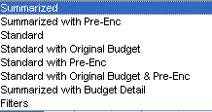
Use the Filters Report View to see all search criteria associated with your report (including dashboard defaults).
Changing Column Content with Column Selectors
Many reports contain the column selector feature. Use column selectors to dynamically change which columns appear in your report. Choose what field value to display from a pre-defined list of choices. A request can have multiple columns with column selectors – each with its own list of choices. Fields that are attached to column selectors are indicated by a yellow label.
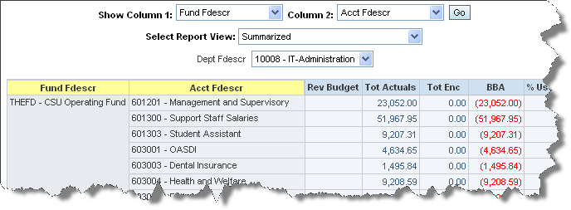
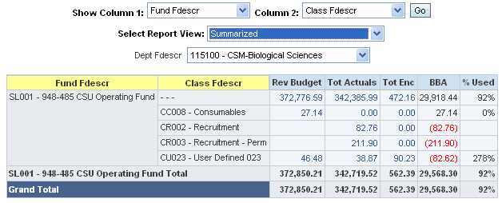

STEP four: DRILL through REPORT Data
When you place your cursor over and item and it appears as a hyperlink, you are able to drill on that item. Drilling on a hyperlinked numeric value will take you to the details of the selected amount.
1 Drill down on a hyperlinked numeric value.
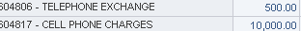

2 At the bottom of the screen use the icons to move forward and back through the returned results.
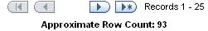
3 Sort data by individual columns or multiple columns.
- Sort on an individual column by clicking on the column label.
- Sort by multiple columns by holding down the control key while selecting the column titles. Release the control key to execute the sort.
4 Click the Return link to return to the parent report.

step five: download data/ Print Report
The term “action link” is used to apply to the icons and hyperlinks that appear at the bottom of a dashboard page or individual reports. The actions that can be performed using action links include:
Downloading to Excel
This option downloads the data from a selected request and saves it to an Excel file with extra visual formatting.
- Formulas are not downloaded. The value in a cell is downloaded as that value, not as a formula
- Monetary columns download as numbers. Values with commas are formatted as numbers and retain formatting that was displayed on the dashboard; that is, if two decimal places are shown, then those appear in Excel.
- Monetary columns without a comma are formatted as general, which is a number but with no specific number format. The value does not change but decimal places are suppressed if zeros appear to the right of the decimal place.
- Columns that are numeric and contain values with leading zeros lose the leading zeros when downloaded to Excel.
Download Report Data
- Downloads all data in the request, including fields not displayed in the current view, as a Tab Delimited file. This file will open in Excel without any formatting and can then be saved as an Excel file.
- Download to data creates a CSV (Comma Separated Values) file, which includes all of the columns included in the Answers request (not just the view displayed on the screen). Formatting from the screen will not be carried over to the file.
Print
There are two print action links on every page. One is a hyperlink located beneath each report. The other is a print icon located at the bottom of every dashboard page.

Print Individual Report to PDF
1 Click on the Print hyperlink immediately below the report.
2 Select PDF.
Another window will open up with the report to be printed.
3 Print PDF per usual procedure.

Print Page to PDF
1 Click on the Print icon at the bottom of the page.
2 Select PDF. Print.
All page content, including section headings and report filters, will print to the PDF.

HOW TO: NavigatE through THE Dashboard
Dashboard Pages with Links to Report Pages
Some pages within the data warehouse contain a list of hyperlinks that allow you to select from a list of similar reports. These reports are identical except for the number of columns that can be arranged with user-selected attributes for the display of report data.
These report pages allow you the opportunity to create unique report filters and page options for each version of the main report. For example, you can have a different set of saved options for the 2 Columns version than you do in the 4 Columns version.
Dashboard Pages with One Main Report
Some dashboard pages are designed to display one main report. If other related reports are available, those reports are listed in the Additional Report Layouts section located immediately beneath the main report window.
From any location, you can click a dashboard name hyperlink to return to a dashboard’s Home Page.

how to: CUSTOMING YOUR REPORTS
Using the Page Options / Saved Selection feature, you can store report criteria and formats. You can save as many different combinations of these items as you want for an individual page. You can also choose a saved selection as the default for a page. Saved selections can be renamed or deleted, as needed.
When you save a page option, all of the following components are stored in the saved option:
- Dashboard filters
- Report filters
- Column selectors
- Report view
- Collapsed / expanded sections
Create a Saved Selection and Save as Page Default
1 First, generate a report that has the report filter values that you want to store.
2 Select the Report View you want to save.
3 Use the Columns Selectors to choose the columns to wish to save.
4 Click Go to execute your selection.
5 From the Page Options menu, choose Save Current Selections > For Me …
Keep the default name or enter a new name. You probably will want to name that helps you identify the options you’ve saved.
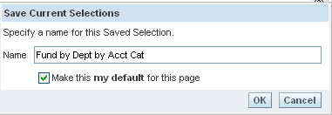
6 Choose Make this my default for this page.
7 Click OK.
Create an Additional Saved Selection
1 Change the report filters, column selectors, report view, and section layout as desired.
2 After the results display, click the Page Options button.
3 Click Save Current Selections followed by For Me . . .
4 If desired, enter a different name for the selection. Do NOT choose the “my default” checkbox.
5 Click OK.
Apply Saved Selections
1 Click Page Options > Apply Saved Selections > Your Selection Name
The selection saved as the page default appears in bold.
- A default saved selection will be activated the first time that you access a page within an OBIEE session OR when moving back and forth between dashboards.
- Saved selections are specific to an individual dashboard PAGE.
- There is no limit to the number of saved selections per page.
2 Repeat the steps above to apply a different saved selection.
Change Page Default Selection
1 Click the Page Options button.
2 Choose Save Current Selections > Edit Saved Selections and Defaults.
The Edit Saved Selections and Defaults dialog will display.
3 Select the option that you want to save as the default page option.
4 Click OK to save your changes.

