Service Level Agreement (SLA) Between Technology & Communication (T&C) and Card Services in Support of OneCard Issues

Overview

This service level agreement has been developed to accomplish the following goals:
- To create an orderly, consistent method of gathering information about card-related operational issues;
- To provide Card Services and Technology & Communication (T&C) technical staff with sufficient initial information to coordinate further troubleshooting of operations support issues;
- To facilitate documentation of chronic technical issues which will enable proactive repair and support;
- To document effectiveness and speed of response to support requests for card-related issues; and
- To clarify roles and responsibilities for card-related operations support and project requests.

Affected Groups
This SLA affects the following campus groups:
- Card Services
- Cashier’s Office
- T&C staff (including Help Desk and other technical staff)
- Campus card system users (including students, employees and general public)
- Card system vendors (e.g., BlackBoard, Micros, RockWest, eXceedID, RFIdeas, etc.)
- Local support for card issues. Local support includes but is not limited to:
  - Broome Library staff
  - Student Union Information Desk staff
  - Campus Dining staff or manager
  - University Glen vendor manager (e.g., manager of Subway, manager of Tortillas, etc)

Affected Systems

This SLA applies to all campus card and card-related systems, including but not limited to:
- Pharos (card swipes, release stations, printers, copiers, related desktop software)
- DolphinOne Card Kiosks (DOCKs) and any other PHIL stations for campus cards
- Card generation systems, including card printers and related software, hardware and equipment
- Card reading systems, including POS and activity devices (e.g., AT3000, Micros, etc)
- Blackboard Transact Server (including related hardware, software)
- Other card system related servers, including Micros server
- Transaction Integration Agents (TIAs) for all card-related systems

Definitions

DolphinOne Card Kiosk (DOCK): an automated station which permits cardholders to add value to DolphinOne or Guest cards, view balances on associated card accounts, and purchase guest cards using cash or credit cards.

OneCard Support Form: a web form where Tier 1 support inputs information about card-related issues. The contents of the submitted form are stored in a database, and emailed upon submission to helpdesk@csuci.edu, which creates a work order in the TrackIT work order system. The form is located at: http://go.csuci.edu/cardsupportform. The OneCard Support Form gathers the following information, which is necessary to resolve card-related issues:
- the cardholder name and email address
- type of card (DolphinOne or Guest)
- card number (Dolphin ID number or Guest card number)
- contact phone number
- location where problem occurred (printer location/ID number, DOCK location, etc)
- Detailed information about problem/issue
- Error message information, if available
- What was done to attempt to remedy the problem
- Name of form submitter

Operations: everyday business activities. Operations are repetitive activities, typically with the same outcomes. Further, operations are ongoing, with no start and end dates.

Service Description and Standards

Operations Support Standards

Overview
The diagram in Figure 1 represents the process flow for card-related operations support requests.

There are 3 tiers in the support process, which are described in detail in the “Roles and Responsibilities” section below.

Figure 1. Diagram of Operations Support Process

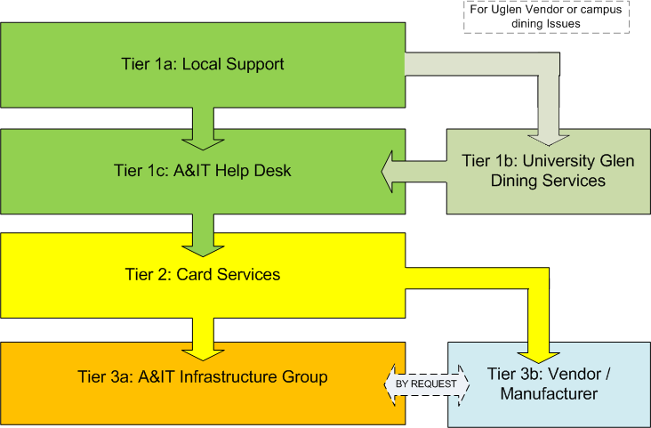

Roles & Responsibilities

Tier 1 Support
Tier 1 support will be provided by the following areas:

Tier 1a
- Broome Library Staff
- Cashier
- Student Union Information Desk
- Campus Dining staff or manager
- University Glen vendor manager (e.g., manager of Subway, manager of Tortillas, etc)

Tier 1b
UGC Administrative & Marketing Coordinator (currently Angelo Heredia).

Tier 1c
T&C Help Desk

All Tier 1 support personnel provide basic troubleshooting. This includes the following tasks:
- Repeat the transaction, and verify that the problem happens again.
- Verify that card swipe was done correctly: was card stripe facing the right way?
- Verify that card is not obviously physically damaged
- Verify that card is readable by more than one existing card station or terminal (DOCK, AT3000, Micros, copier/printer)
- If it is a Pharos-related issue, perform basic printing troubleshooting (see “Printing Troubleshooting Flowchart” in Appendix.)

If completion of basic troubleshooting does not solve issue, Tier 1 support will document sufficient information and report the problem to Tier 2 support via completion of the “OneCard Support Form” (See Definitions and Appendix).

Tier 2 Support

Tier 2 support will be provided by Card Services staff (currently Marysia Wancewicz and Missy Jarnagin).

Tier 2 support provides enhanced troubleshooting for issues that cannot be resolved by Tier 1 support. This includes the following tasks:
- Review OneCard Support Form
- Contact OneCard Support Form submitter, affected cardholder, and other stakeholders as necessary to resolve problem
- Provide both technical and non-technical solutions for card-related issues to the extent of knowledge and capabilities.
- Serve as liaison between cardholder, Tier 1 and Tier 3 support
- Research and gather information
- Document additional steps performed to resolve issue
- Maintain documentation on issue resolution

If Tier 2 support is unable to solve issue, Tier 2 support will escalate request to Tier 3 support, and provide Tier 3 support with necessary information to continue resolution of issue.

Tier 3 Support
Tier 3 support will be provided by the following areas:

- T&C Infrastructure group
- Card system vendors/manufacturers

Tier 3 support provides enhanced troubleshooting for issues that cannot be resolved by Tier 2 support. This includes the following tasks:
- Work with Tier 2 support to research and troubleshoot issues.
- Work with a range of vendors/manufacturers to resolve technical issues.
- Serve as a liaison between Tier 2 and vendor/manufacturer, if explicitly requested by Tier 2 support.

Hours & Response Times

T&C provides Tier 1 and Tier 3 operational support during regular business hours (Monday through Friday, 8:00am to 5:00pm) excluding holidays.

T&C will make a best effort to respond within 2 business days to standard priority requests for operational support which have been submitted to Tier 3 support.

T&C will make a best effort to respond within 4 business hours to urgent priority requests for operational which have been support submitted to Tier 3 support. “Urgent priority requests” are defined as requests where timely response is required to respond to, or to prevent, major downtime or disruption of core campus card systems or services.

Emergency requests outside of regular business hours should be routed using the Operations Support Process as described in this document. Missy Jarnagin will be after-hours Card Services contact for emergency requests. Cel phone information for Missy is available upon request.

Card Services will make a best effort to respond within 3 business days to standard priority requests for operational support which have been submitted through the standard support process.

Card Services will make a best effort to respond within 4 business hours to urgent priority requests for operational which have been support submitted through the standard support process. “Urgent priority requests” are defined as requests where timely response is required to respond to, or to prevent, major downtime or disruption of core campus card systems or services.

Operations Support Use Case

This use case describes how a reported operations (non-project) issue would be reviewed and resolved. (Please see “Project Support Use Case” section for information on project requests and system enhancements.)

- Student/employee has a problem with their OneCard, Guest Card, or other Card Services-supported campus card at a given campus location.
- Student/employee contacts “local support” or T&C Help Desk. Local support includes:
  - Broome Library Circulation Desk
  - Student Union Information Desk
  - Campus Dining staff or manager
  - University Glen vendor manager (e.g., manager of Subway, manager of Tortillas, etc)
- If issue is at University Glen (UGC) vendor, UGC vendor manager must contact UGC Administrative & Marketing Coordinator (currently Angelo Heredia).
  - Administrative & Marketing Coordinator will respond with initial support, and then escalate to T&C Help Desk as required.
- Local support or T&C Help Desk staff assist as much as possible with basic troubleshooting, such as:
  - Repeating the transaction step-by-step to verify that the problem is still occurring
  - Verifying that the cardholder swiped their card facing the right way
  - Verifying and documenting any error messages generated.
- If problem cannot be solved by local support or T&C Help Desk staff, local support or T&C Help Desk staff will gather information about the issue and complete the “OneCard Support Form”: http://go.csuci.edu/cardsupportform
- Support Form will automatically generate a work ticket in the T&C work order system (TrackIT).
- T&C Help Desk staff will set work ticket “Requestor” to the support form submitter.
- T&C Help Desk staff will assign ticket to technician queue “Q-Card Services”
  - Email notification will be sent automatically by TrackIT to cardservices@csuci.edu when a new ticket is assigned to “Q-Card Services”.
  - Marysia Wancewicz is the assigned manager of that TrackIT queue.
- Card Services will review the request via TrackIT and/or cardservices@csuci.edu shared email address, and attempt to resolve the issue.
  - If Card Services is able to resolve the issue, Card Services staff will update and close the TrackIT ticket, and communicate resolution of the issue with the work ticket Requestor (report form submitter) and Cardholder.
- If Card Services is unable to resolve the issue, Card Services will reassign the ticket as needed to the “Q-Infrastructure” ticket queue in TrackIT.
  - Tickets must be assigned to the Q-Infrastructure; they may not be assigned to individual T&C members; individual assignments will delay the T&C response.
- “Q-Infrastructure” will be reviewed regularly by Infrastructure group staff, and overseen by Manager of Infrastructure. Card-related tickets will be assigned to appropriate Infrastructure group staff.
- The assigned T&C technician will coordinate resolution of the issue and communicate with the student/employee who had the issue.
- Once the issue has been resolved, the TrackIT ticket will be updated and closed by the assigned technician.
- Assigned T&C technician will communicate resolution of issue with Card Services and work ticket Requestor (support form submitter).

Roles & Responsibilities Summary

T&C provides the following services in support of Card Services operations:

- Help Desk will provide Tier 1 operations support to supplement local support across campus
- Infrastructure group will provide Tier 3 operations support for troubleshooting
- Infrastructure group is willing to serve as primary campus contact for vendors/manufacturers during problem resolution, if specified by Card Services.
- Infrastructure group will assist Card Services with regular & emergency maintenance, per this SLA
- ATS Group will assist Card Services in design and manufacture of signage, by request
- T&C staff and management will evaluate and renew support contracts that are currently assigned to T&C
- T&C staff and management will provide technology advice and research, by request. This includes assistance with development of requirements, scope of work, specifications, and estimations of T&C resources required to complete work.
- T&C will provide a means of sending notification to the campus community for planned or unplanned campus card system maintenance or outages
- T&C will provide technical solutions for card-related projects based on defined requirements, scope of work, specifications and timelines, which are mutually agreed upon prior to the start of work.

T&C will not provide the following services in support of Card Services operations:

- Perform communication and marketing activities for card-related issues, such as creating & publishing card-related system documentation, content for web pages, branding, improving awareness, and developing campaigns
- Writing or distributing notifications to the campus community for planned or unplanned campus card system maintenance or outages
- Write, communicate, distribute, or update terms of service agreements for campus cards or card systems
- Check or replenish guest cards in DOCKs or at any other campus location
- Service receipt paper in DOCKs
- Provide Tier 2 (Card Services) support or serve as backup for Tier 2 support.
- Remove deposited currency from DOCKs
- The issuance, deactivation or destruction of DolphinOne, Guest or other related cards
- Check, order or stock consumables for card equipment (such as card stock, laminate film, printer ink or ribbons, etc)
- Order any new equipment used by Card Services, including readers, printers, DOCKs, etc, including spare parts
- Reboot of card-system services (such as Micros and BBTS), unless Tier 1 and Tier 2 support has been thoroughly completed
- Monitor overall health and quality-of-service of Affected Systems listed in this SLA
- Provide general project planning services for card-services related projects, including planned maintenance, upgrades/enhancements, and deployment of new features or services. Project planning services include:
  - Creation of project plans and timelines
  - Leadership of project and/or stakeholder meetings, including creation and distribution of meeting notes, agendas and action items
  - Communication of project status with the campus community
- Provide other non-technical operations support for card-related operations issues or projects, including but not limited to card reactivation, balance or transaction history requests, account refunds, and charge disputes.

Project Support (including upgrades, maintenance, enhancements and new system installation)

Overview

Planned project requests for the card system must be scheduled at least 6 weeks in advance of project start date. These include but are not limited to:
- Planned (standard) system upgrades or maintenance
- Installation or configuration of new equipment, features, enhancements, or services
- Card system changes that affect core card system functionality, operations, or security
- Card system changes that affect other enterprise systems
- Card system changes that affect more than 10% of card system users
- Card system changes that require more than 15 minutes of T&C staff time to accomplish

Unplanned (emergency) requests upgrades or maintenance should be arranged with Manager of Infrastructure as soon as possible, with as much lead time as possible.

Project Request Process

- Card Services group determines a need, and submits project request to T&C Manager of Infrastructure.
- T&C Manager of Infrastructure and Card Services complete initial project assessment, which includes the following standard project documentation:
  - Purpose of project
  - Project benefit
  - Start date of work
  - Deadline for completion of work
  - List of affected systems
  - List of impacted groups
  - List of project stakeholders
  - List of major project tasks/milestones
  - Project Costs
  - Project Risks & Dependencies
- T&C Manager of Infrastructure will determine availability and scope of T&C resources necessary to complete the project.
- T&C Manager of Infrastructure will submit project for approval from IT governance, including CIO.
- IT governance provides preliminary approval, and assigns an T&C project leader.
- T&C project leader coordinates project planning activities, and serves as T&C liaison for duration of project, including finalizing scope of work.
- IT governance provides authorization to proceed to project execution.
- T&C and Card Services staff execute project according to project plan.
  - During project execution, significant changes to project scope of work must be reviewed and approved by both Card Services and IT governance. Once all identified project tasks have been completed, project is formally closed.
- Card Services staff and related stakeholders assume responsibility for operations support.

Appendix

OneCard Support Form example (http://go.csuci.edu/cardsupportform)

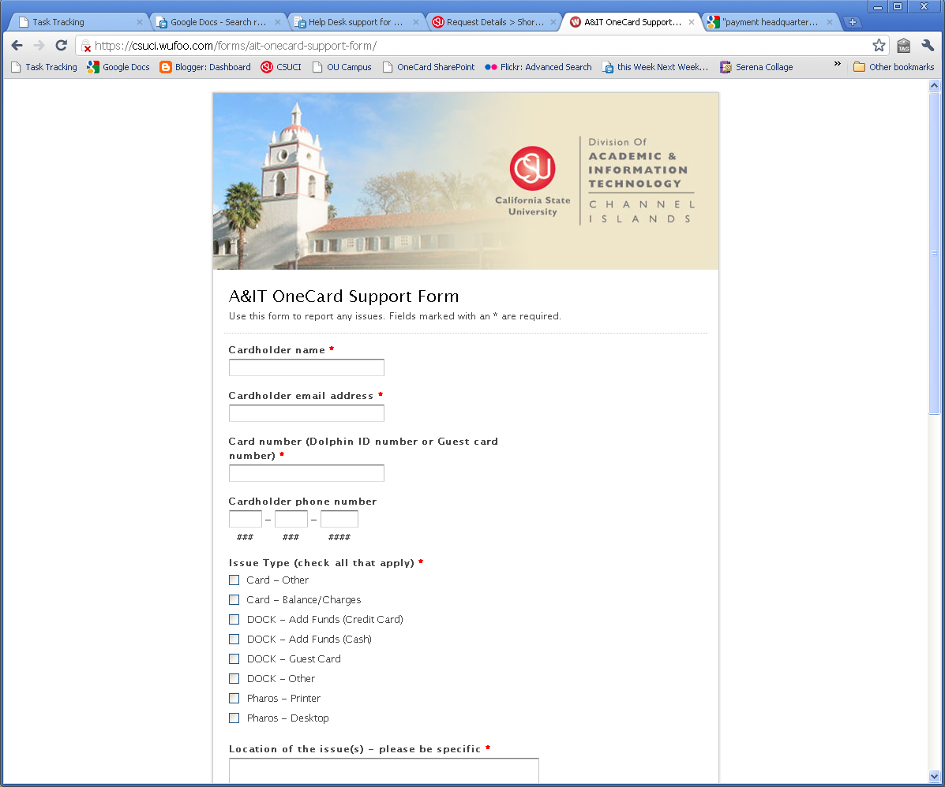
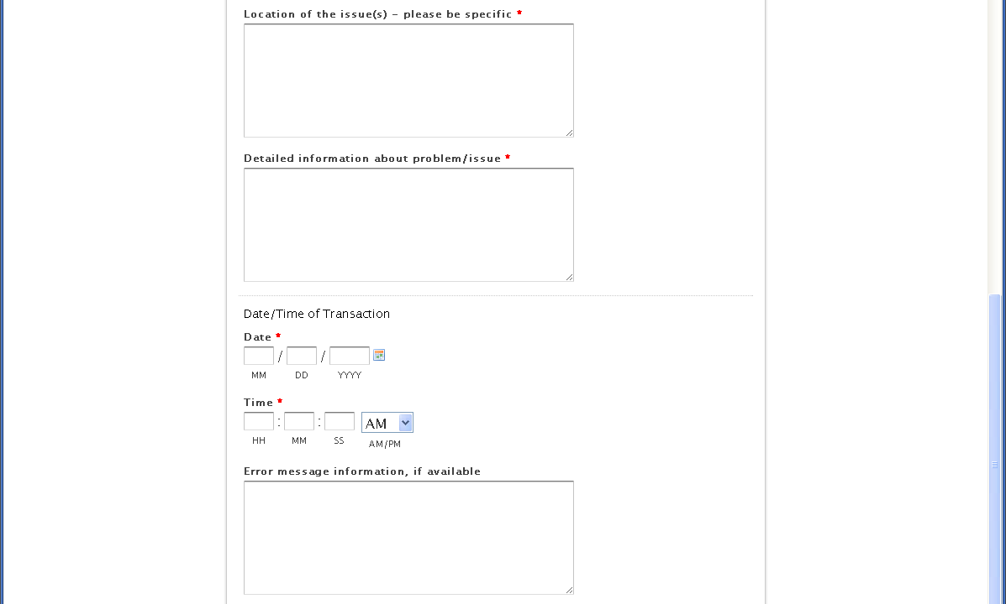
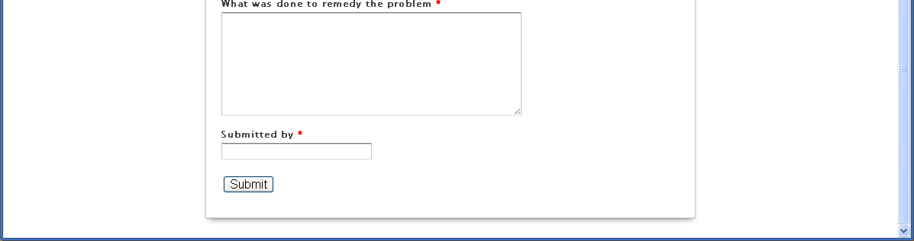

Printing Troubleshooting Flowchart

This flowchart can be used by Tier 1 support to assist in troubleshooting basic Pharos and card-related printing issues.

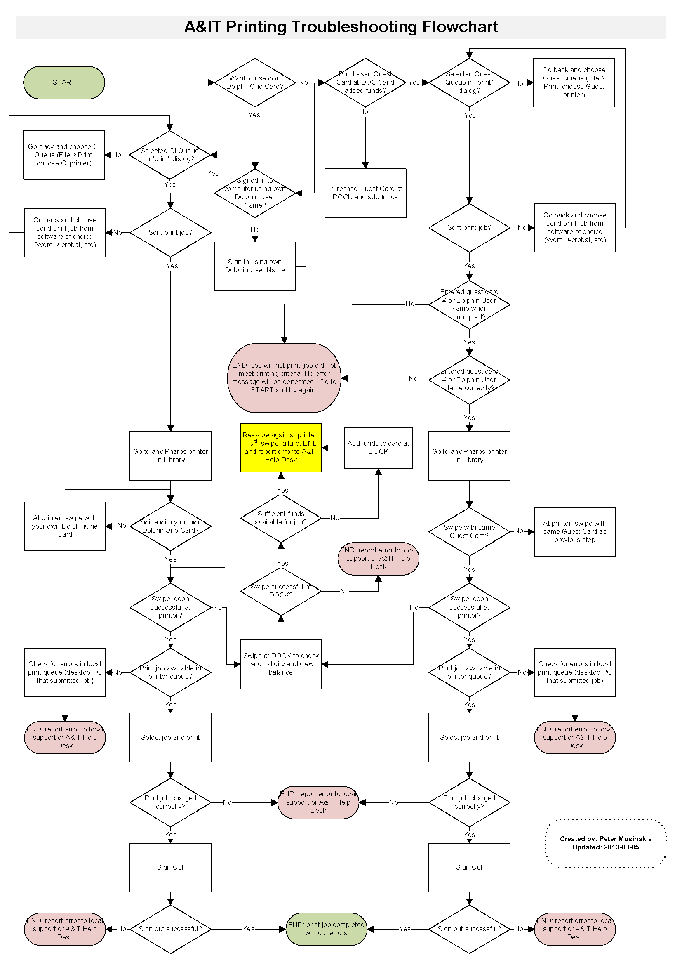

About this Document

Prepared by: Peter Mosinskis, Chris Murphy, Nasser Mansour, Judy Swanson

Updated: November 3, 2010
Created: July 20, 2010

