Service Level Agreement (SLA) for NetDocuments at CSU Channel Islands

Overview
This service level agreement has been developed to accomplish the following goals:
- Create an orderly, consistent method for reporting issues concerning NetDocuments;
- Clarify roles and responsibilities for providing operational support by the CSU Chancellor’s Office (CO), CI, and NetDocuments;
- Define difference between NetDocuments operational support and project support;

Affected Groups
This SLA affects the following campus groups:
- T&C staff (including Help Desk and other technical staff)
- CI Human Resources Staff
- CI Faculty Affairs Staff
- CSU Chancellor’s Office
- NetDocuments Customer Support

Affected Systems
This SLA applies to NetDocuments

Definitions
E-Counsel: System that will be replacing GRARB as a tool to track status of grievances, meet and confers, unfair labor practices, information requests, disciplinary matters, complaints, and collective bargaining. E-Counsel is a software-as-a-service (SaaS).

NetDocuments: Confidential cloud-based document repository used by selected staff within Faculty Affairs, Human Resources at CI and the CO to store, share/collaborate, track, and organize employee grievances as well as everything that it tracked in e-counsel. NetDocuments is a software-as-a-service (SaaS). www.netdocuments.com

Operations: Everyday business activities. Operations are repetitive activities, typically with the same outcomes. Further, operations are ongoing, with no start and end dates. This includes, but is not limited to adding documents, setting up new users with permissions to NetDocuments, and/or removing permissions for users who no longer have a business need to access NetDocuments. Operations typically require less than 30 hours of time to complete.

Project: A task or planned program of work that requires more than 30 hours of time, effort, and planning for completion. Projects have clear start and end dates, and create new products or functionality that were not previously available. Examples include: major upgrades, procurement of additional services/modules, and/or major Service Level Support changes.

Service Description and Standards

Operations Support Standards

Overview
The diagram in Figure 1 represents the process flow for NetDocuments’ operations support requests.

There are 3 tiers in the support process, which are described in detail in the “Roles and Responsibilities” section below.

Figure 1. Diagram of Operations Support Process
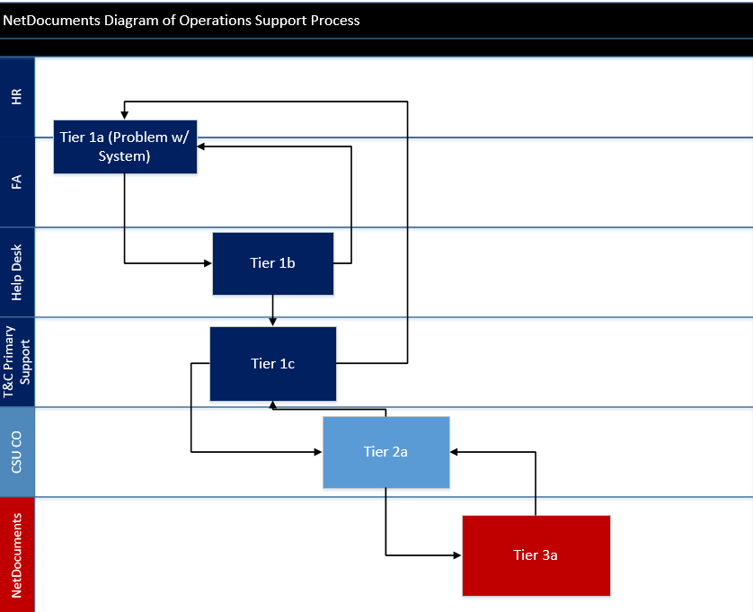

Roles & Responsibilities

Tier 1 Support
Tier 1 support will be provided by CI staff in the following functional areas:
- Tier 1a- Human Resources and/or Faculty Affairs
- Tier 1b- T&C Help helpdesk@csuci.edu
- Tier 1c- T&C Primary Support per T&C System & Service Catalog

All Tier 1 support personnel provide basic troubleshooting. This includes the following tasks:
- Repeat the transaction, and verify that the problem happens again.
- If it is a NetDocuments related issue that cannot be resolved and/or answered by the HR or FA staff, and/or T&C staff, the assigned T&C support will be responsible for contacting the CSU CO.

Tier 2 Support

Tier 2 support is the responsibility of CSU CO Support.

Tier 2 provides enhanced troubleshooting for issues that cannot be resolved by CI staff or Tier 1 support.

If Tier 2 support is unable to solve issue, Tier 2 support will escalate request to Tier 3 support.

Tier 3 Support

Tier 3 support is the responsibility of NetDocuments. NetDocuments will troubleshoot issue and respond to the CO with a fix and/or recommendations on how to proceed or work around the issue. The CO will be responsible for reporting fix and/or work around to CI T&C Primary Support. Unique fixes projected to take longer than 30 hours shall go through the official T&C Project Request Process.

Recovery Needs and Response Times
NetDocuments has been categorized by CI T&C as a deferrable important system. This means that in the event that the system goes down, CI T&C will do everything possible to bring it back online and available within 30 days.

Service Description and Standards

Roles & Responsibilities

Roles | Responsibilities
Faculty Affairs End Users | - Maintaining user account and login credentials  - Following instructions provided by the CO  - Using the systems when intended or needed  - Notifying CSU Chancellor’s office to de-active and/or activate user accounts.
Human Resources End Users

CSU Chancellor’s Office | - Notify end users of any planned or unexpected changes, outages or downtime.  - Notify T&C NetDocuments Primary Support and end users of system fixes and/or work arounds.  - Costs associated with Saas.  - Server as liaison between NetDocuments and CI end users  - Setup of new user accounts
NetDocuments Customer Support | - Primary point of contact for Tier 3 Support
T&C Help Desk | - Route all tickets to the appropriate Subject Matter Expert in T&C.  - Ensure that all T&C service desk tickets are tracked and monitored through completion.
T&C NetDocuments Primary Support | - Campus subject matter expert  - Assist authorized Faculty Affairs and Human Resources Staff with gaining access to NetDocuments. This includes assisting with installation of latest software and browser requirements to ensure that NetDocuments works properly. From an operational standpoint this will be necessary when new users start with the university, when current users receive a new work computer, or after system upgrades.  - CI liaison to CO Tier 2 support  - Assist with Change Management (e.g. upgrades, training, and service level agreement changes)  - Issue Escalation & Troubleshooting  - Assist with projects (something that will take over 30 hours to complete and has a clear beginning and an end) per CO, HR, and/or FA request and approval of T&C Project Review Board  - Name and their supervisor’s name will be listed in the T&C Systems & Services Catalog.

Contact Information

CSU Chancellor’s Office

Name: Thomas Le
Phone: 562-951-4203
Email: tle01@calstate.edu

Name: Yvette Menacho
Phone: 562-951-4416
Email: ymenacho@calstate.edu

Authorized End Users

Name: Beth Hartung
Phone: 805-437-3274
Email: Elizabeth.Hartung@csuci.edu

Name: Donna Vea
Phone: 805-437-8485
Email: Donna.Vea@csuci.edu

Name: Jerilee Petralba
Phone: 805-437-8876
Email: Jerilee.Petralba777@csuci.edu

Name: Anna Pavin
Phone: 805-437-8425
Email: Anna.Pavin@csuci.edu

Name: Laurie Nichols
Phone: 805-437-8423
Email: Laurie.Nichols@csuci.edu

Name: Ria Fidler
Phone: 805-437-8457
Email: Ria.Fidler@csuci.edu

T&C Help Desk
Email: Helpdesk@csuci.edu
Phone: 805-437-8552
Helpdesk@csuci.edu

T&C NetDocuments Primary Support
Name: Art Carpenter
Phone: 805-437-2764
Email: Art.Carpenter@csuci.edu

About this Document

Date: 10/28/2015
Author: Melissa Bergem

Approved by:
Melissa Bergem
Carlos Miranda
Ria Fidler
Jerilee Petralba
Beth Hartung
Donna Vea
Thomas Le

