Service Level Agreement (SLA) for CashNet eMarket Sites at CSU Channel Islands

Overview
This service level agreement has been developed to accomplish the following goals:
- To create an orderly, consistent method of gathering information about CashNet eMarket issues;
- To provide Budget and Fiscal Services (cashnet@csuci.edu) and Technology & Communication (T&C) technical staff with sufficient initial information to coordinate the creation of new eMarket storefront sites;
- To provide Budget and Fiscal Services (cashnet@csuci.edu) and T&C technical staff with sufficient initial information to coordinate the integration of new eMarket checkout sites;
- To facilitate documentation of chronic technical issues which will enable proactive repair and support;
- To clarify roles and responsibilities for CashNet eMarket operational support and project requests.

Affected Groups
This SLA affects the following campus groups:
- Budget and Fiscal Services (cashnet@csuci.edu)
- Student Business Services
- T&C staff (including Help Desk and other technical staff)
- Campus eMarket users (including students, employees and general public)
- eMarket vendors (e.g., CI clubs and organizations, CI Conference Groups such as SCCUR, CI Parking Services, CI Advancement, etc.)

Affected Systems
This SLA applies to all campus websites that have a need to collect method of payment online, including but not limited to:
- CI Donor and Advancement websites
- CI Parking Services
- CI Conferences
- CI clubs and organizations
- CI affiliates tasked with making purchases online

Definitions

BP-03-008: DRAFT T&C Business Practice for System and Service Catalog

CSU Channel Islands eMarket Request: This form is to be completed by anyone requesting a new CashNet eMarket Checkout or Storefront. The form must be submitted via email to cashnet@csuci.edu at least 6 weeks prior to the desired “go-live” date. Requests are processed in the order they are received.

CashNet eMarket: Current system being used by Budget and Fiscal Services to provide departments and auxiliaries of CSU Channel Islands a method to collect revenue online for events, donation and other special purposes from members of the community.

Checkout: One of two CashNet eMarket options where only the checkout features are used in CashNet. This is the less common option. With this option, an end user will visit a separate online system to respond to a series of questions and will then be directed to the CashNet site to respond to method of payment questions. Once the method of payment is verified and complete, the end user will be redirected back to where they started (online system). This option typically results in 2 email confirmations (one from each system).

eMarket Vendor: Any campus organization or affiliate that has a need to collect method of payment online. A list of approved CI eMarket Vendors and their key contact (per the CSU Channel Islands eMarket Request) is maintained by Budget and Fiscal Services.

Higher One: Company that brings us CashNet eMarket

Method of Payment: American Express, Master Card, and Discover. eChecks may be accepted if the end user is authenticated via MyCI prior to reaching CashNet eMarket checkout. Visa is only accepted if the requesting organization is willing to absorb the additional costs associated with Visa.

Operations: everyday business activities. Operations are repetitive activities, typically with the same outcomes. Further, operations are ongoing, with no start and end dates. For example shutting down an eMarket site per a CSU Channel Islands eMarket Request Form is an operation.

PayPal: A legacy system used by CSU Channel Islands to collect payment online. PayPal is being phased out in lieu of CashNet eMarket. No new PayPal sites are to be implemented starting October 1, 2012, and all existing PayPal sites will be shut down and converted to CashNet eMarket storefronts or checkout sites by December 31, 2012.

Project: a task or planned program of work that requires more than 30 hours of time, effort, and planning for completion (e.g., Implementation of new online systems that require eMarket integration, Implementation of new online storefront). Projects have clear start and end dates.

Refund: A cancel of purchase and return of funds. All requests for refunds must go through the designated eMarket Vendor. The 2.9% credit card convenience fee is non-refundable.

Same-Day-Void: A refund that is processed on the same day an online purchase was made (see refund). Same-Day-Voids differ from a typical refund because the credit card convenience fee of 2.9% is also refunded. All requests for Same-Day-Voids must go through the designated eMarket Vendor.

Service Fee: An additional 2.9% charge that is applied for the use of credit cards.

Storefront: One of two CashNet eMarket options where all CashNet features are used. With this option, an end user will visit the CashNet site to respond to all questions. This option typically results in one email confirmation.

Testing: This happens prior to go-live. Finance tests the General Ledger (GL) connection and the requesting organization tests the look, feel, grammar, and functionality. Once testing is complete the system is copied in production.

Service Description and Standards

Roles & Responsibilities

Any CI organization or auxiliary (eMarket Vendor)
- Request a new site by completing and submitting a CSU Channel Islands eMarket Request.
- Participate as new eMarket site team member tasked with making key decisions on site and for implementation strategy.
- Perform testing of new CashNet eMarket site.
- Report problems with eMarket site to cashnet@csuci.edu
- Request updates to eMarket site by sending email to cashnet@csuci.edu
- Request refunds by sending an email to emarketrefunds@csuci.edu
- Provide monthly reconciliation of site against general ledger and any other system that is integrated with their CashNet eMarket site.

Budget and Fiscal Services
- Initiate, schedule, and facilitate team meetings to create and implement new eMarket sites.
- Implement the visual front-end and back end of CashNet eMarket
- Perform testing of the General Ledger connection
- Review reconciliations
- Confirm receipt of eMarket Request
- Evaluate and process CSU Channel Islands eMarket Requests
- Respond to questions regarding eMarket requests

Student Business Services
- Process refund and same-day-void requests

T&C Representative
- Ongoing T&C Support for CashNet
- Ongoing T&C Support for eMarket
- Participate as new “Checkout” eMarket site team member tasked with ensuring HigherOne’s technical support work with 2nd vendor’s technical support to ensure a smooth transition between sites.
- Perform testing of the transitions between storefront and checkout
- Tier 3 support (troubleshooting) for CashNet
- Tier 3 support (troubleshooting) for eMarket

Operations Support

Overview
The diagram in Figure 1 represents the process flow for CashNet eMarket operational support requests and troubleshooting for CI CashNet eMarket sites. There are 3 tiers in the support process, which are described in detail below.

Figure 1. Diagram of Operations Support

Tier 1: eMarket Vendor
Tier 2: Budget & Fiscal Services

Tier 3b:
T&C

Tier 3a:
Higher One

The following are examples of CashNet eMarket operation support requests:
- CashNet eMarket customer decides to cancel their order on the same day they submitted a request for purchase
- CashNet eMarket vendor cancels event and must refund money to all who purchased tickets
- Vendor would like to turn off their CashNet eMarket site.
- An error message occurs on the vendor eMarket site.

Tier 1 Support
Tier 1 support will be provided by the eMarket Vendor. Examples include:
- CI Parking Services
- CI Alumni Relations
- CI Advancement
- CI SCCUR Team

All Tier 1 support personnel provide basic troubleshooting. This includes the following tasks:
- If practical, replicate the issue, and verify that the problem happens again.
- If completion of basic troubleshooting does not solve issue, Tier 1 support will document sufficient information and report the problem to Tier 2 support via email at cashnet@csuci.edu

Tier 2 Support
Tier 2 support will be provided primarily by CI Budget and Fiscal Services.

Tier 2 also provides enhanced troubleshooting for issues that cannot be resolved by Tier 1 support. This includes the following tasks:
- Review emailed request for assistance
- Provide both technical and non-technical solutions for CashNet eMarket issues to the extent of knowledge and capabilities.
- Serve as liaison between Tier 1 and Tier 3 support
- Research and gather information
- Document additional steps performed to resolve issue(s)
- Maintain documentation on issue resolution

If Tier 2 support is unable to solve an issue, Tier 2 support will escalate request to Tier 3 support, and provide Tier 3 support with necessary information to continue resolution of issue.

Tier 3 Support
Tier 3 support will be provided by the following areas:
- Higher One
- T&C

Tier 3 provides enhanced troubleshooting for issues that cannot be resolved by Tier 2 support. This includes the following tasks:
- Work with Tier 2 support to research and troubleshoot issues.
- Work with a range of vendors/manufacturers to resolve technical issues (i.e. in the case of CashNet eMarket Checkout site, T&C will work with the second system administrator).
- Serve as a liaison between Tier 2 and Tier 1, if explicitly requested by Tier 2 support.

Example Operations Support Case
A CI online shopper believes they clicked on the submit button one too many times and after receiving multiple emails are concerned that their credit card transaction went through more than once. The online shopper contacts the eMarket Vendor (per the contact information on the CI site).

The eMarket Vendor asks the shopper to forward all emails received to them.
- There should only be 2 for Checkout sites
- There should only be 1 for Storefront sites
If there are more emails than what is specified above, the eMarket Vendor verifies whether or not the transaction went through twice in CashNet eMarket.

If it is clear that the transaction did go through twice than s/he will email Student Business Services requesting that they process the refund; however, if it is unclear, or the eMarket Vendor’s findings are questionable, s/he will contact Tier 2 for further investigation.

Budget and Fiscal Services Research gathers information from the eMarket Vendor and reviews GL to see if the transaction went through multiple times. Budget and Fiscal Services will report back their findings to Tier 1 with findings.

If the additional emails are being sent in error, and it is determined that the online shopper did not make duplicate purchases, then Tier 2 will follow up with Tier 3 to resolve the issue of having one too many email confirmations. Tier 2 will keep Tier 1 apprised of any updates and Tier 1 is responsible for circling back with the CI online shopper to let them know what in fact happened.

However, if it is determined that the online shopper did indeed make a duplicate purchase, then Tier 2 will not need to involve Tier 3. Tier 2 will tell Tier 1 to request the refund through Student Business Services.

Higher One and/or T&C will work to troubleshoot the multiple confirmation emails and notify Tier 2 of findings and corrective action(s) taken. Tier 2 will pass this information along to Tier 1, and Tier one is still responsible for circling back with the CI online shopper to let them know what in fact happened.

Project Support

Overview
The diagram in Figure 2 represents the process flow for CashNet eMarket project support. requests for CI CashNet eMarket sites.

Figure 2. Diagram of Project Support

Tier 1: eMarket Vendor
Tier 2: Budget & Fiscal Services

Tier 3b:
T&C

Tier 3a:
Higher One

Tier 3c:
3rd Party System/Application

The following are examples of CashNet eMarket project support requests:
- Upgrades
- New system installation
- Enhancements
- Implementing New CashNet eMarket site

Tiers 1, 2, 3a, and 3b for Project Support are the same as for those defined under Operations Support. However, there are 4 differences. These are as follows:
- Direct line of communication between Tier 1 and Tier 3b
- Direct line of communication between Tier 3a and Tier 3b
- Addition of a Tier 3c (for Checkout sites only)
- Dotted line of communication (per the special request of Tier 3b) between Tier 3a and Tier 3c.

Tier 1 Project Support
Tier 1 support will be provided by the eMarket Vendor. Examples include:
- CI Parking Services
- CI Alumni Relations
- CI Advancement
- CI SCCUR Team

All Tier 1 support personnel provide basic project input. This includes the following tasks:
- Completing and submitting the CSU Channel Islands eMarket Request
- Actively participating in discussions with Tier 2 and the three Tier 3s regarding their project needs
- And any other role(s) listed under the Service Description and Standards section (See Table 1. Roles & Responsibilities) with eMarket Vendor as the responsible party.

Tier 2 Project Support
Tier 2 support will be provided primarily by CI Budget and Fiscal Services.
- Primary point of contact for all CSU Channel Islands eMarket Requests
- Project initiator responsible for serving as a central point of contact and liaison between Tier 1 and the three Tier 3s.
- Any other role(s) listed under the Service Description and Standards section (See Table 1. Roles & Responsibilities) with Budget and Fiscal Services as the responsible party.

Tier 3 Project Support
Tier 3 support will be provided by the following areas:
- Higher One
- T&C
- 3rd Party System/Application

All Tier 3 support personnel provide basic project input. This includes the following tasks:
- Any role(s) listed under the Service Description and Standards section (See Table 1. Roles & Responsibilities) with T&C as the responsible party.

Example Project Support Case
CI organization plans to host a conference. They have already created a website that allows interested individuals to read more about the event and register, but the organization still needs a way to collect registration fees from those who sign up to attend. In this example the CI organization hosting the event is the eMarket Vendor (Tier 1).

eMarket Vendor completes and submits a CSU Channel Islands eMarket Request.

Budget and Fiscal Services (Tier 2), contacts the eMarket Vendor and T&C (Tier 3b) to Initiate, schedule, and facilitate team meetings to create and implement new eMarket sites.

Since a website/database already exists for the conference, T&C will need to include the creator/administrator of website/database (Tier 3c) in any project discussions, and possibly facilitate conversations and decisions between Tier 3c and Tier 3a to ensure that the Checkout runs smoothly.

Tier 1, Tier 2, Tier 3a, and Tier 3b will work closely and follow Tier 2’s direction. Each will follow the assigned schedule of tasks and attend meetings.

Tier 2 will take suggestions from the team and build the visual front-end and back end of CashNet eMarket. Questions, comments, and issues pertaining to the new site will be addressed either at project meetings or by following the process outlined in Figure 2.

Tier 2 will provide Tier 1 and Tier 3b with testing criteria, and provide a method of documenting identified issues, level of priority, comments/updates, and date of resolution.
- Tier 1 will test the site from a user perspective.
- Tier 3b will test transitions between the conference site and the Checkout site.
- Tier 2 will perform testing on the General Ledger (GL).

Tier 2 will make final decision on go-live and implement the site.

Hours & Response Times
Department | Response Time
Student Business Services  (See website for hours) | Within one business day.  The deadline for submitting a same day refund request is 3:00 PM.
Budget and Fiscal Services  (See website for hours) | Within one business day for operations support.  Requests for new eMarket site can take 4-6 weeks. And requests are processed in the order received. Project related response times will be further defined by project plan, schedule, and team meeting action items.

Appendix A

CSU Channel Islands eMarket Request Form: http://www.csuci.edu/budget/forms.htm

Appendix B

CashNet Customizations
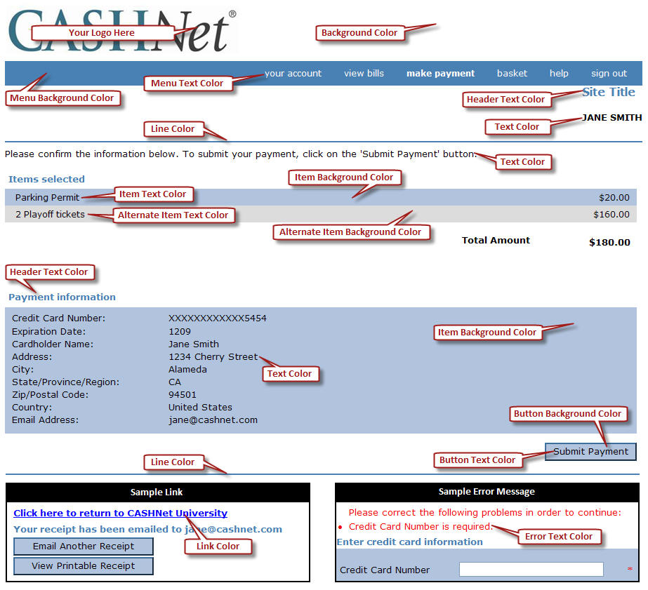
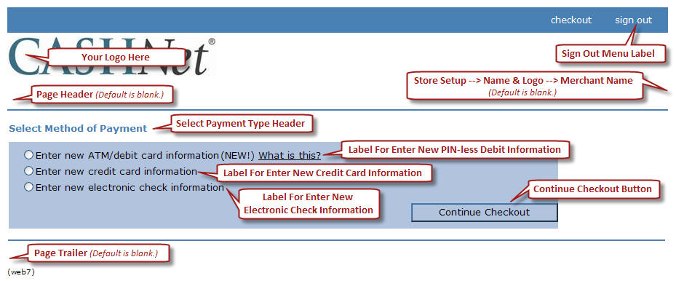
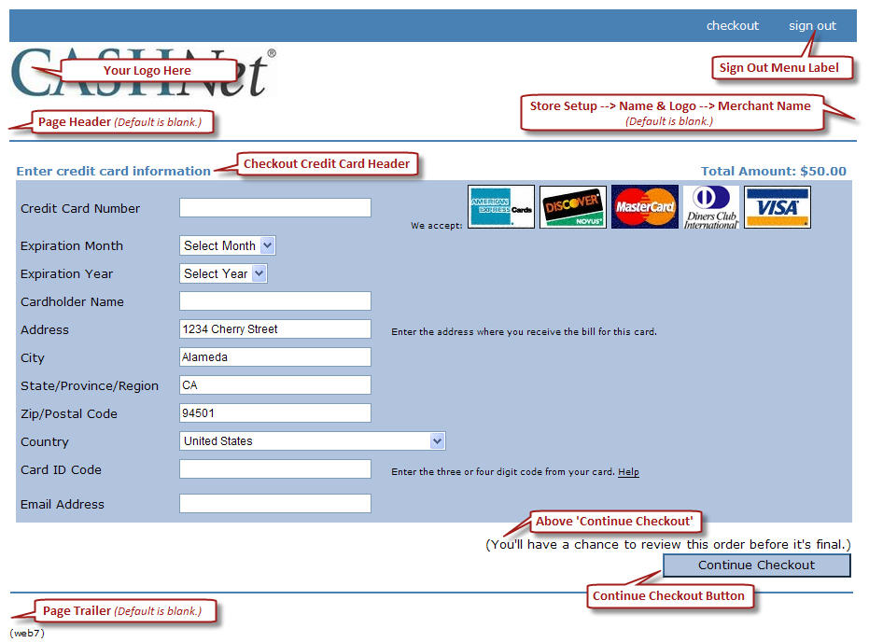
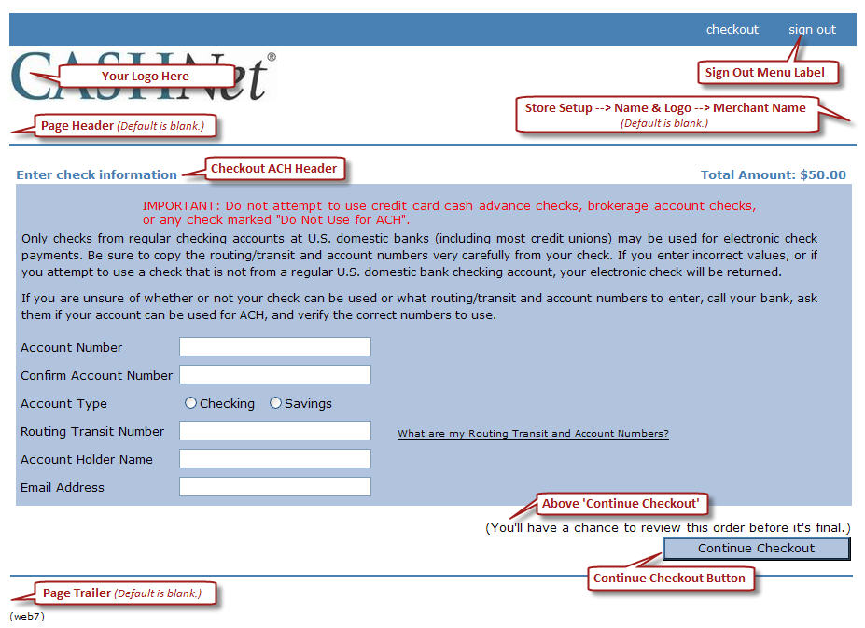
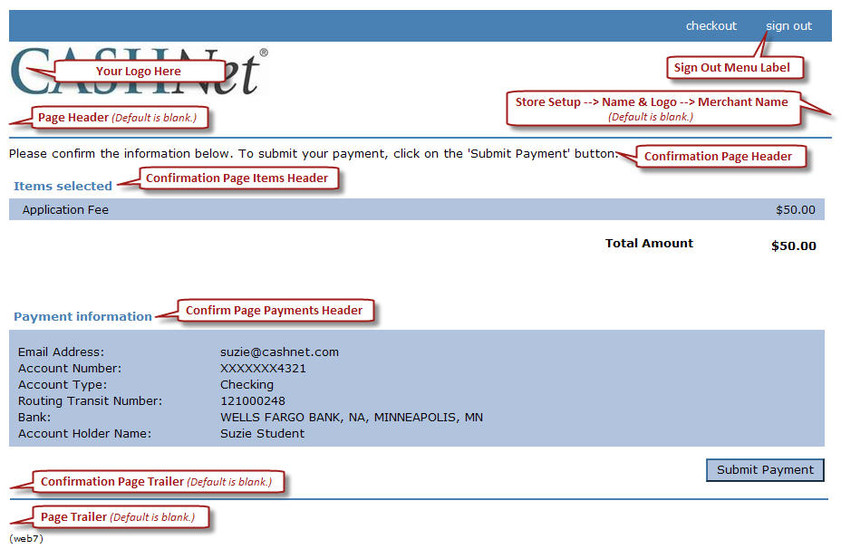

Appendix C

CashNet Emarket “Checkout” Online Payment Flow – Example
2012-07-03
Peter Mosinskis, Director of IT Strategy, peter.mosinskis@csuci.edu

Overview & Caveats

CI is configuring HigherOne’s CashNet Emarket to enable University organizations to take online payments for events and services. The following images and descriptions describe how the online payment flow will work. Please note that these are just examples of the system in its current state; further visual, content and layout changes are expected in production versions.

Step 1. Registration / Payment page on existing site.

This is a payment page built into the SCCUR web application.

In this case, the user fills out a conference registration form with certain information, and submits the form.

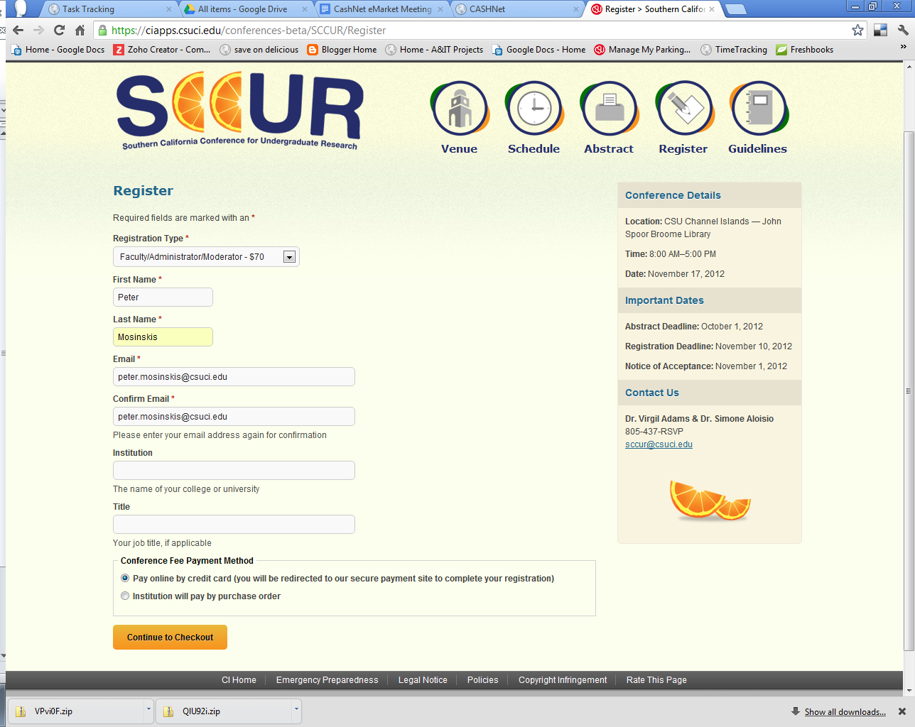

Step 2. Initial CashNet Payment Page

The user is redirected to a CashNet page, hosted on the CashNet site, prompting for credit card information. If a user forgets to complete fields, they are prompted with the error messages, as shown in red.

The user fills out all required fields and clicks the “Continue Checkout” button

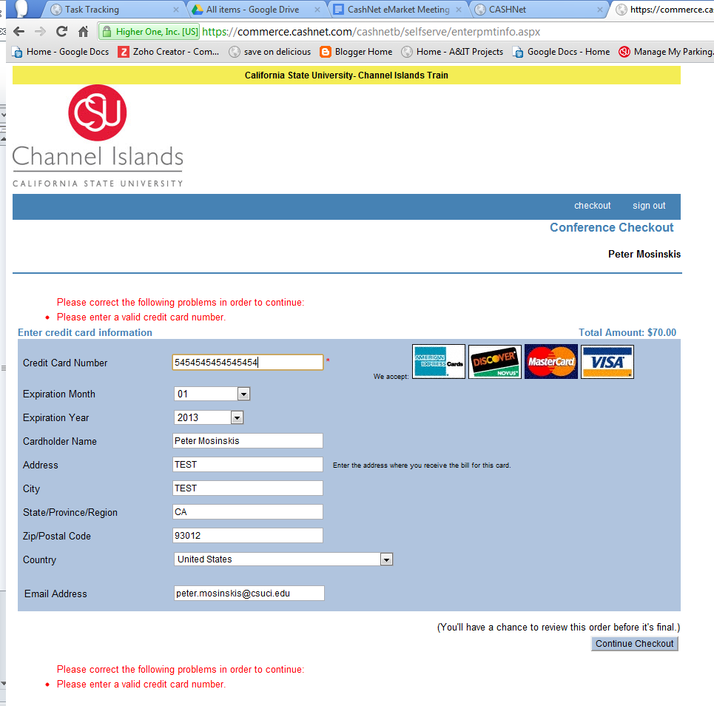

Step 3. Payment Review and Payment Submission Page

Next, the user can review the proposed transaction, including the amount and which card will be charged. Here the user must click the “Submit Payment” button to complete the payment transaction.

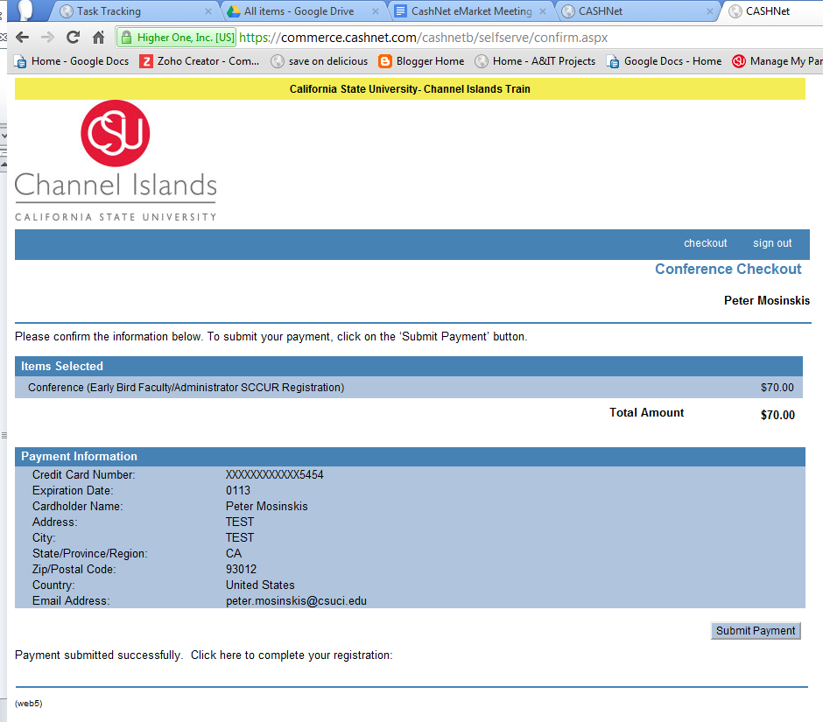

Step 4. Transaction Approved and Redirect to Originating System

If the credit card was successfully charged, the user receives this “Transaction Approved” page, where they can print or email a receipt of the transaction.

In addition, there is another button (currently) called “Complete Transaction”, which redirects users back to the original site where the transaction was conducted. (This is slightly strange, but really the only good way to pass people back to the original site, especially if other processing must take place. Careful instructions, button naming and design can help alleviate this confusion).

A confirmation number is provided here, but this is a CashNet confirmation number, and not necessarily a confirmation number from the originating system.

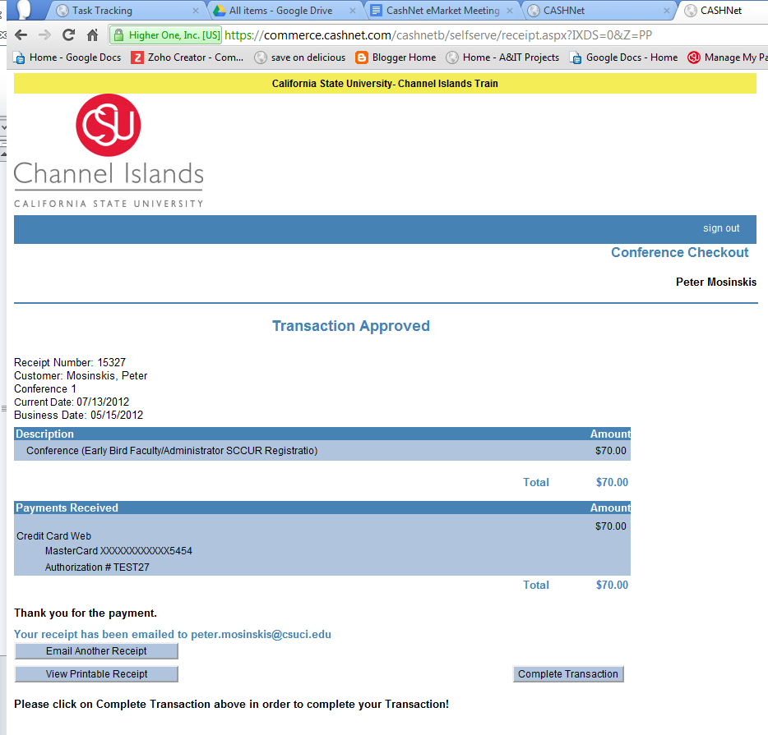

Step 5. Registration Successful Confirmation

Finally, registration is confirmed by the originating registration system with a confirmation number for the conference.

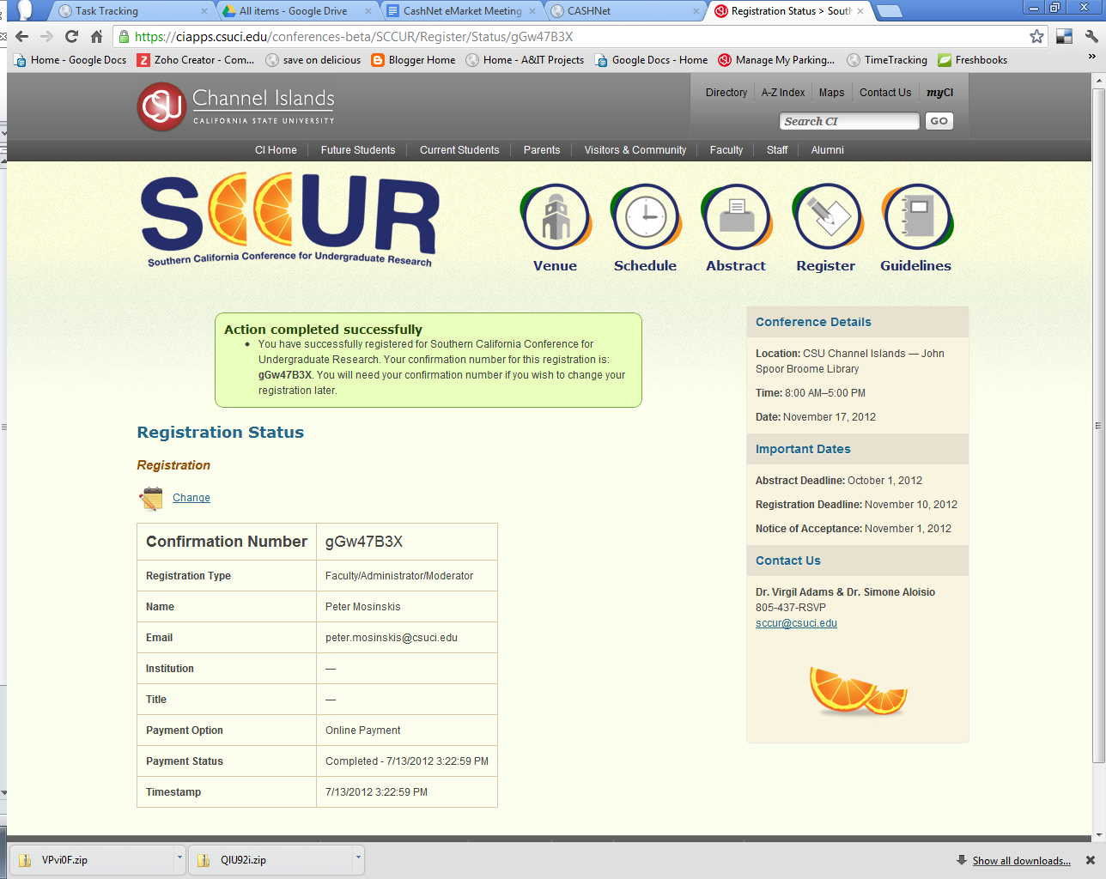

Follow Ups: Email Messages

Both CashNet and the originating system generate confirmation email messages for each transaction.

Here’s what CashNet’s message looks like (foreseeably, this could be different for each eMarket checkout):

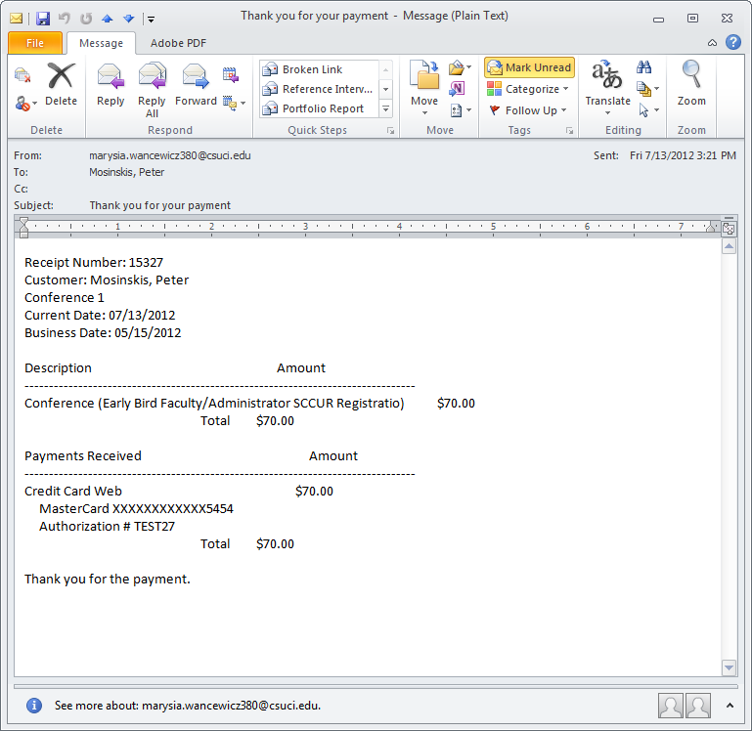

Here’s what the originating system’s message looks like (in this case, the SCCUR conference confirmation message); foreseeably, this could be different for each originating system:

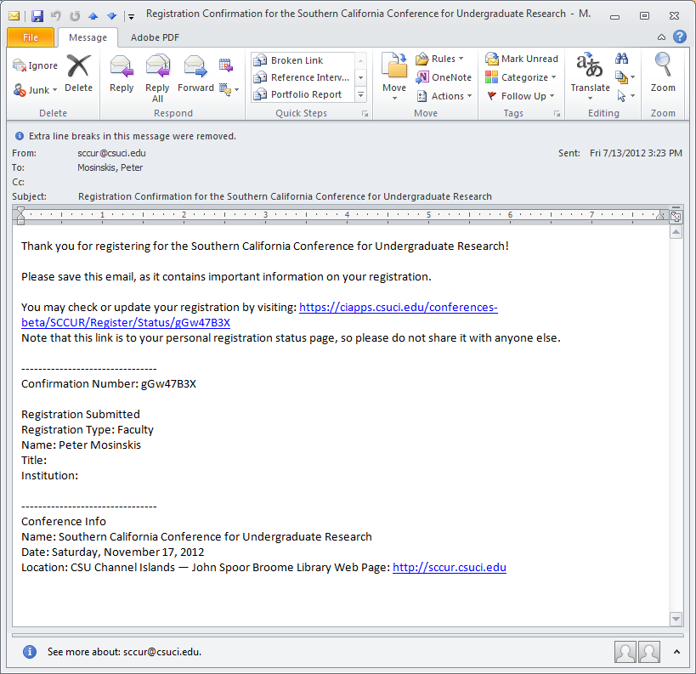

Appendix D

CashNet EMarket “Storefront” Online Payment Flow – Example
2012-08-22
Peter Mosinskis, Director of IT Strategy, peter.mosinskis@csuci.edu

Overview & Caveats

CI is configuring HigherOne’s CashNet EMarket to enable University organizations to take online payments for events and services.

The following images and descriptions describe how the online payment flow will work using the “Storefront” component of CashNet EMarket. Please note that these are just examples of the system in its current state; further visual, content and layout changes are expected in production versions.

Step 1. Call to Action on existing CI web site

In this example, University Advancement is soliciting donations via the “Make a Gift” web page (http://www.csuci.edu/impact/). After arriving at this page, a prospective donor would click the “Give Online Now” button to start a donation transaction.

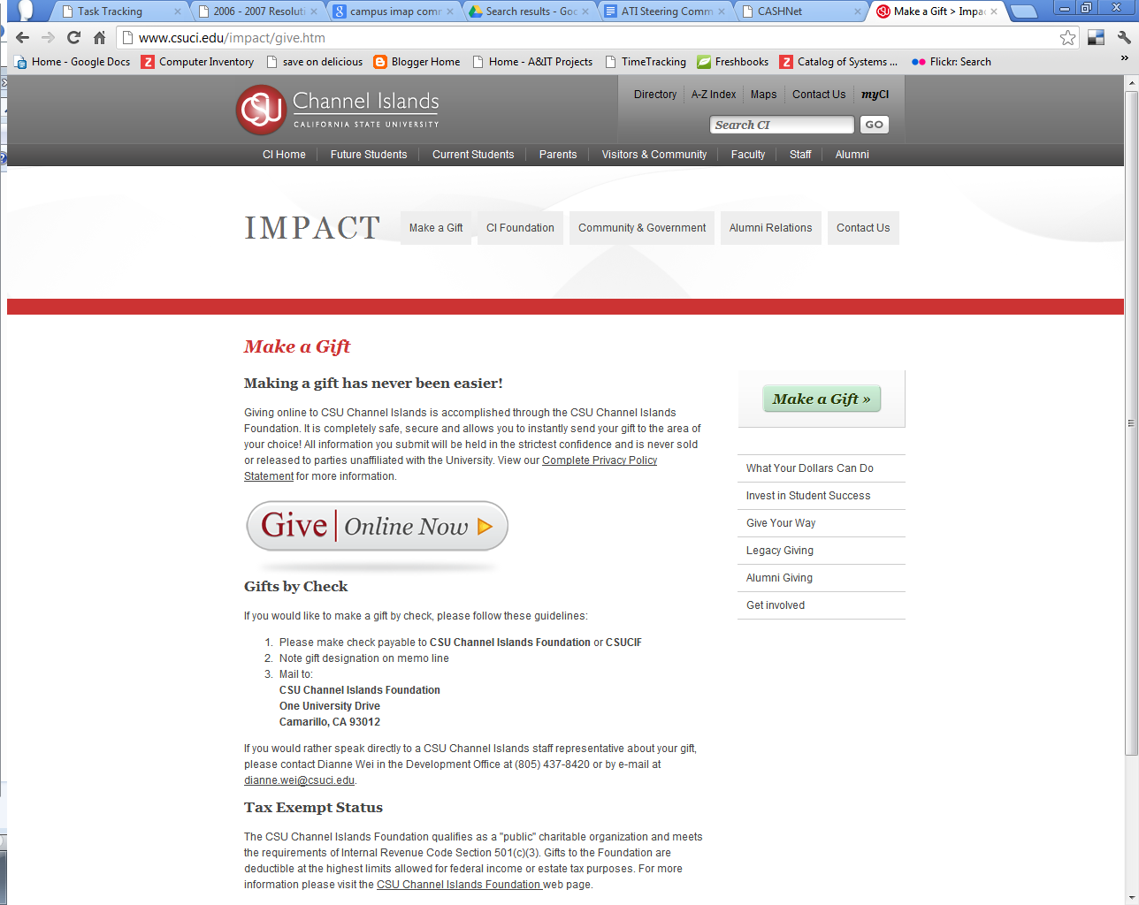

Step 2. Initial CashNet Storefront Page

The user is redirected to the CashNet page for the corresponding Storefront (in this example, https://commerce.cashnet.com/CSUChanelIslandsFoundationDonation). The initial page (as well as subsequent Storefront pages) are hosted on the CashNet site. The initial page will prompt the user to select the product to purchase (in this case, the type of donation). To continue, the user must select a product (or donation type) using the appropriate button.

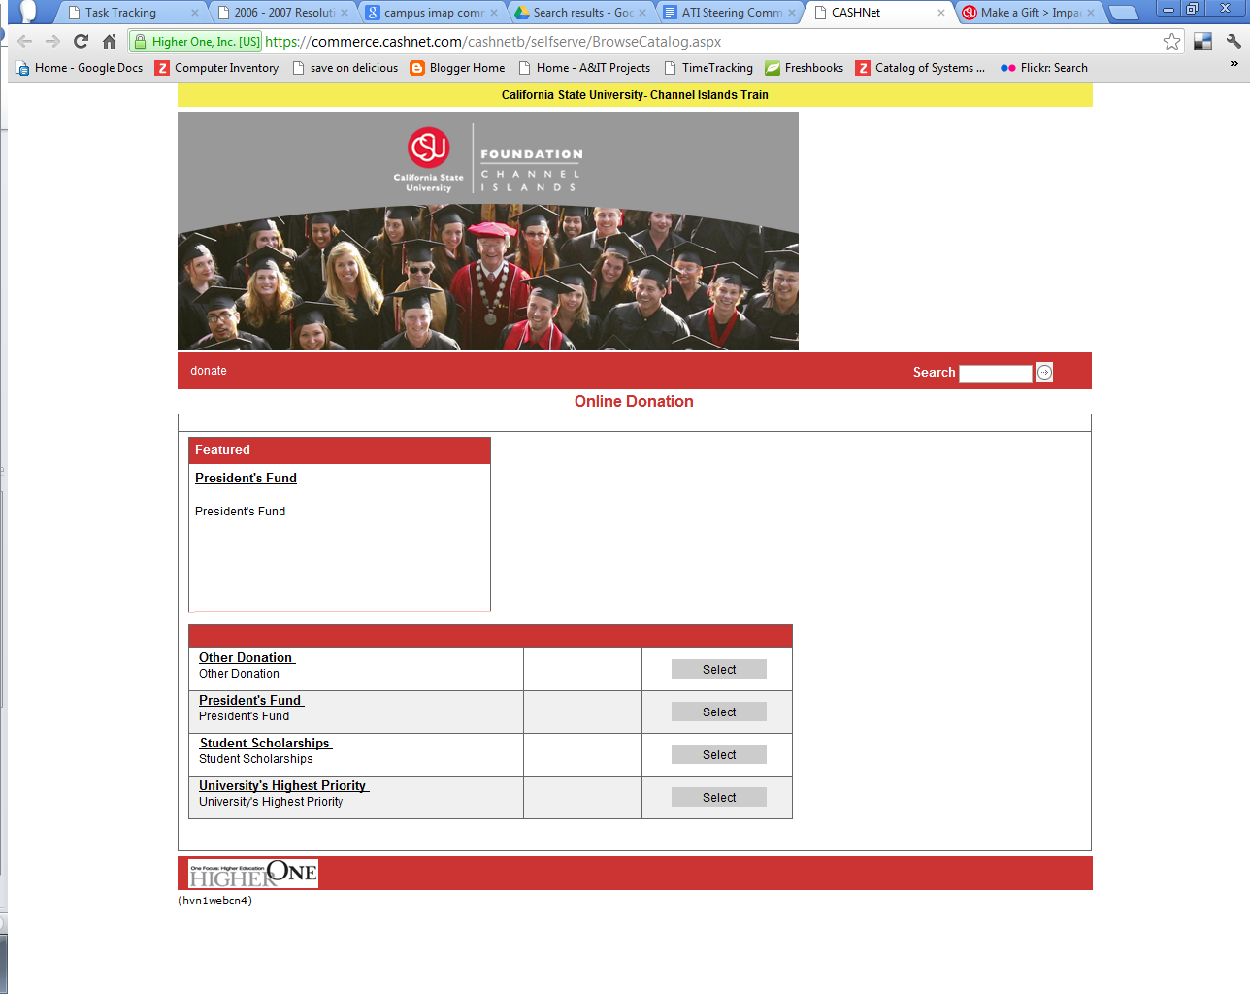

Step 3. Information Gathering Page

Next, the user is prompted to enter additional information for this transaction. (Each CashNet eMarket Storefront can be customized to include a different set of fields to gather information). Some fields can be marked as required. Data gathered in this page will be available to each eMarket Storefront manager via reports.

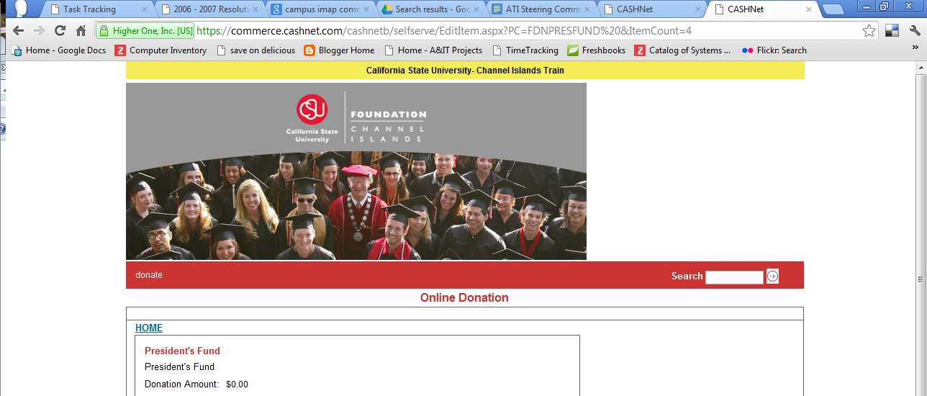
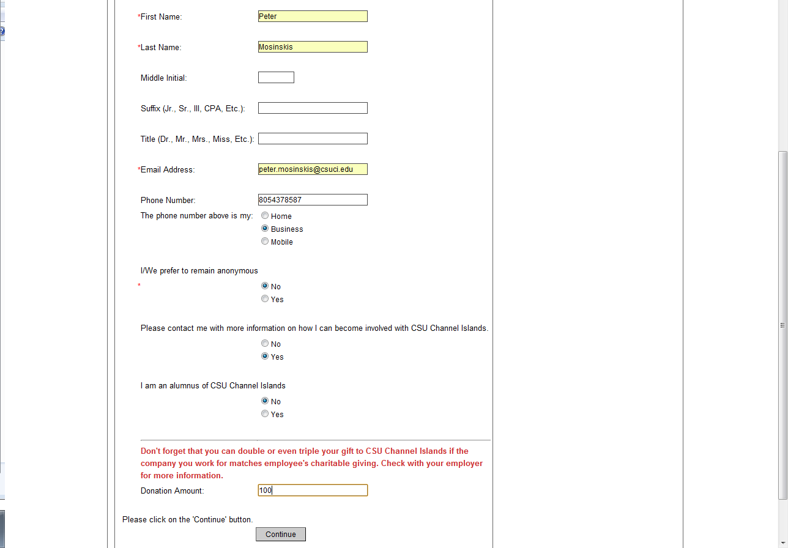

Step 4. Payment Information Page

Next the user is prompted to enter payment information. Certain fields are required.

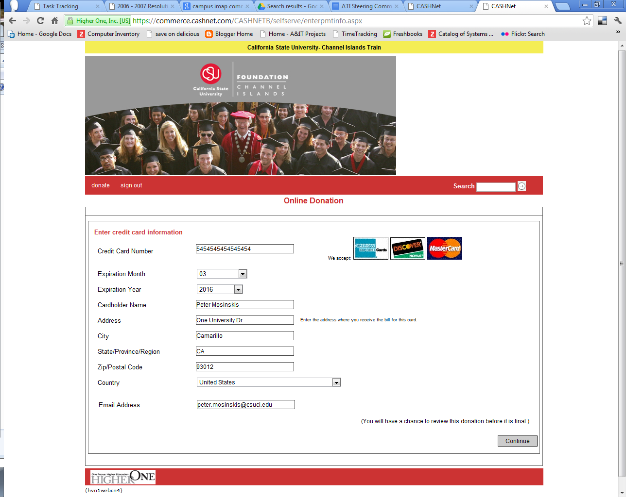

Step 5. Transaction Review and Submission

During this step, the user is given a final opportunity to review the transaction, including items specified, transaction amount and payment information. The user must click the “Submit” button to complete the transaction.

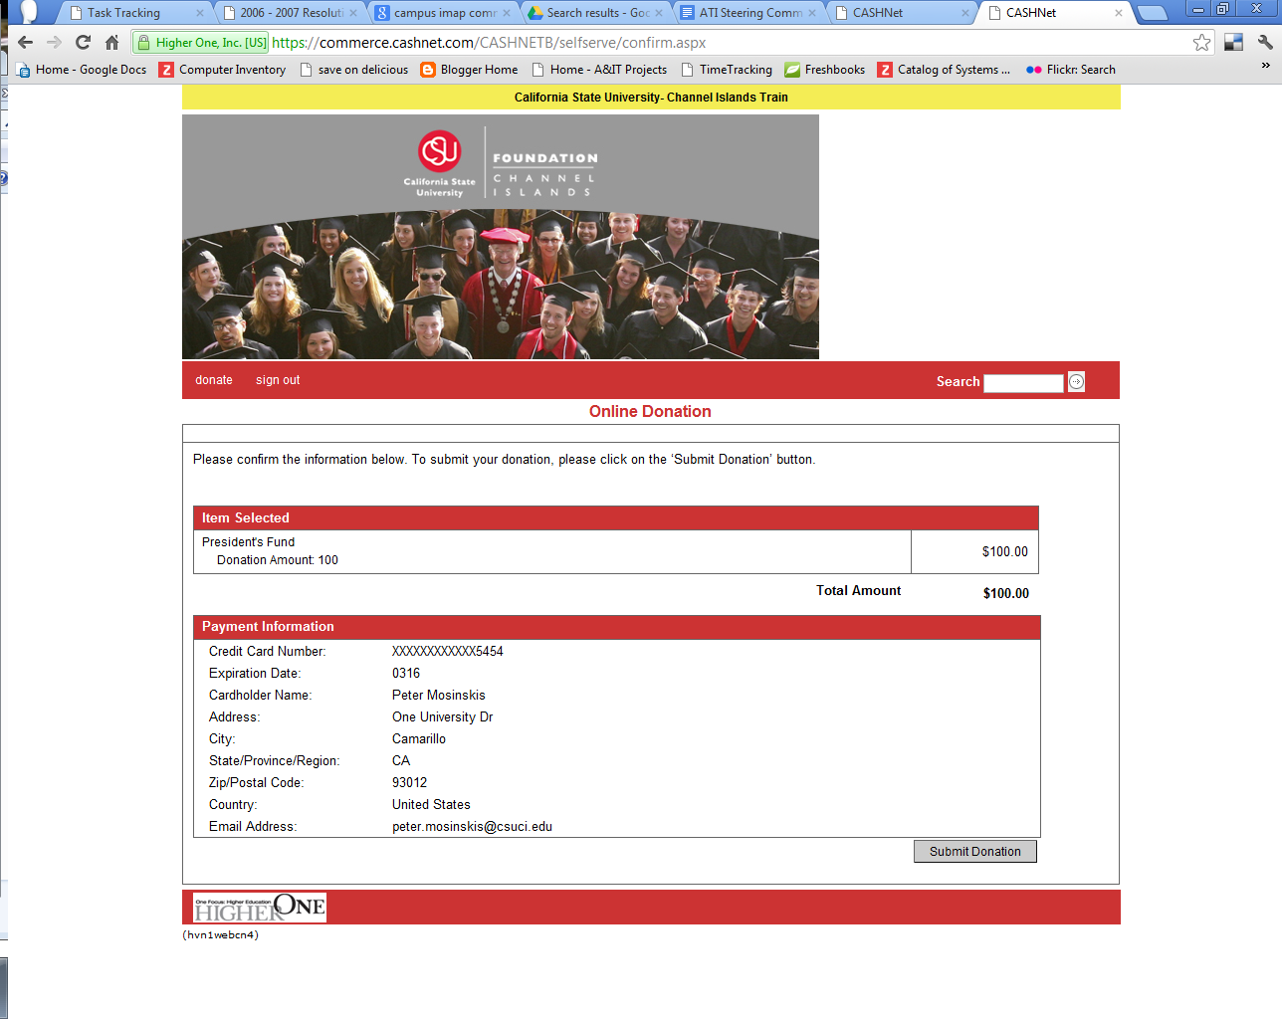

Step 6. Transaction Approved and Redirect to Originating System

If the credit card was successfully charged, the user receives this “Transaction Approved” page, where they can print or email a receipt of the transaction. A receipt number is provided on this page, enabling users to provide quick reference regarding the transaction.

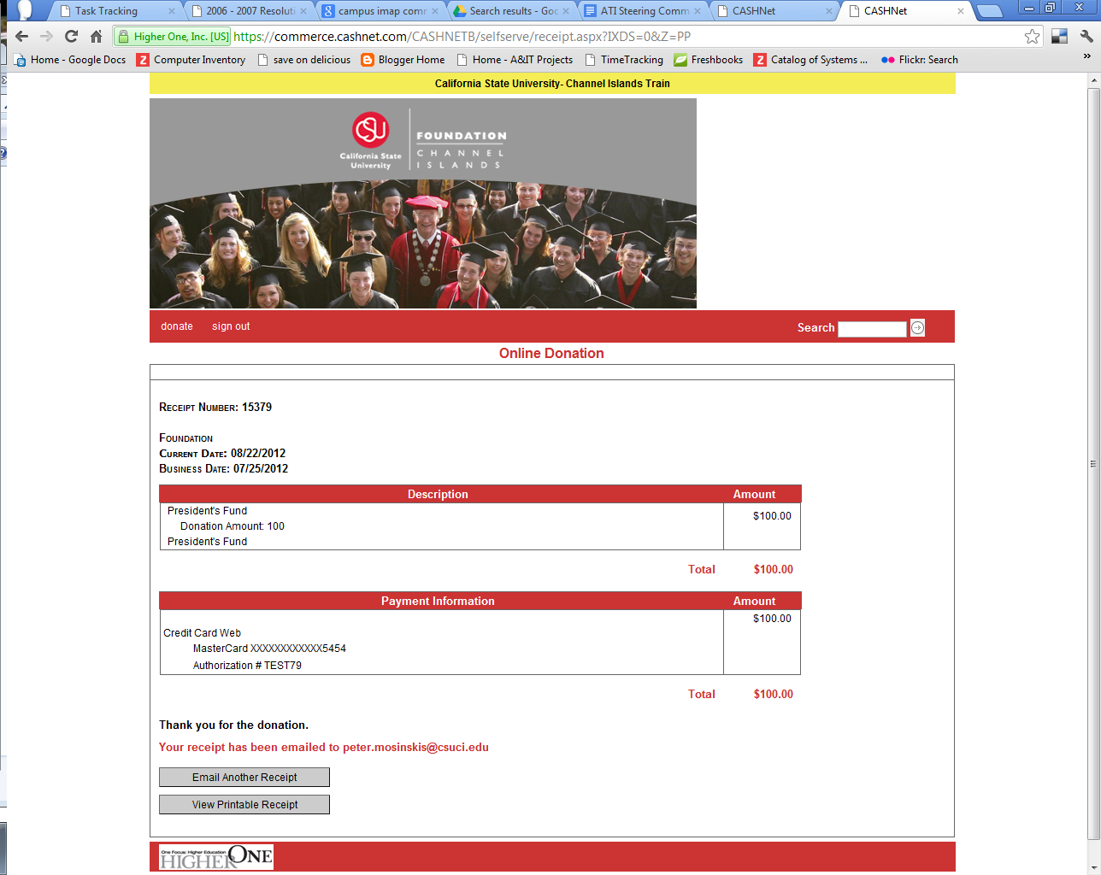

Step 7. Email Confirmation Messages

The CashNet eMarket Storefront will then send an email to the address specified during Step 4. This message should be customized for each eMarket storefront as follows:

From address: should be email address of the person and/or organization that will provide customer support for disputes and returns. A shared, catch-all CI email address may be preferable.

Subject: should include “CI” or “CSU Channel Islands”, the words “Receipt”, and the name of the organization. For example “Donation Receipt – CI Foundation”.

Message body: should include contact name, email address and phone number of the person(s) to contact with any questions or problems with the transaction.

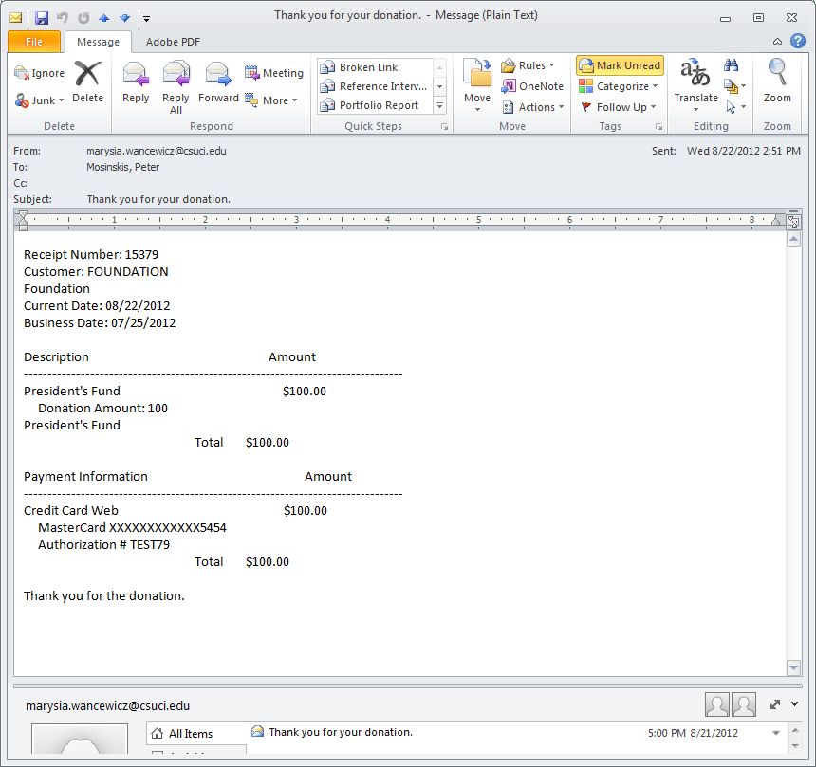

About this Document

This document was created by Melissa Bergem, Peter Mosinskis, Neal Fisch, Lacey Lovejoy, Kevin Craig, Marysia Wancewicz, Theresa Olivo, Phyllis Vicker, Missy Jarnagin, and Scott Petersen

The project team that first implemented CashNet eMarket at CSU Channel Islands recommends that this document be revisited for possible revisions after the first roll out of a CI storefront site and on an annual basis thereafter.

Prepared by: Melissa Bergem

Updated: September, 26, 2012
Updated: September 18, 2012
Updated: September 11, 2012
Updated: September 4, 2012
Created: September 4, 2012

