Service Level Agreement (SLA) for StarRez at CSU Channel Islands

Overview
This service level agreement has been developed to accomplish the following goals:
- Create an orderly, consistent method of gathering information about StarRez issues;
- Facilitate documentation of chronic technical issues which will enable proactive repair and support;
- Clarify StarRez and CI Divisions’ roles and responsibilities for providing operational support;
- Define difference between StarRez operational support and project support;
- Reiterate that any work performed by T&C will be recharged back to Housing and Residential Education; and
- Clarify HRE recovery needs and expectations regarding response times per type of service and time of year.

Affected Groups
This SLA affects the following campus groups:
- Financial Services
- Student Business Services
- T&C staff (including Help Desk and other technical staff)
- Student residents and prospective student residents (StarRez portal end users)
- Housing and Residential Education (HRE) (Student workers, Staff, and StarRez super users)
- StarCare, StarRez’s Customer Support
- CI Parking Services
- Campus Police Department
- Student Health Services
- Enrollment Services
- University Glen Corporation (impacted by meal plan export)

Affected Systems
This SLA applies to the StarRez Client, StarRez Portal, and the StarRez Mobile Apps (Mobile Directory and Mobile Maintenance) environments and all of the Core System and Modules within, the infrastructure established by CI T&C, and the interfaces and integrations created by both CI and StarRez resources.

Core System and Modules
- Main Module/Resident Directory
- Main Reports/Charting/Occupancy Graph & Dashboard
- Billing & Accounts (StarRez Module that feeds into Student Financials via Financial Export to PeopleSoft)
- Auto Allocation
- Email & Correspondence Tracking
- Active Directory (AD) Integration (Single Sign On for Staff)
- Reservation Pro Rate Billing
- Meal Plan Pro Rate Billing
- Conference
- Incidents

Interfaces and Integrations
- Online Payment Interface (CashNet eMarket)
- People- Demographic & Academic Import
- Financial Export to PeopleSoft
- SSO for Web Portal (Single Sign On via myCI for Students)
- SSO Insert Interface (Single Sign on and insert of data for new Students’ StarRez Record)
- Meal Plan Export (to BlackBoard Transactions)
- CI Parking Permits (T2) Export (Reflects up to date information regarding students’ eligibility to purchase RA, SH, or SHUG permits)
- Dolphin One Photo Import into StarRez Client
- Dolphin One Photo Import into StarRez Mobile App

Web / Portal Modules
- Web Directory
- Room Swap
- Room Maintenance
- Room Inventory
- Incidents
- Mobile Directory and Check-In and Check-Out

Definitions
Application Fee: Non-refundable fee collected via CashNet eMarket at the time a student applicant applies for housing. The application fee is subject to change. Visit the CI Housing and Residential Education site for the latest pricing.

BlackBoard (Transact): Application administered by Financial Services to track and monitor Student Meal Plan and Residential Flex Cash usage. It is important to note in this SLA because data captured in StarRez will eventually be exported to Blackboard. When student applicants sign their housing contracts they are required to enroll in a Meal Plan (w/ Residential Flex Cash) via the StarRez Portal. A student may also change (increase or decrease their meal plan and/or terminate their residence. When one’s residence ends during a semester so too does their meal plan. For those who continue to be enrolled during the semester theirs ends at 11:59 PM on the last day of the semester. Res Flex ends at the end of the Academic Year (Spring Semester).

CashNet eMarket: Web based system by Budget and Fiscal Services to provide departments and auxiliaries of CSU Channel Islands a method to collect revenue online for events, donations and other special purposes from members of the community. A SLA for CashNet as well as some other CI systems can be found on the IT Service Level Agreement site.

CI Records: Otherwise known as People Soft HCM/CS, Students who notice an error with their personal information via the StarRez portal should be directed to update their CI Record information via myCI.

CMS Compliance Form: Required for all staff, student workers, and affiliates who have access to confidential information. This includes StarRez users since data from CI Records is visible http://www.csuci.edu/as/doc.htm

DOGWOOD: StarRez Application and Database server (virtual). The server follows all CI T&C security and backup business practices. Requests to gain access to the client, database refresh requested, or restoration of data must go through the helpdesk@csuci.edu.

Housing Deposits: Money paid for by a student applicant to secure placement into student residence (some restrictions apply: must be paid in full prior to the application deadline). The housing deposit differs from the application fee in that it is refundable to a certain degree. Penalties due apply based on the timeframe of the cancelation. Deposit money can be applied directly to housing expenses. It is collected via CashNet eMarket at the time the student signs the student housing contract. Although first captured in StarRez, these are exported to CI Financials. The Housing Deposit is subject to change and its process is revisited on an annual basis. Visit the CI Housing and Residential Education site for the latest pricing.

Meal Plan Pro Rate Billing: The StarRez terminology for the tool used to pro rate the standard Meal Plan Rate.

Non-Sufficient Funds (NSF) and No Account Found transactions: AKA returned checks. A $25 fee applies any check that cannot be processed regardless of whether or not they are an e-check or hard copy check.

Operations: Everyday business activities. Operations are repetitive activities, typically with the same outcomes. Further, operations are ongoing, with no start and end dates. This includes, but is not limited to the coordination of system upgrades and the testing that follows, defining new use(s) for already in existence but unused fields, annual updates to housing prices, and contract guideline revisions. Operations typically require less than 30 hours of time to complete.

Project: A task or planned program of work that requires more than 30 hours of time, effort, and planning for completion (e.g., Updating the Student Code and Group Code fields to allow for seamless automation with room and roommate preference per current CI HRE guidelines and restrictions). Projects have clear start and end dates.

Remote Access: The University provides a virtual private network that allows identified HRE Staff to access StarRez Client remotely. This virtual network differs from the standard VPN Access provided across the board to identified Faculty and Staff. Remote StarRez access requires the installation of Aruba VIA Client (software) onto any CI HRE owned computers that are used to access StarRez remotely. StarRez Client users who have recently received a new computer and/or new StarRez Client users who require remote access, should place a work order directly through CI’s help desk helpdesk@csuci.edu.

Reservation Pro Rate Billing: The StarRez terminology for a tool that allows users to charge room rates by booking, block, month, or room rate session. SANDREEF: StarRez Portal web server (virtual). The server follows all CI T&C security and backup business practices. Requests to increase memory and/or performance for anticipated spikes in volume should go through the helpdesk@csuci.edu. Current server hardware and StarRez software setup allows for up to 500 users at one time.

StarCare Online: AKA Help Desk. Online method of submitting a StarRez work order request at https://support.starrez.com/3998/_layouts/StarCareOnlineApp/NewSupportRequest.aspx

StarRez Client: Software administered and maintained primarily by HRE staff to manage student housing and student resident records. It is also where interface schedules can be viewed and set. Access to the client is restricted and requires the installation of software onto one’s computer. Requests to download the StarRez Client to CI computers should go through the Help Desk at helpdesk@csuci.edu VPN Access and cci-connect Wireless Access are also important steps to consider when becoming a new user of the StarRez Client. Unless specifically requested, staff with access will only be able to access the StarRez Client while working at their primary work location (desk).

StarRez Mobile Directory: An IOS App that may be used to lookup for normal operations, check-in, and check-out student residents. Access is restricted to HRE staff and RAs. It contains student residents’ photo, name (first and last), age, room location, and student ID number. The StarRez Portal may be accessed on the go as long as one has an internet connection. Additional entry level data may be added, but it is recommended that this is done so on a separate report that may be removed during times of low usage/need.

StarRez Mobile Maintenance: An IOS App used to lookup room locations and manage maintenance requests. It may be accessed on the go as long as one has an internet connection.

StarRez Portal: Web based version of StarRez that is accessed using a SSO via myCI. The system allows students to apply for housing, initiate changes to their meal plan and or room assignment via room swap, look-up contact information of other student residents, view their account information, initiate maintenance work orders, and receive important CI Housing updates. It is also a place where incidents may be reported by RAs. Accessing the StarRez Portal does not require any additional installation of software, VPN access, or access to cci-starrez wireless. The StarRez Portal may be accessed on the go as long as one has an internet connection.

T2: CI Parking Database used by Students to purchase Student Housing (SH) and other parking (A) permits. T2 is updated daily with the most up to date Student Housing and Resident Advisor information. These updates ensure that the appropriate permit for which the student is eligible appears via the portal.

Wireless Access: Over 300 wireless access points on campus provide wireless access for major campus facilities. Visit the T&C Wireless Access site for additional information.

Recovery Needs and Response Times
StarRez has been categorized by CI T&C as a critical system because it contains important emergency contact information. This means that in the event that the system goes down, CI T&C will do everything possible to bring it back online and available to end users within 4 hours. However, in the event that the student resident emergency contact information is still available via StarRez and other problems exist, CI T&C’s response time will be 48 hours of being notified of the request.

Priority 1= 4 hours
Priority 2= 2 days
Priority 3 = 1 week
Priority 4 = Project

All non-critical work requests are to be submitted and recorded through StarCare first.
T&C understands that the Fall Housing Cycle (beginning in March and ending with Fall Semester Move-In) is the busiest time of year for HRE. In the event that an issue comes up during this timeframe, HRE reserves the right to fast track their request and place a work order directly through CI’s help desk helpdesk@csuci.edu .

Listed below under Important Dates & Deadlines are details regarding the Fall Housing Cycle. System downtimes and problems during these timeframes will likely have a negative impact to a greater number of StarRez records and student residents.

Important Dates & Deadlines

March-April
- StarRez Applicant Window Opens for Fall Student Residents
- Discover CI

June
- 1st business day of June: Priority deadline for Fall Housing Applications and Deposits
- 1st business day of June: Priority deadline to cancel housing application without penalty fee.
- Mid June: Extended deadline for Returning Residents Withdrawing Housing Application without $200 Fee.
- 3rd week in June: Deadline for Returning Residents to complete room assignment based on eligibility (age/units) requirements for Fall Semester.
- 4th week in June: Room assignments for Transfer/CI/Non Residents who met June 1 deadline begin.

July
- 3rd business day of July: Deadline to cancel housing application with $100 cancellation fee retained.
- 2nd week in July: Room assignments for Freshmen who met June 1 deadline begin.
- 3rd week in July : Fall Parking Permits for Students, Student Residents, and Resident Advisors become available for purchase (in office only)
- 3rd week in July: Room assignments begin for waitlisted students based on space availability. 1 month prior to Move-In Day: Deadline to cancel housing application with $200 cancellation fee.
- < 1 month prior to Move-In Day: Cancellations begin to result in $200 cancellation fee PLUS a prorated room and board fees as outlined in Section 7.2.1 of housing license agreement.

August
- 1st week in August: Fall Parking Permits for Students, Student Residents, and Resident Advisors become available for purchase online
- 1 week prior to Move-In Day: First Room and Board Fees Due
- Friday before start of Fall Semester: CI Resident Move-In Day

Service Description and Standards

Roles & Responsibilities

Roles | Responsibilities
StarRez StarCare Team (vendor) | - Primary point of contact for StarRez related questions
Housing Residential Education (HRE) | - CI StarRez Process and day-today operation ownership  - Ensure accuracy of Housing Financial transactions  - User Access Administration  - System Upgrades
Financial Services | - CashNet eMarket Administration  - Meal Plan Export to BlackBoard Interface
Student Business Services | - Process Student Housing Payments
Technology & Communication (T&C) | - Change Management  - Help Desk Support  - Issue Escalation & Troubleshooting  - Interface & Integration Support  - Project Management  - Server and Access Support

StarRez StarCare Team
The first line of contact for questions pertaining to StarRez.
Email: starcare@starrez.com
Phone: 1-877-812-7802
StarCare Online: https://support.starrez.com (credentials were sent via separate emails)
Direct link to StarCare Online request form: https://support.starrez.com/3998/_layouts/StarCareOnlineApp/NewSupportRequest.aspx

HRE
CI StarRez processes and day-to-day operation ownership (See Figure 1)
- Report all issues to starcare@starrez.com or 1-877-812-7802
- Report issues that cannot be resolved by Starcare to T&C Help desk helpdesk@csuci.edu
- Submit increased wireless range requests to helpdesk@csuci.edu in support of HRE special events (i.e. move-in, Discover CI, etc.) that may be located on undeveloped parts of campus where wireless is not readily accessible.
- Initiate the Installation of StarRez Client onto new HRE staff’s computer by submitting a help desk ticket helpdesk@csuci.edu
- Initiate VPN and wireless access requests for CI HRE and StarRez end users to CI T&C Help Desk helpdesk@csuci.edu .
- Train new HRE staff on StarRez Client and mobile app
- Enter StarRez Portal users when necessary (Portal users should be updated automatically via the Active Directory; however, in the event that they do not because they are with Extended University or International Programs they will need to be added manually) and this is communicated with International Programs and Extended University.
- Schedule and coordinate upgrades with StarRez
- Route StarRez Invoices and Contract Addendums through the Procurement Office

Maintain an Equally Effective Alternate Access Plan (EEAAP)
Ensure accuracy of Housing Financial transactions
- Notify SBS about refunds refunds@csuci.edu
- Notify sbs@csuci.edu regarding NSF and/or No Account Found instances so that SBS may apply the $25.00 fee and collect payment due.
- Enter Financial Transactions for Room and Board as well as Misc. charges into StarRez and ensure that appropriate due dates are entered. If a due date is not selected the date the transaction was entered will become the due date.
- Request updates as needed to eMarket site by sending email to cashnet@csuci.edu
- Provide monthly reconciliation of site against general ledger and any other system that is integrated with their CashNet eMarket site. Report to Finance any variances that have been identified (for application fees and deposits). Keep in mind June 30th is the end of the fiscal year.
- Delivery of Meal Plan information (electronically exported or manually generated) to Financial Services.

User Access Administration (See Figure 2-5)
- Administer Group Membership in the Active Directory (AD):
  - Initiate creation of new StarRez User Groups requests to Help Desk helpdesk@csuci.edu.
  - Add new StarRez and mobile app Users into the StarRezUser Group
  - Add and remove StarRez Users from AD Groups based upon HRE business needs
- Administer StarRez Security Module:
  - Add 4 digit PINs for Mobile App Users
  - Update Security Items to reflect appropriate level of access for the intended AD Groups
- Process Owner for Setting up New Users- See Figure 2
- Process Owners for Updating Users- See Figure 3
- Process Owners for Deactivating Users- See Figure 4

System Upgrades
HRE is primarily responsible for the coordination of all upgrades. This is done in cooperation with StarRez. Request for assistance with the creation of test scenarios, the copying of the production database for testing, and validation may be submitted to the help desk at 805-437-8552 or helpdesk@csuci.edu. Issues discovered following an upgrade shall be reported to 805-437-8552 or helpdesk@csuci.edu.

Financial Services
CashNet eMarket Administration
- Respond to questions regarding CashNet eMarket requests submitted via cashnet@csuci.edu
- Implement and maintain the visual frontend and backend of CashNet eMarket
- Perform testing of the General Ledger connection
- Respond to requests from HRE to change pricing in CashNet eMarket(post cabinet and President Rush approval). This is expected to occur at minimum on an annual basis.
- Create reports and queries as requested by HRE

Meal Plan Export to BlackBoard Interface:
Assist in establishing requirements. Once built, support financial and meal plan interfaces as requested by HRE.

Student Business Services
Process Student Housing Payments
- Process refunds and same-day-void requests per SLA in Support of CashNet eMarket Sites at CSU Channel Islands in MS Word format (Download MS Word)
- Process NSF and No Account Found transactions per CI SBS business practice apply $25.00 fee.
- Process hard copy checks as cash transactions and notify HRE of payment toward Housing application and/or deposit so that StarRez may be updated accordingly . This should be handled as an exception not a norm.

T&C
Change Management:
- Assist with Upgrades and Testing per HRE’s request.
- Assistance with data refreshes per HRE’s request.

Help Desk Technical Support:
  - Assist with installation of StarRez client per HRE request
  - Assist with installation of StarRez Mobile app per HRE request

Interface and Integration Support:
- Demo Import Interface
- Financial Export to Psoft Interface
- T2 Interface support
- Assist with data validation concerns regarding CI Financials, CI Records, and Student Financials per HRE’s request.
- Process requests received from HRE to increase CI Financial, CI Records, and Student Financials per HRE’s request. Requests will be processed by T&C, but they will be routed to CI data owners for approval.

Issue Escalation and Troubleshooting:
Tier 2 support for StarRez Client, Mobile app, and StarRez Portal Support. This refers to issues that have already been addressed with StarCare and StarCare says that it is an issue on our end or having to do with CI business processes.

Project Management:
Assist with projects (something that will take over 30 hours to complete and has a clear beginning and an end) per HRE request and approval of T&C Project Review Board

Server and Access Support:
- Backup of DOGWOOD server
- Process VPN and Wireless Access Requests received by HRE
- Process requests received by HRE to increase the wireless range for cci-starrez
- Process requests received by HRE to grant Active Directory Delegate rights
- Process Requests for new AD Group(s)

Figure 1. StarRez Service and Support

Figure 2. New User Setup in StarRez

Figure 3. Updating Users Accounts in StarRez
Figure 4. Deactivating User Accounts in StarRez

Figure 5. Active Directory and StarRez Security Module
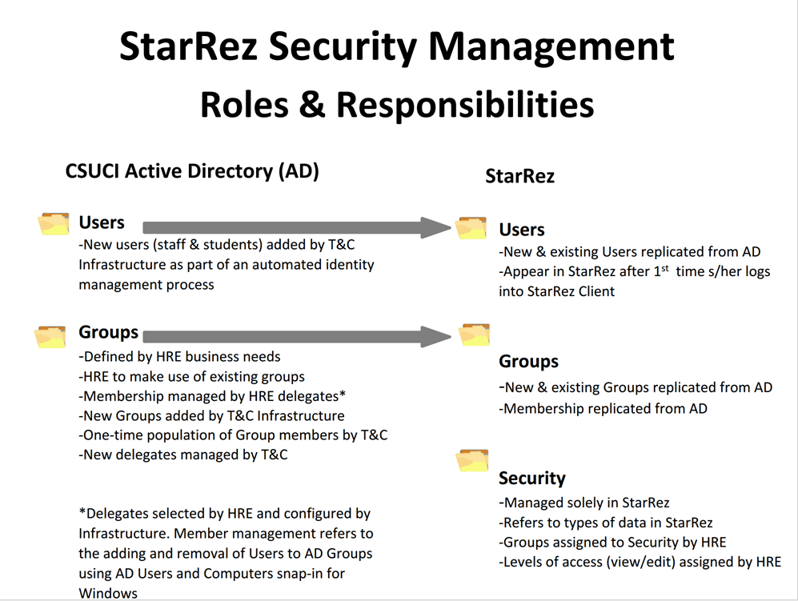

About this Document

This document was created by Melissa Bergem, Peter Mosinskis, Cindy Derrico, Janel Suliga, Rachel Tafoya, Scott Petersen, Lacey Lovejoy, Marysia Wancewicz, Herb Aquino, Marc Aten, Joseph Dobzynski, and Nasser Mansour.

The project team that first implemented StarRez at CSU Channel Islands recommends that this document be revisited for possible revisions on an annual basis.

Prepared by: Melissa Bergem

Initiated: 3/27/2013
Updated: 12/17/2013
Updated: 4/13/2015

