AccVerify and AccRepair Instructions

Peter Mosinskis
Supervisor of Web Services
CSU Channel Islands

Revised: April 23, 2009

AccVerify and AccRepair Instructions 1
What are AccVerify and AccRepair? 2
Important Note About Automated Check Tools 2
Installing AccVerify 3
For Files from a “live” web site 3
Part 1. Run AccVerify & Configure System Settings 3
Part 2. Create a New Project (for a Section 508 check) 6
Part 4. Reading the Reports 13
Passed Files Reports 13
Failed Files Reports 13
Repairing Files Using AccVerify/AccRepair 14
Strategy 1. For users of Serena Collage 14
Strategy 2. For personal web sites, or web sites not stored in Serena Collage 15
Making Repairs by Hand in AccRepair 19
Other Options 26
Other Tools 26
Questions about AccVerify or web accessibility? 26

What are AccVerify and AccRepair?

AccVerify and AccRepair are part of a single software package from HiSoftware which allow you to check and repair accessibility issues within web pages.

Important Note About Automated Check Tools

There are no automated accessibility evaluation and repair tools that can detect and repair all accessibility issues. In fact, the majority of checks require human review, evaluation, and repair.

For example, automated tools cannot tell:

- Whether images have sufficient alternate text to describe them
- Whether “color words” were used properly correctly within your web pages
- Whether document sections are marked using meaningful HTML code
- Whether forms and scripts will be understandable and navigable via keyboard
- Whether web pages will work correctly with assistive technology like screen readers
- Whether a text-only page is required necessary

Thus, results from automated checks should be carefully considered and evaluated alongside manual checks of web accessibility.

More information on performing manual evaluations can be found on the CSUi Accessible Technology Initiative web site at http://www.calstate.edu/accessibility/

Installing AccVerify

AccVerify software is only available on the Windows platform. To install the software, please contact the Information Technology Help Desk at helpdesk@csuci.edu or call 805-437-8552. An IT technician will visit your computer and install it for you.

For Files from a “live” web site

Part 1. Run AccVerify & Configure System Settings

- Start AccVerify. In Windows, go to the Start menu, choose “All Programs”, “HiSoftware AccVerify”, then “AccVerify Professional”

- First, go to the “Settings” menu, choose “Accessibility Interview Wizard”, then “Interview Wizard Settings…”

- Switch to the “Workflow” tab, and uncheck the “Run Interview Wizard immediately following verification” checkbox. Click “Save” to finish.

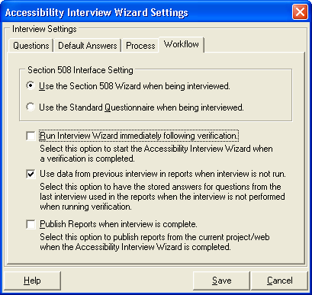

- Next, go to the “Settings” menu again, and select “Report Settings…”

- In the “Report Mode” tab, make sure the “Section 508 Report Mode (US Only)” is selected, and click “Save”
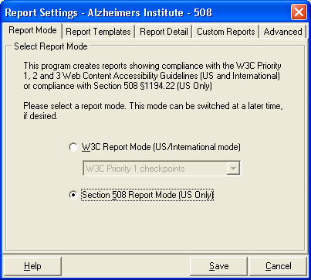
- A confirmation dialog box will appear. Click “OK” to continue.

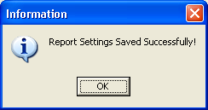

Part 2. Create a New Project (for a Section 508 check)

- Begin by going to “File” menu, choosing “Project”, then “New…”

- In the “New Project” window, type in a project name & type of scan (W3C Priority 1 or Section 508). Also, select the “Internet-Based (Automated Crawler)” button:

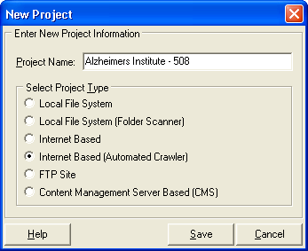

- Click “Save” to continue.
- The Project Settings dialog will appear. In the “Domain” text box, type in the URL to your website (e.g., http://beta.csuci.edu/alzheimer/)

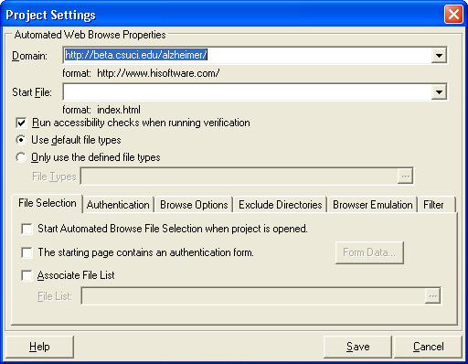

- For “Start File”, click the dropdown menu, and choose of your home page file. This is usually called “index.htm”. You must specify a start file. If the start file is not listed in the default list, please type in the name of the start page here (example: myhomepage.htm)
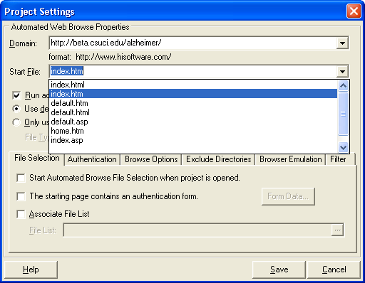

- Select the “File Selection” tab and check the “Start Automated Browse File Selection when project is opened” checkbox.
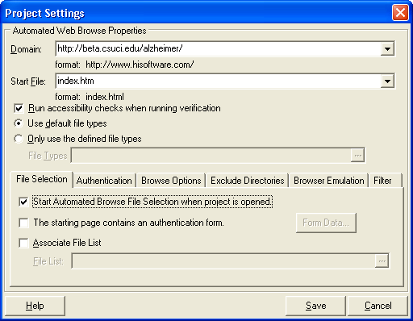

- Next, switch to the “Browse Options” tab, and set “Levels to Crawl” to 5. This will crawl five subfolders/sublevels deep within your web site. Usually 5 levels deep is sufficient to check the majority of web sites; however, you can set this number higher as desired, depending on how many links “deep” you wish to crawl within your site.

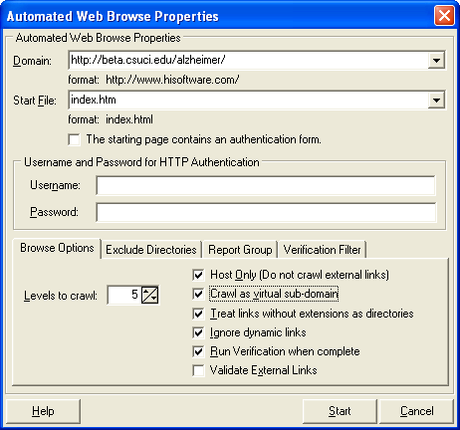

- Check the “Crawl as virtual sub-domain” and “Run Verification when complete” checkboxes, so the checkboxes appear as follows:

- Click the “Save” button to finish. A message box will appear confirming your setup completion. Click “OK” to finish.

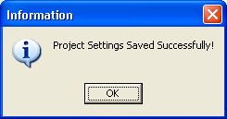

- The “Automated Web Browse Properties” dialog box will appear. Click the “Start” button. This will download and begin web page analysis.

- A dialog box will show you the status of the web page analysis.
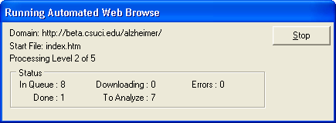

- Then, a dialog box will appear while the verification process runs:
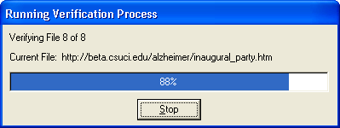

- Once complete, a report will appear in the main window.

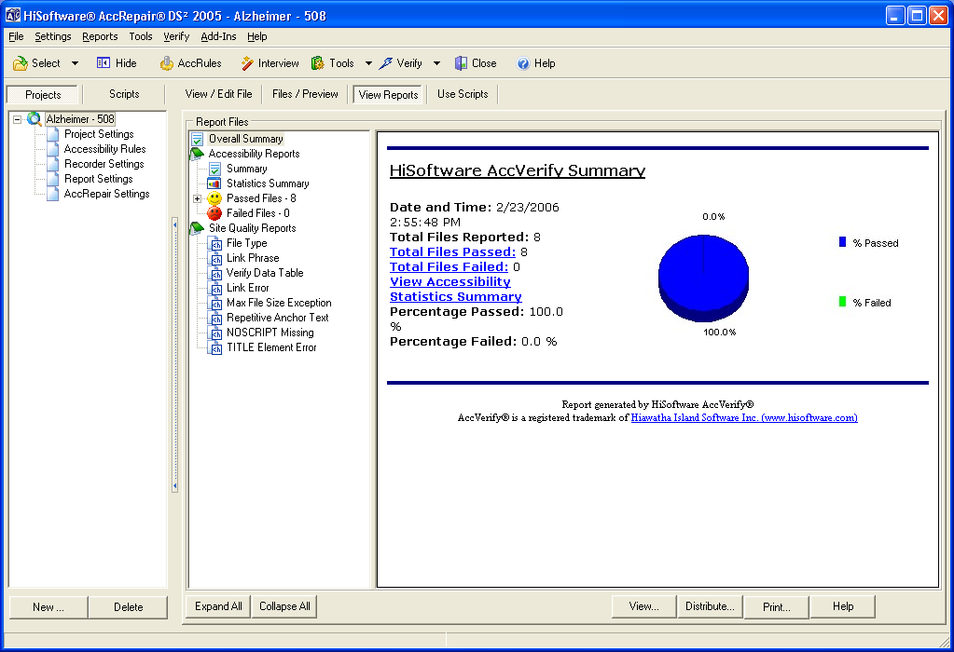

- You have now completed setup of a Section 508 project.

Part 4. Reading the Reports

The list of available reports includes:
- Overall Summary: overall accessibility statistics with pass/fail numbers and percentage. This is the best report to start with.
- Summary: everything in Overall Summary + more graphs
- Statistics Summary: detailed counts of different statistics (number of images/ tables/links/scripts/applets)
- Passed Files reports: detailed checklists for each file which passed the automated check.
- Failed Files reports: detailed checklists for each file which failed the automated check.
- Site Quality reports: these reports provide quality & usability information about your web site:
  - File Type: what non-HTML files are being linked to
  - Link Phrase: list of pages that have links that say “Click Here” or generic text
  - Verify Table Data: shows what kinds of tables exist in your web site (according to criteria set within AccVerify)
  - Link Error: reports any broken links and “file not found” errors
  - Max File Size Exception: if you have files that are greater than 100KB in size, provides a list of those files
  - Repetitive Anchor Text: shows names of links that have same link title on the page
  - NOSCRIPT Missing: shows pages which have scripts but do not have <noscript> element
  - TITLE Element: shows pages which are missing the <title> element within the page <head> tag.

Passed Files Reports

The “Passed Files” reports will give you detailed information about how each page passed a particular checkpoint, or if a particular check was not applicable to the page (listed as “N/A”)

Failed Files Reports

The “Failed Files” reports will not only give you information about which checkpoints failed, but also which lines of the HTML code failed the accessibility test.

A line-by-line listing of the HTML source code of the failed files can be viewed at the bottom of each “Failed Files” report page.

Repairing Files Using AccVerify/AccRepair

Strategy 1. For users of Serena Collage

If you use Serena Collage, your accessibility check process should be as follows:

- Create & edit files as desired in Collage, but do not approve them.
- Configure AccVerify to check files using the http://beta.csuci.edu/ domain, instead of http://www.csuci.edu (beta.csuci.edu contains the LATEST versions of your Collage web site, including unapproved versions; www.csuci.edu contains only APPROVED versions of your Collage web site).
- Run AccVerify, & review the reports
- Make corrections to your pages in Collage.
- Collage will automatically publish your LATEST versions to http://beta.csuci.edu/ twice per day.
- Repeat steps 3-5 until the accessibility report comes back with no errors
- Approve your web pages in Collage. Then only pages which have been checked and corrected for accessibility will be published to www.csuci.edu.

Strategy 2. For personal web sites, or web sites not stored in Serena Collage

This strategy will enable you to check and repair files on your local computer before publishing them to your web site (such as a faculty web site). This processcannot be used in conjunction with Collage, because the XML files stored in Collage are not readable by AccRepair.

Requirements: you must have either FTP access to your web site, or have all of your files stored locally on your computer, or stored in a network storage space.

- Start AccVerify
- Go to the “File” menu, choose “Project”, then select “New”
- In the new project window, type in a project name, and choose one of the following options:
  - Choose “FTP Site” if you wish to scan your “live” site via FTP
  - Choose “Local File System (Folder Scanner)” if you wish to scan a folder on your computer.
For this example, we will be scanning a folder on the local computer, so select “Local File System (Folder Scanner)”

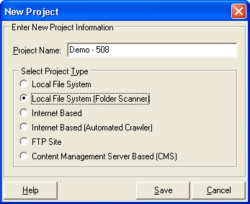
- In the next window, first choose your base folder (i.e., where to begin the scan) by selecting the “. . .” button
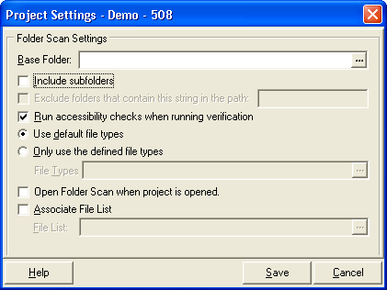

- Then, browse to the folder that you wish to check, and click “OK”.
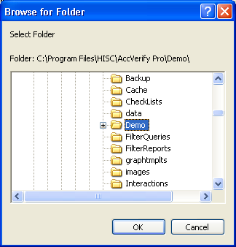

- Next, check the “Include Subfolders” and “Open Folder Scan When Project is Opened” checkbox, and click “Save”.
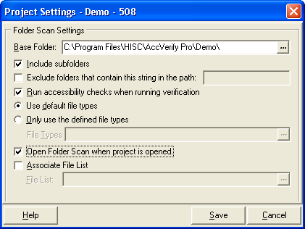

- A confirmation window will appear; click OK to finish.
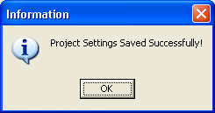

- Next, the “Scan Folders” dialog box will open. Click the “Start” button to begin.
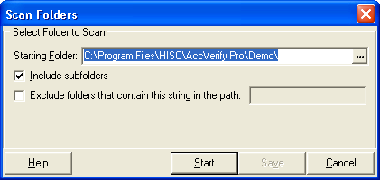

- A confirmation dialog box will appear, listing the number of files you have selected. Click “OK” to continue.
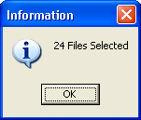

- Next, click the “Verify” button on the toolbar.
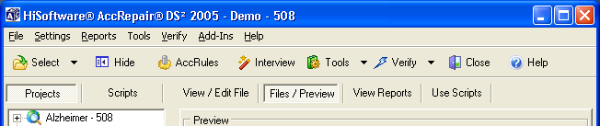

- The “AccRepair” wizard will start, and walk you through repairs on many of the files. Some repairs will need to be done by hand. To use the wizard on a given page, click “Yes”. Otherwise, click “No”

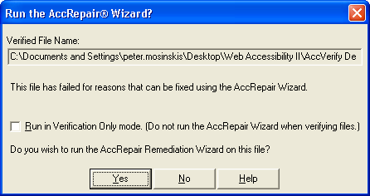

Making Repairs by Hand in AccRepair

- Click on the “Files/Preview” button to switch to the “Files/Preview” view.
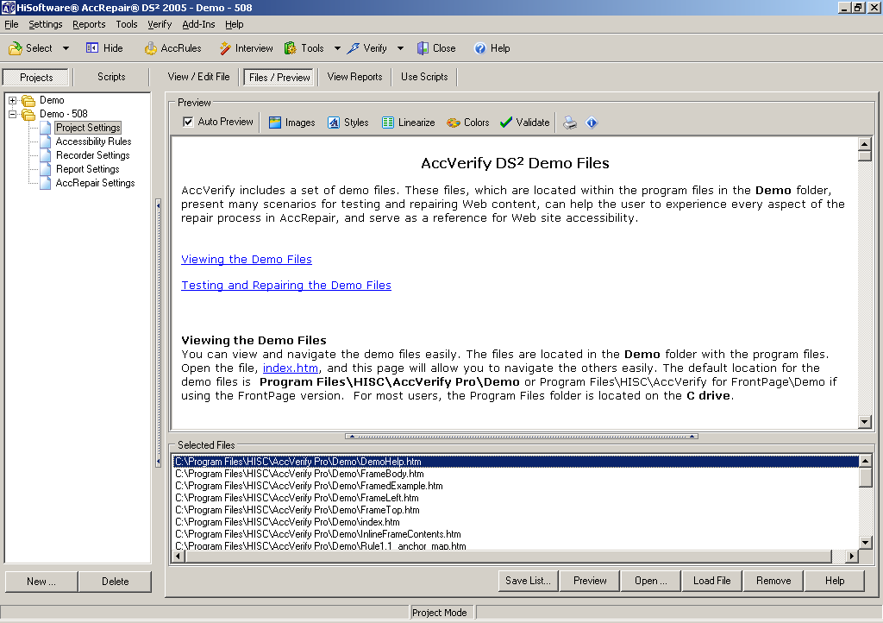
- Click on a single file in the “Selected Files” list, so that it is highlighted.

- Click the “Load File” button to load the file into the AccRepair editor.

- The view will automatically switch to the “View/Edit File” view.
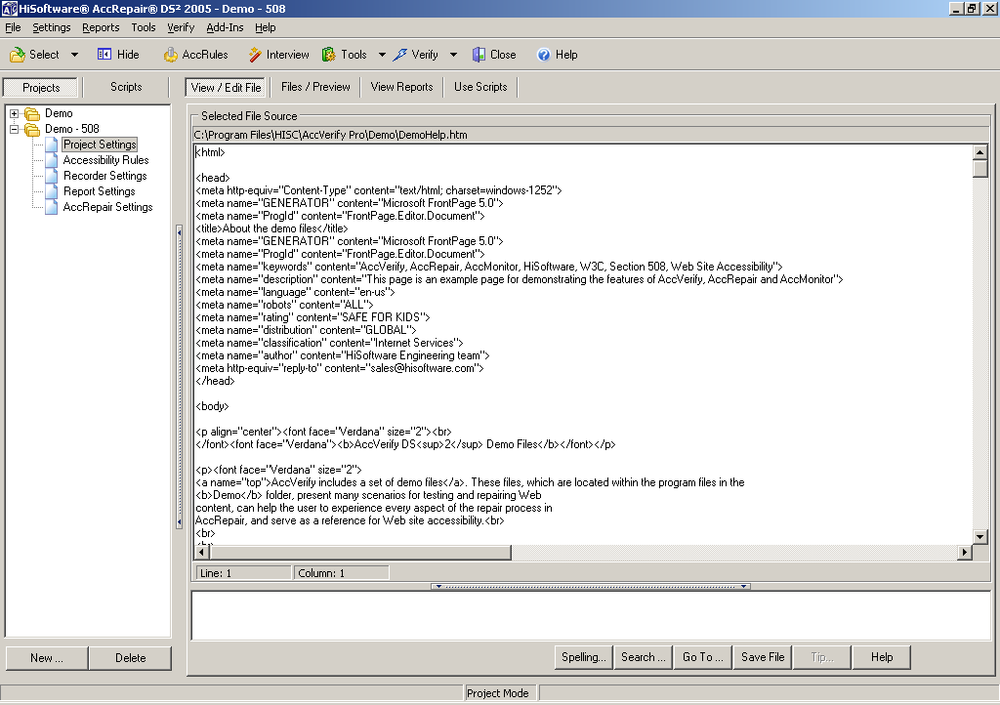
- Different bits of HTML code may be highlighted in different colors. These signify different error levels. By default:
  - Red: errors (Accessibility Errors)
  - Green: warnings (Less critical errors)
  - Blue: notes (Even less critical issues)
  - Black: normal (HTML code has no issues)
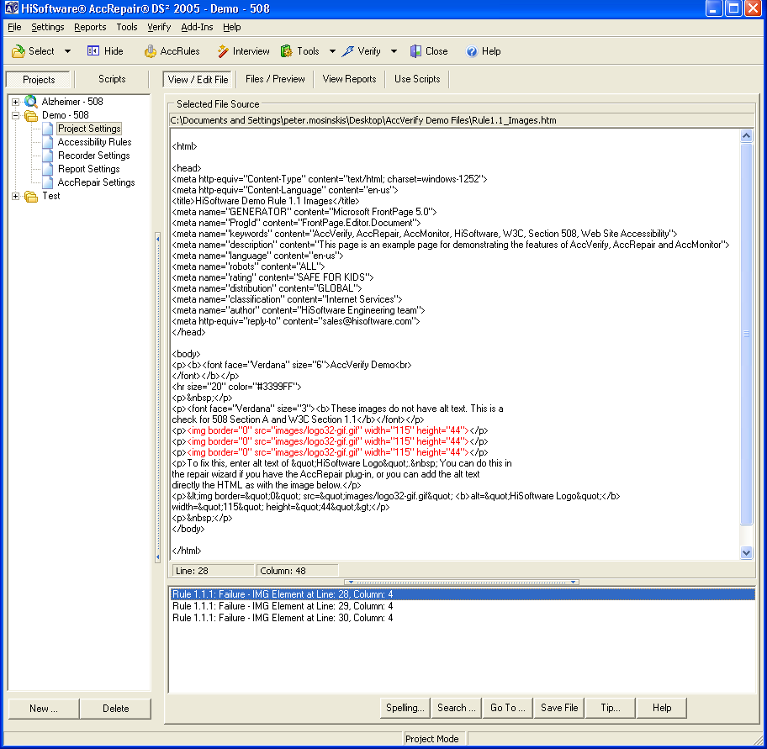

- You may change the HTML highlight color by:
  - Go to the “Settings” menu and choose “Source Editor Settings”
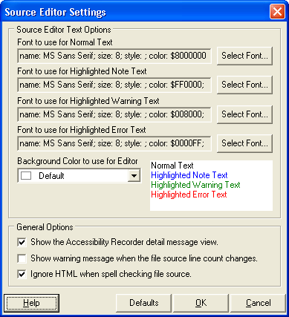
  - Select a font, size, style and color for each of the 4 states as desired using the “Select Font…” buttons, and click OK to finish.
- In the bottom pane of the window, if accessibility issues were found with the file, a list of errors will be displayed. This area is called the “Message View Panel”.
- Highlight one of the items in the Message View Panel and choose the “Tip…” option to get accessibility repair information for that item.

- A new window will appear with a Repair Tip for that item, which gives detailed information about how to repair the item.
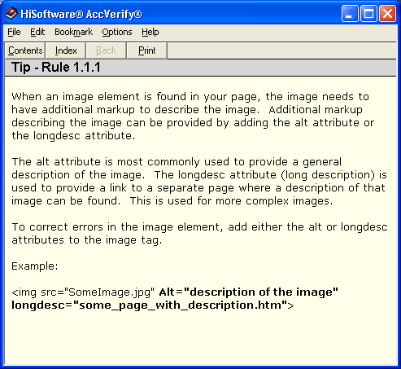

- You can make your repairs directly to the “View/Edit File” window, like you would using Notepad or any other plain text editor.
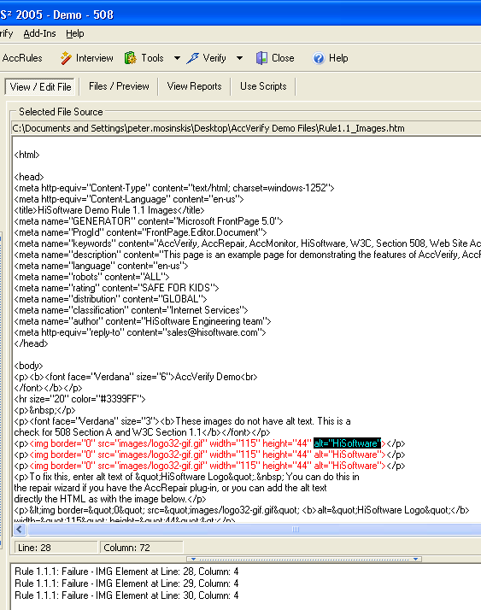

- Once you have made your repairs, click the “Save File” button at the bottom of the screen.
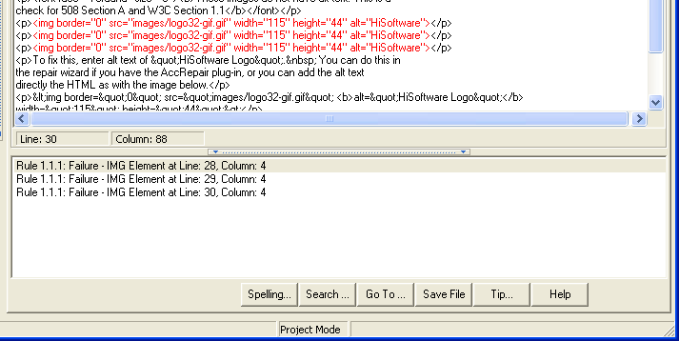
- Then re-verify the file by choosing the “Verify” button on the toolbar.

Other Options

In the “Project Settings” dialog of any web site, you can set AccVerify to scan external web sites (i.e., Yahoo, Google, Amazon) that your web site links to by checking the “Validate External Links” checkbox and clicking “Save”.

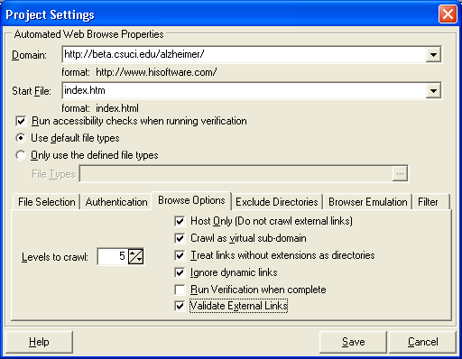

Other Tools

- Accessible Form Creator. This Windows-based program may be downloaded for free from http://www.hisoftware.com/downloads/formbuilder.exe. This standalone software enables you to build Section 508 and WCAG complaint web forms.
- HiCaption. This software must be installed separately, but is included with our current HiSoftware license. HiCaption enables synchronous captioning of videos.

Questions about AccVerify or web accessibility?

Please contact the Help Desk at helpdesk@csuci.edu or call 805-437-8552.

