Cisco IP Phone Quick Reference Guide

Index
Basic Campus Calling Information
Basic Phone Features
Voice Mail
Volume and Ringer Sound
Buttons and Features
MeetMe Conference Calls

Basic Campus Calling Information

To place a call to another phone on campus:
• Dial the four digit extension of the party you wish to reach.

To place a call to any number off campus:
• For local calls—Dial 9, then the seven digit phone number.
• For long distance calls—Dial 9, dial 1, then the seven digit phone number.
• For international calls—(most campus phones are not pre-authorized to make international calls. If you need to make this type of call, contact the T&C Helpdesk at ext. 8552 and it can be activated as needed.)—Dial 9, dial 011, then dial the remaining digits of the party you are trying to reach.

Basic Phone Features
(Note: A “Soft key” is a physical button on your phone that has various functions based on the mode you are using the phone in at any given time.)
To place a call:
(Any of the below listed methods enable you to place an outgoing call.)
• Lift the handset and dial the number.
• Press the line button for your extension, then dial.
• Press the Speaker button, then dial.
• Press the NewCall soft key, then dial.
• If you are using a headset, press the Headset button, then dial.
• If you have established speed dial numbers, press a Speed dial button.
• If you have selected a number from a directory, press the Dial soft key.

To answer a call:
• Lift the handset.
• If you are using a headset, press the Headset button. If necessary, press the line button of the incoming call.
• To use the speakerphone, press the Answer soft key or the Speaker button.

To end a call:
• Hang up the handset.
• If you are using a headset, press the Headset button or the EndCall soft key.
• If you are using the speakerphone, press the Speaker button or the EndCall soft key.

To redial a number:
To redial the most recently dialed number, press the Redial soft key.

To view missed calls:
1. Press the Directories button. (The button with the open book symbol.)
2. Press 1 for Missed Calls.

To speed dial from a directory menu:
1. Press the Directories button.
2. Find the directory that you want, then press the corresponding item number. For example, press 3 for Placed Calls.
3. Press the Dial soft key to speed dial a selected number. Press EditDial to add or remove digits before dialing.
Note: To enter any letter on your LCD screen, use a corresponding number key. Press the key one or more times to display a particular letter. For example, press 2 once for “a,” twice for “b,” and three times for “c.” To back up, press the << soft key.

To put a call on hold:
• Press the Hold soft key.
• To return to the call, press the Resume soft key.
• If multiple calls are on hold, use the Navigation button to select the desired call before you press Resume.
• If multiple calls on multiple lines are on hold, press the line button for the line to
which you want to switch and use the Navigation button to select the desired call. Press
Resume.
Note: Because engaging the Hold feature generates music or a beeping tone, avoid putting a conference call on hold.

To place a conference call:
1. During a call, press the More soft key and then the Confrn soft key to open a new line and put the first party on hold.
2. Place a call to another number.
3. When the call connects, press Confrn again to add the new party to the call.
Note: Also see the “MeetMe Conference” section below for more conferencing options.

To transfer a call:
1. During a call, press the Trnsfer soft key. This puts the call on hold.
2. Dial the number to which you want to transfer the call. As soon as you hear ringing, or after the party answers, press Trnsfer.
Note: If the transfer fails, press the Resume soft key to return to the original call.

To forward all calls to another number:
1. Press the CFwdAll soft key. You will hear two beeps.
2. Enter the number to which you want to forward all of your calls. Enter the number exactly as you would if you were placing a call to that number (i.e., 9 + number.) An animated phone icon flashes in the upper-right corner of your LCD screen.
3. To cancel call forwarding, press the CFwdAll soft key.

To mute a call:
Press the Mute button. To disengage mute, press Mute again or lift the handset.

Voice Mail

To access your Voice Mail from your IP phone:
Press the Messages button and follow the voice instructions. (The Messages button is the button with the envelope symbol.)
Note: When you receive a new message, a flashing envelope icon displays on your LCD screen. Depending upon your phone configuration, the light on your handset glows to indicate that you have received a new message.

How to access Voice Mail by phone:
1. Dial the applicable number to call voice mail:
a. If you are calling voice mail from on campus, dial x8850.
b. If you are calling voice mail from off-campus (or an outside line), dial
805-437-8850.
2. If you dialed the off-campus phone number, press * when voice mail answers.
3. Enter your ID (your phone extension), then press # .
4. If required, enter your voice mail password, then press #.

Voice Mail Commands
A PDF file containing a chart of available voice mail commands can be downloaded at:
http://www.csuci.edu/tc/documents/Cisco_Unity_Voice_Mail_Commands.pdf

Volume and Ringer Sound

To adjust the ringer volume:
Press the up or down Volume button while the handset is in its cradle.

To change the ringer sound:
1. Press the Settings button.
2. Press 2 for Ring Type.
3. Use the Navigation button to scroll through the list of ring types and press the Play soft key to hear samples.
4. Highlight the ring you want, then press the Select soft key.
5. Press the OK and Save soft keys.

To adjust the handset, speakerphone, or headset volume:
During a call, press the up or down Volume button. Press the Save soft key to apply the new volume level to future calls.

Buttons and Features
• Press the ? button once, then press a button or soft key.
• Highlight a feature in the Directories, Settings, or Services menu, then press the ? button twice quickly.

Button Legend

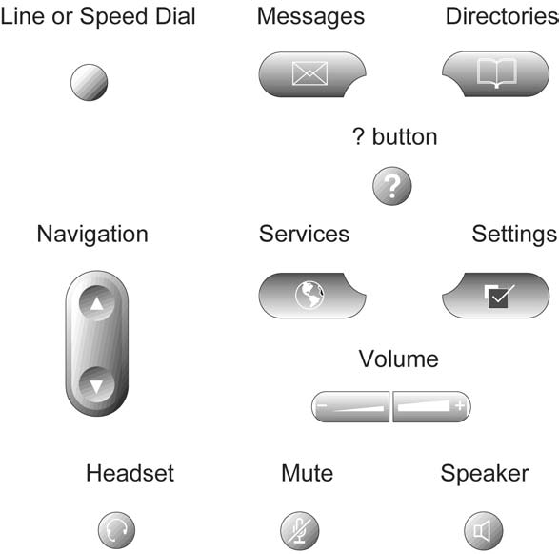

MeetMe Conference Calls
What is a MeetMe Conference?
The MeetMe conference feature allows for the quick setup of phone based conferences, by allowing on-campus and off-campus users to dial in to a shared phone number that will automatically join the caller to the conference. MeetMe numbers are shared by all campus users and must be scheduled like a regular conference room.

To reserve a MeetMe conference number:
Using Microsoft Outlook Calendar (or Microsoft Outlook Web App Calendar,) create a new meeting invite. From the new meeting interface, select the “Scheduling Assistant” button. At the bottom left side of the Scheduling Assistant window, select “Add Rooms”. A “Select Rooms: All Rooms” window will open and from here you can select one of the available MeetMe Conference lines as a resource as an attendee. As with rooms, MeetMe numbers are available on a first come first served basis.
The available MeetMe numbers are labeled as follows:
MeetMe Conference Room 3580
MeetMe Conference Room 3581
MeetMe Conference Room 3582
MeetMe Conference Room 3583
MeetMe Conference Room 3584
MeetMe Conference Room 3585
MeetMe Conference Room 3586
MeetMe Conference Room 3587
MeetMe Conference Room 3588
MeetMe Conference Room 3589

To initiate a MeetMe conference from you IP phone:

1. Go “off-hook” by lifting the handset, or pressing the speaker button on your IP phone.
2. Press the More softkey (softkeys are the four buttons running across the bottom of the phone’s display screen.)
3. Press the MeetMe softkey, (If MeetMe is not shown, press the More softkey until MeetMe is available.)
4. Dial the four digit MeetMe number you previously reserved. Once you have entered this “meeting room”, other participants are then free to dial in and will automatically be joined to your conference call. Advise others who will be a part of your conference call to dial either the four digit extension that you reserved (for on-campus callers), or for off-campus callers, (805) 437-XXXX (where the X’s are the four digit extension that you reserved.) If participants call into the number before you have “opened” the MeetMe room by calling into it, they will simply get a busy signal.
Note: MeetMe calls can only be initiated from an on campus IP telephone.

