Note: included in this attachment are two syllabi (one for Spring, one for Summer)
Two-Week Summer Trip (3 units):
Coastal Resource Management in the Cook Islands
Summer 2015
Co-Instructors: Anderson, Wormald & Anderson
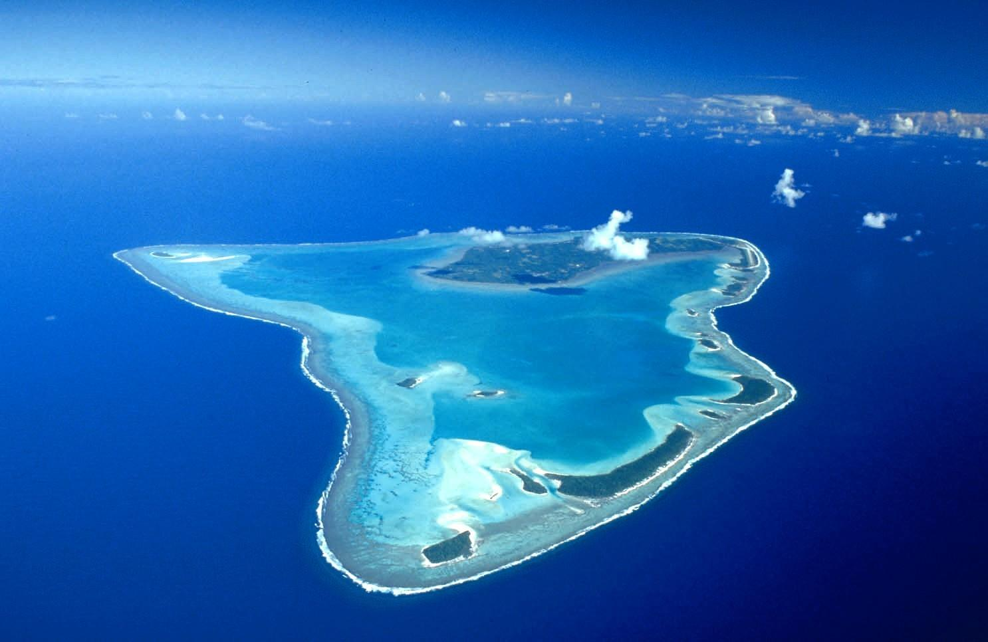
Cook Islands Trip Overview
We will travel to the South Pacific island nation of the Cook Islands for an intensive, two-week long exploration of these incredible people and unique ecosystem. We will travel from Los Angeles to Rarotonga (the Capitol of the Cook Islands) on a commercial passenger jet and on to the Aitutaki via a smaller, short-haul plane. Once on Aitutaki, we will be based out of a large “dorm style” guest house where we will sleep, eat, etc. Recognizing that our time in the Cooks is limited we will generally be up early and to bed late. Our days will emphasize practical exploration of coastal resources and culture, often on/in the water or “off trail.” Some of our activities will be designed to support to our local partners and colleagues and their management goals (i.e. Service Learning) while others will be designed to simply help you better understand the extant conditions on Aitutaki.
Enrollment in this course is conditional upon passing our Spring Seminar. All attendees should be in good health and able to undertake strenuous activities on land and underwater. Research SCUBA certification is strongly encouraged, although not mandatory if the participant has strong snorkeling/free diving skills by the start of our trip.

General Learning Outcomes
By completion of this course, students should by able to clearly describe:
- a basic understanding of the cultural, biographical, and historical underpinnings of modern South Pacific Small Island Nations.
- current issues most relevant to Cook Islanders.
- the effects of the recent diaspora on both Cook Islands society and coastal resources.
- the benefits and downsides of a tourism-based economy in Aitutaki.
- the current state of reef-based resources in Aitutaki Lagoon.
- the specific challenges climate change is posing to Aitutaki.
- the interrelatedness of our global culture, economy, and society.
- specific management options for improving or maintaining Cook Island resources.
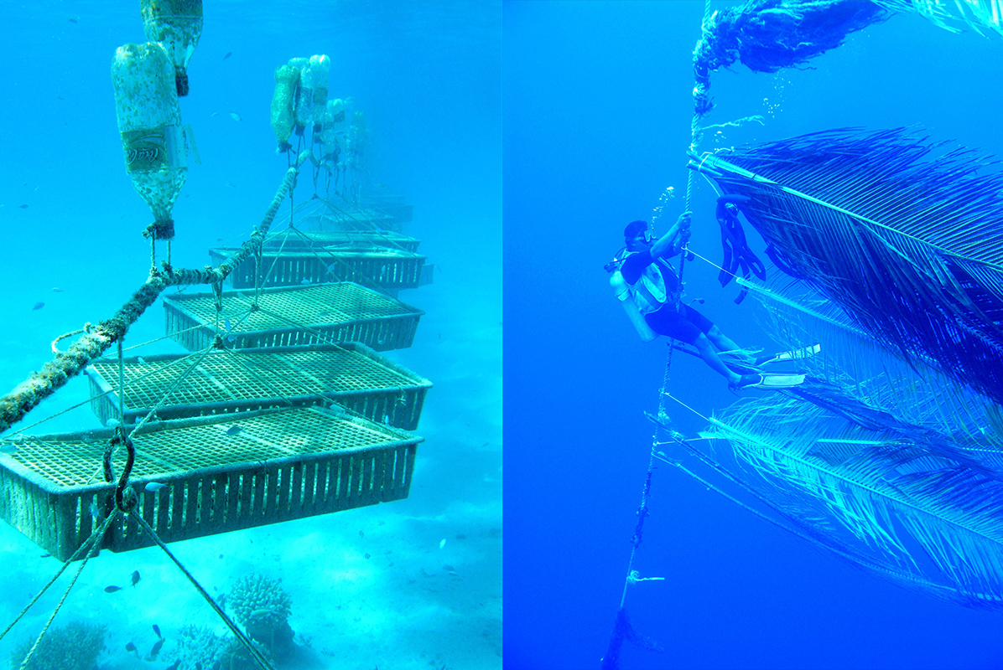

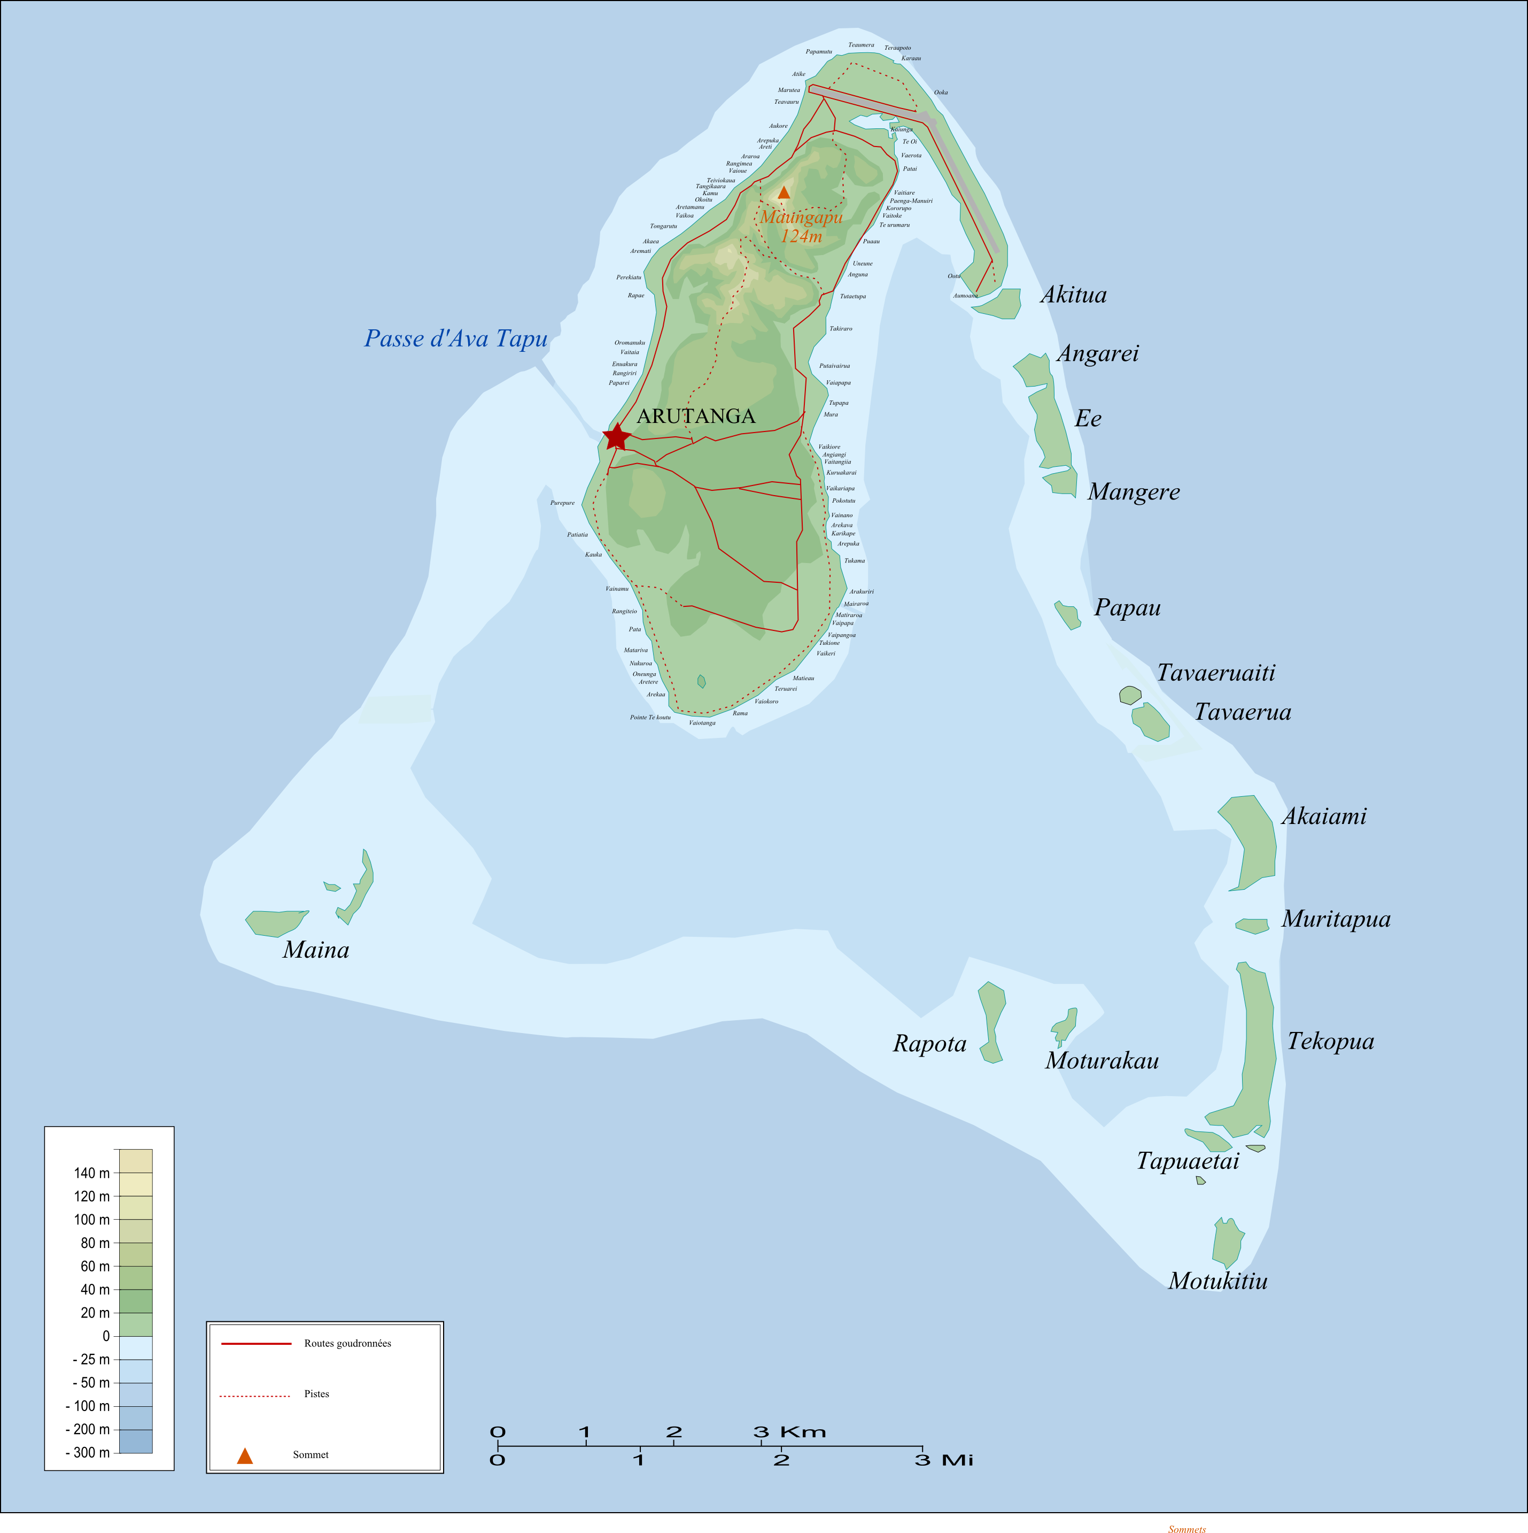
Course Topics
Please note that this is an evolving/dynamic list that will be modified throughout the fall as we rework our specific ideas/logistics. As of this writing, our topics will include many of those from our Spring Seminar. Selected topics which will be a major focus of our 14-day exploration include:

1. Biogeography of Aitutaki:
Marine:
Offhsore, Epipelagic Realm
Fore Reef
Reef Crest
Back Reef
Lagoon/Patch Reef

Littoral:
Sandy Beach
Swamp
Motu

Terrestrial:
Lowland Tropical Palm Forests
Artificial/Turf Systems

Wetland:
Taro Fields

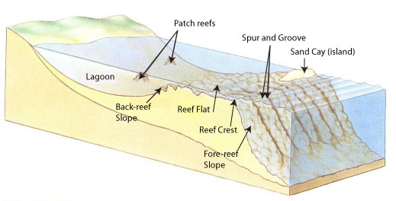

Managing Island Resources:
Human Impacts in the Coastal Zone
Climate Change and Sea Level Rise in Small Island Nations
Origins Of Customary Tenure and Island Resource Management
Human Population Trends in Polynesia and Near-Term Forecasts
Aitutaki’s history of fisheries species exploitation
Tradition Ra-Ui Integrated Ecosystem Management
Marine Protected Area Approaches
Lagoon Aquaculture

2. Managing Island Resources:
Supporting Human Occupation in the Coastal Zone
Water Sources and Consumption
Electrical Generation and Consumption
Waste Streams
Sewage
Burnable Waste
Recyclables
Climate Change and Sea Level Rise on Motus
Fisheries Management
Customary Tenure and Island Resource Management
Aitutaki’s History of Fisheries Species Exploitation
Tradition Ra-Ui Integrated Ecosystem Management vs. Modern Marine Protected Area Approaches
Lagoon Mariculture

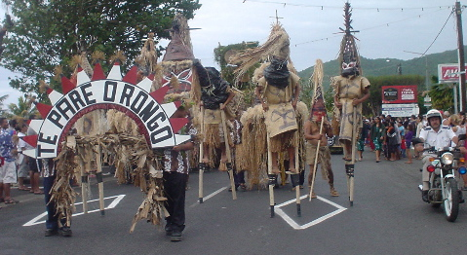

3. Site-Specific Inventories:

Surveying Lagoon/Reef Organisms (exploited and unexploited)
Reef Fish
Invertebrates
Algae
Lagoon Water Quality Monitoring

4. Bioassays for Water Quality:

Bioassay Training for High School Students
Sea Urchin Fertilization Bioassay: Theory
Sea Urchin Fertilization Bioassay: Lab Practical

5. Beach Profiles:

Motu Beach Profiles and Sediment Characterization
Island Beach Profiles and Sediment Characterization

6. Quantifying Visitor Use:
Documenting Visitor Distribution Across Lagoon
Parasailing Use of Popular Motus
Visitor Behavior During Snorkeling Tours

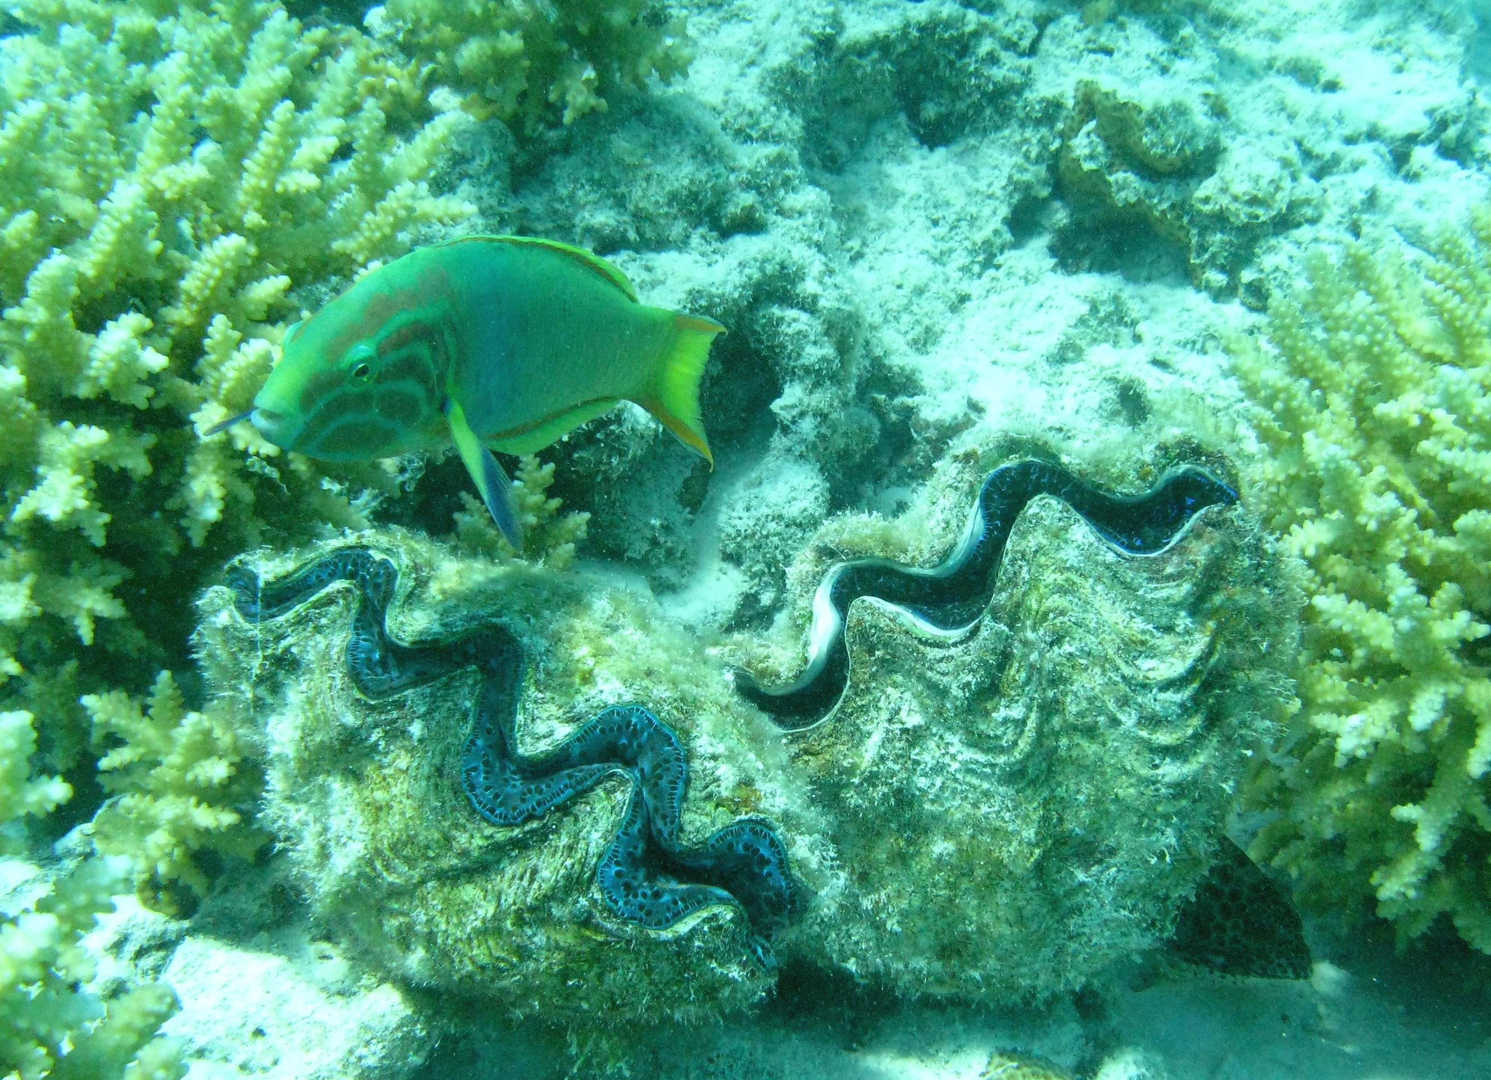

Draft Trip Schedule
Draft Daily Schedule (subject to change due to weather):

Day 1-Arrival/Orientation
Day 2-Intro Day-Tour of Island with TeKing, Equipment Prep, Boat Check
Day 3-Lagoon Tour, Visit Marine Research Station
Day 4-Intial run-throughs of Field Surveys and Initial Site Selection
Day 5-Begin Formal Field Surveys, Meet with Island Council
Day 6-Field Surveys, Tour Aitutaki Lagoon Resort Facility
Day 7-Field Surveys, Meet with Koru Café Owners
Day 8-Data Entry Morning, Resume Field Surveys when complete
Day 9-Field Surveys, Collect Urchins, Visit Fish Market, Island Night
Day 10-Field Surveys, Urchin Fert. Trials, Afternoon Tea Tauono’s Garden
Day 11-Meet with High School Students, Urchin Bioassay Training
Day 12-Water Sampling/Testing with High Schoolers, Afternoon Off
Day 13-Data Entry Workshop/Graphing with High Schoolers, pack up
Day 14-Departure
(Day 21 post-trip in California): Day Long Post-Trip Meeting at CSUCI to Finalize Project Reports and Final Debrief
(Day 28 post-trip from California): Faculty will submit final report comprised of trip overview and component project reports to Cook Island Partners.
(Day 29 post-trip from California): Faculty (and any interested students) will engage in a conference call to the Cook Islands to debrief and discuss both the deliverables and the overall course outcomes.

Deliverables
All students will participate in all aspects of our service work while on Aitutaki. However, pairs of students will be assigned to particular monitoring endeavors and in charge of compiling, entering, analyzing and reporting on the results. Brief, draft reports (most likely PowerPoint-based oral presentations) will be generated prior to our departure and presented to Village Councils, Government Partners, and our other collaborators. Within two weeks of returning to California, the faculty will submit a master report to our Cook Island partners electronically.
For example, all students will assist with reef surveys, but students A and B will be responsible for compiling and reporting on our Tridacna (Giant Clam) surveys, students C and D will be responsible for compiling and reporting on our snorkeling tourists behavioral data, students E and F will be responsible for compiling and reporting our coastal erosion/sandy beach profile data, etc. In addition to written reports, each team of students will be required to submit a 5-10 minute video or animated slideshow about their service/experience in Aitutaki. These written reports and videos will be made available to the campus community as part of the IRA requirement to have a campus-based component to IRA-funded trips. (Note: given the likelihood that many of our students will be graduating seniors, a Fall Semester-based poster session or presentation is not realistic for this summer-based experience).

Logistics

- Airfare will be provided by arrangement with University Travel Agent. We will arrange our LAX-Rarotonga and Rarotonga to Aitutaki flights ourselves.

- All other logistical arrangements will be organized by our colleague Stephen Lyons at the Pacific Islands Conservation Initiative (which is based in Rarotonga, Cook Islands). We had extensive meetings with Steve this past summer and discussed how to conduct our course. Housing will be in one large communal house with multiple guest rooms designed to accommodate large families and groups of our size. The house includes a kitchen allowing us to make our own breakfasts and sack lunches. Dinners will be provided for us by the owners. While we visited several such houses on Aitutaki while there this past summer, the exact one he books for us will depend on the timing of our confirmation of funding for the trip. He has tentatively booked one house for us as of the last week in September.

- We will arrange most meals, although undoubtedly students will be on their own for two or three meals. There are multiple “take-away” and more formal eating establishments within walking distance of our work and house sites.

- Transportation.

Land transportation will be by one of two methods: 11-passenger vans will be the typical means to move us around. We will supplement this with scooters, likely renting four for our weeks there. Faculty will drive the vans, but students will be permitted to drive the scooters once they 1) complete a university driving training course (prior to leaving) and 2) obtain a Cook Islands Drivers License ($5 at the Police Station). Scooters are the primary means of transport in the Cook Islands. Aitutaki has a total of approximately 8.4 miles of paved roads. Scooters will primarily be used for smaller group trips to the market, opposite site of the island, Marine Research Station, etc.

Water transportation will be via one or more small boats reserved for our use as part of our accommodations. Faculty will helm the boats, although all students will have gone through small boat training and be capable of handling the vessels.

- Security
The U.S. State Department recognizes the Cook Islands as a self-governing parliamentary democracy in free association with New Zealand and a member of the British Commonwealth. As such there are no political challenges of relevance to our course. Owing to the Cook’s small size, the State Department does not routinely post county profiles. Most State Department information centers on the 2012 visit by then-Secretary of State Hilary Clinton and various warnings about Cook Islands’ offshore sector making it potentially vulnerable to money laundering. However, due to recent legislative and regulatory changes, the Cook Islands comply with current international standards.

No significant safety or security warnings are in effect, particularly for any of the outlying islands (including Aitutaki).

The U.S. Centers for Disease Control suggests all travellers have routine vaccinations and that travellers of our student’s age obtain Hepatitis A and Typhoid vaccines. While we will require these, our own inquiries this past summer show that these latter vaccines are motivated by the CDC considering the Cooks a “developing” country in Southeast Asia that uses septic systems as the primary means of treating wastewaters. In practice, there is no more particular concern over these diseases in the Cooks than anywhere else in the hemisphere.

Locals drink tap water, but boiled or bottled water is advised for visitors.

The nearest police station is in Arutanga (approx.. 15 minutes by vehicle).

Aitutaki has what we in the States could consider a rural hospital. The 26-bed Aitutaki Hospital is also in Arutanga (approx. 15 minutes by vehicle). It also houses a dental clinic, pharmacy, laboratory, X-ray facility, outpatient care, and Public Health offices. Outpatient hours are from 9am-noon and 1-4pm M-F. Emergencies are treated 24 hours a day, 7 days a week.

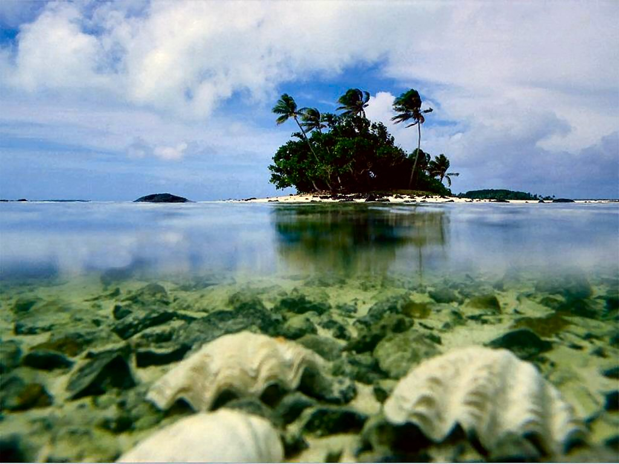

Pre-Trip Orientation Seminar (1 unit seminar):
Hōpara: Exploring & Interpreting the South Pacific
Spring Semester 2015
Co-Instructors: Anderson, Wormald & Anderson
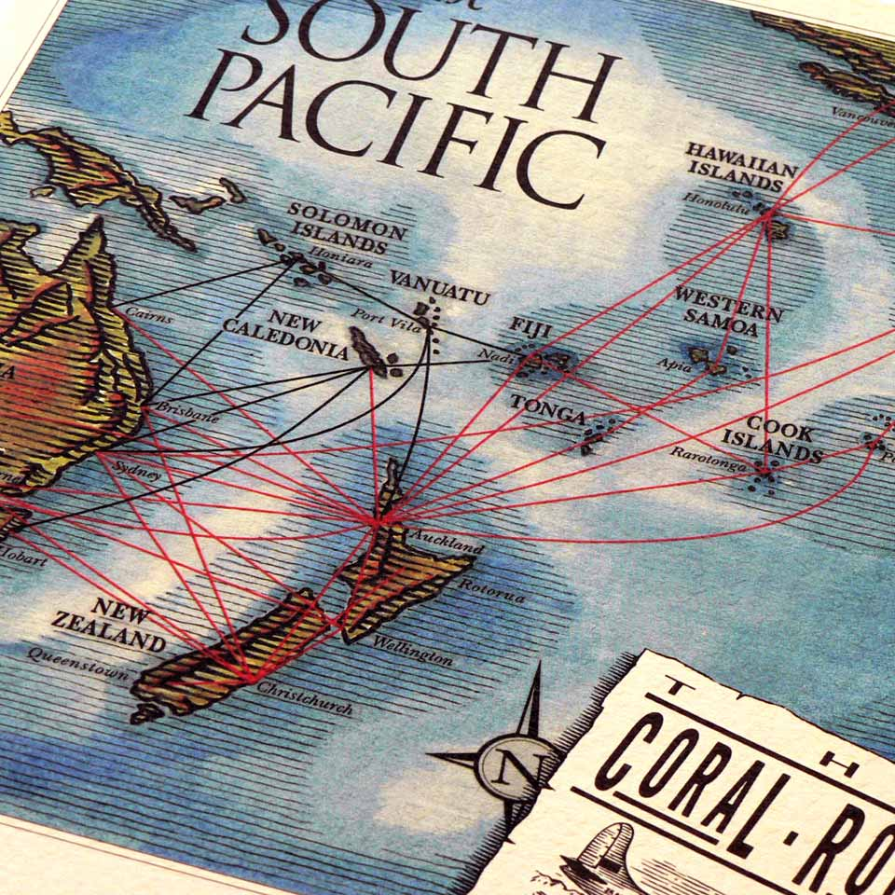
Orientation Sessions/Pre-Trip Seminar Overview
We envision a weekly seminar in the Spring Semester preceding our summer trip. This orientation leading up to the trip will feature an extensive reader, species identification/training literature and video pack, Polynesian cultural profiles, South Pacific literature, colonial history, and history of coastal resource (esp. fisheries) management. We will also have a full-day logistics meeting 14 days prior to our embarkation. In addition to classroom sessions, we will have at least two field sessions (a swim/snorkel test) and a day at our boating facility in the preceding Spring Semester.
Enrollment in this course is by permission of instructions via a fall application. Passing this course (C/NC) is mandatory for participation in the subsequent summer trip. This pre-trip seminar is an essential component of the summer trip/course. This Spring Seminar will focus on contextual and background issues related to management of coastal resources in the Cook Islands and should properly be considered the first part of our learning experience. The subsequent early summer trip will focus on in-country and in situ exploration of extant resources and their management on Aitutaki atoll.

General Learning Outcomes
By completion of this seminar, students should by able to clearly articulate:
- a basic understanding of the cultural, biographical, and historical underpinnings of modern South Pacific Small Island Nations.
- the major cultural and ecological forces structuring modern South Pacific Islands.
- the global resource management context within which the Cook Islands exist (with particular emphasis on climate change and fisheries).
- existing gaps/needs in our understanding of resource management in the Cook Islands.
- the general ecology and history of the Cook Islands.

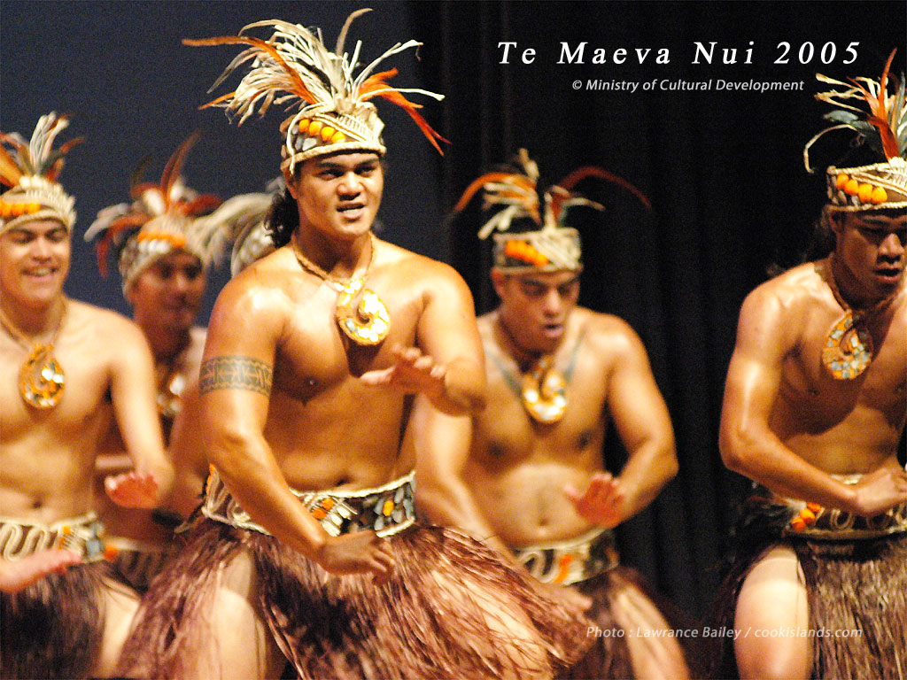
Course Topics
Please note that this is an evolving/dynamic list that will be modified throughout the fall as we rework our specific ideas/logistics. As of this writing, our topics will include:
1. Academics:
Biogeographic Context:
Coral Reef Formation and Biogeography of South Pacific Islands
Colonization and Culture of the Polynesian Triangle
Brief History of the Cook Islands
Geography of the Cook Islands
Unique Island Features and Risks of Resource Overexploitation

Human colonization of Polynesia/Polynesian diaspora:
Polynesian Diaspora
Dance and Song Evolution
Food Items and Cultural Importance
Fishing
Farming (esp. taro)
Seabird harvesting
Tribal Governance

European Colonization:
Age of Exploration to 1800s
Cook’s Initial Visit
British establishment
World War II
Post-WWII Independence

Political Context:
Independence Movement
1990s Economic Crisis
Free Association Status
United Nations and Oceania Governance Cooperation
Non-Governmental Organizations

South Pacific Texts and Visual Rhetoric:
Tasmanian Airline’s “Coral Sea Route”:
Advertisements as Mythos
Polynesia as Eden
Seeds of “Tiki” Culture
Representative Literary Texts:
Two Years Before the Mast by Henry
Once Were Warriors by Duff
The Happy Isles of Oceania by Theroux
Blue Latitudes by Horwitz
South Sea Tales by London
Tales of the Tikongs by Hau’ofa
Leaves of the Banyan Tree by Wendt

Managing Island Resources:
Human Impacts in the Coastal Zone
Climate Change and Sea Level Rise in Small Island Nations
Origins Of Customary Tenure and Island Resource Management
Human Population Trends in Polynesia and Near-Term Forecasts
Brief Overview of Global Trends in Fisheries
Aitutaki’s history of fisheries species exploitation
Intro to Ecotourism/Tourism-based Economies
Tradition Ra-Ui Integrated Ecosystem Management vs. Modern Marine Protected Area Approaches
Lagoon Aquaculture

2. Practical Field Skills:
Site-Specific Ecological Introduction:
Natural History of Aitutaki Lagoon
Traditional, Place-based Rotational Fisheries Mgmt in Polynesia
Tropical Island Ecosystems
Identifying Local Organisms (exploited and unexploited)
Reef Fish
Invertebrates
Sessile
Corals
Bivalves
Motile
Echinoderms
Crustaceans
Cephalopods
Gastropods
Algae

Water Quality Monitoring
Introduction to Bioassays for Water Quality
Sea Urchin Fertilization Bioassay: Theory
Sea Urchin Fertilization Bioassay: Lab Practical
Low Technology Monitoring Techniques for Turbidity, DO

3. Logistics:

Review CSUCI School Trip Policies on Drinking and Professional Expectations
Overview of Customs and Traditions of the Cook Islands
Clothing
Comportment
What to Expect
Cuisine
Hydration
Insects
Weather (esp. sun, wind, rain)
Accommodations
Meals
Emergency Procedures
First Aid & CPR training
Contact/Internet
Overall Safety
State Department Resources/Security and Stability

