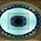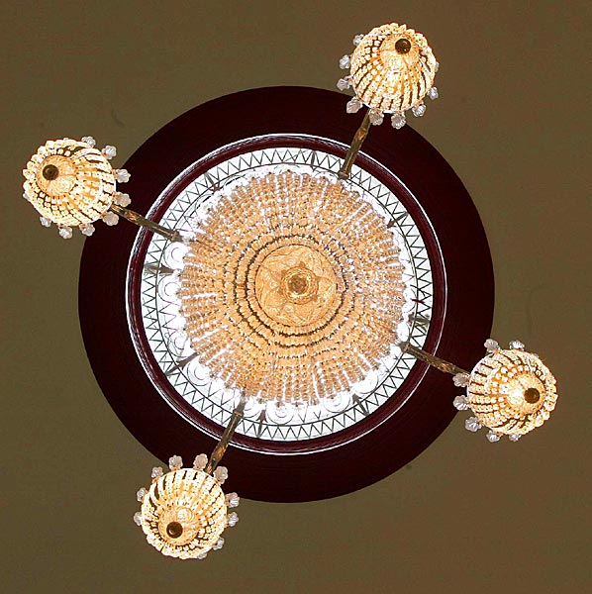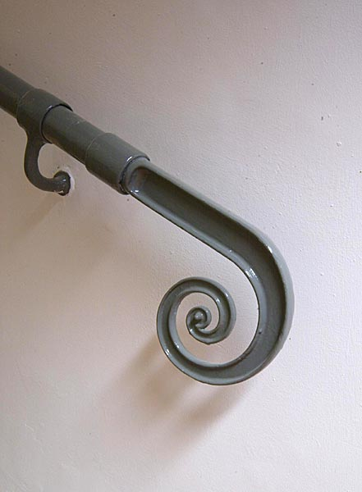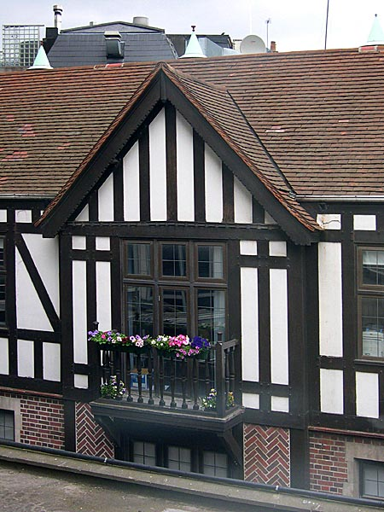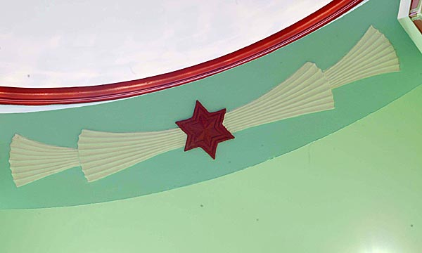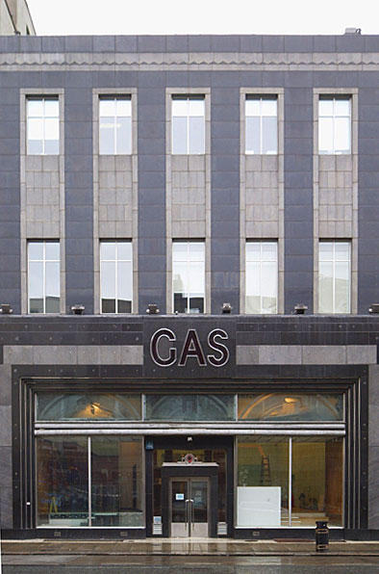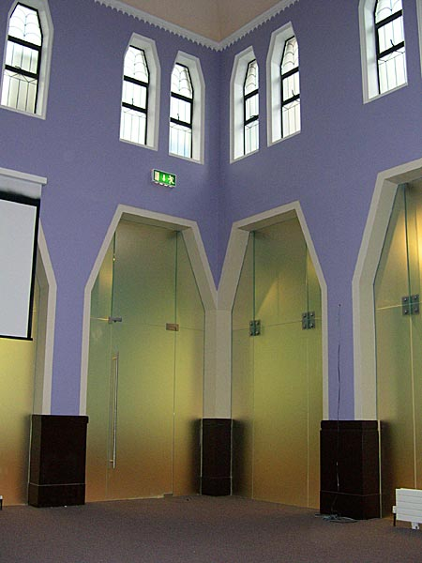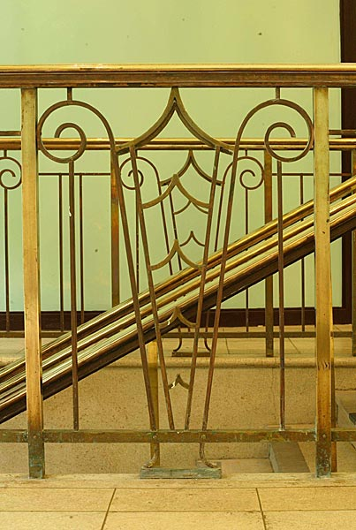
University of Dublin, School of Nursing and Midwifery, Trinity College Dublin

International Nursing School

5-16 January 2015
Monday 5th  Room 1.29  D’Olier Street | 10.00-11.00 Welcome and introduction to the programme. Naomi Elliott & Freda Neill  11.00-11.30 Break  11.30-13.00 Exploring the World of Irish Nursing- General Nursing- Naomi Elliott  13.00-14.00 Break  14.00-16.00 Irish Health Services- Anne Marie Brady
Tuesday 6th  Room 1.29  D’Olier Street | 09.00-11.00 Nursing & Midwifery Regulation in Ireland- Naomi Elliott  11.00-11.30 Break  11.30-13.00 Exploring the World of Irish Nursing- Intellectual Disability Nursing- Carmel Doyle  13.00-14.00 Break  14.00-16.00 The Trinity Experience- visit the historic Book of Kells and contemporary Science  Gallery-Jeni Ryan
Wednesday 7th Trinity Center  St James Hospital  (TCJ) | 09.00-10.00 Exploring the World of Irish Nursing- Children’s Nursing- Carole King TCJ3.15  10.00-10.30 Break  10.30-13.00 Nursing practice in Ireland-simulation activities- Freda Neill & team in Clinical Skills  Lab 3.01-3.04  13.00-14.00 Break  14.00-16.00 Nursing practice in Ireland-simulation activities- Freda Neill & team in Clinical Skills  Lab 3.01-3.04
Thursday 8th  Clinical site visit  TBC | 09.00 Meet in Front Hall, D’Olier Street to travel to clinical site- Naomi Elliott  10.00-15.00 Clinical Site observation visit- the patient experience in the Irish health services.  15.00-16.00 Reflection time- Naomi Elliott & Freda Neill
Friday 9th  Room 1.29  D’Olier Street | 09.00-11.00 Debate team preparation- Naomi Elliott  ”You receive better healthcare in Ireland than in the USA (California)”  11.00-11.30 Break  11.30-13.00 Exploring the World of Irish Nursing- Mental Health Nursing- Louise Doyle  13.00-14.00 Break  14.00-16.00 Debate preparation- Naomi Elliott
The University Of Dublin, Trinity College, School of Nursing and Midwifery, 24 D’Olier Street, Dublin 2, Ireland
http://www.nursing-midwifery.tcd.ie/

University of Dublin, School of Nursing and Midwifery, Trinity College Dublin

International Nursing School

5-16 January 2015
Monday 12th  Room 1.29  D’Olier Street | 09.00-13.00 Irish Lifestyle fieldwork- Naomi Elliott  13.00-14.00 Break  14.00-16.00 Reflection time, discussion and write-up- Naomi Elliott
Tuesday 13th  Room 1.29  D’Olier Street | Freetime  11.30-13.00 Marginalised groups in Irish Society- Gobnait Byrne  13.00-14.00 Break  14.00-16.00 Marginalised groups in Irish Society- Damien Brennan  Evening Community outreach to disadvantaged groups- Naomi Elliott
Wednesday 14th  Room 1.29  D’Olier Street | 09.00-11.00 Midwifery- the Irish birth experience- Kathryn Muldoon  11.00-11.30 Break  11.30-13.00 Discover current research innovations and practice development  11.30-Mary McCarron; 12.00-Catherine Comiskey; 12.30 Agnes Higgins  13.00-14.00 Break  14.00-16.00 Trinity Nursing Student Experiences- round table discussion- Naomi Elliott
Thursday 15th  Clinical site visit  TBC | 09.00 Meet in Front Hall, D’Olier Street to travel to clinical site- Naomi Elliott  10.00-15.00 Clinical Site observation visit- the patient experience in the Irish health services.  15.00-16.00 Reflection time- Freda Neill & Naomi Elliott
Friday 16th  Room 1.29  D’Olier Street | 09.00-11.00 Debate preparation- Naomi Elliott & Freda Neill  11.00-11.30 Break  11.30-13.00 The Debate- ”You receive better healthcare in Ireland than in the USA (California)”  13.00-14.00 Break  14.00-15.00 Evaluation, presentations, close of programme- Naomi Elliott & Freda Neill
The University Of Dublin, Trinity College, School of Nursing and Midwifery, 24 D’Olier Street, Dublin 2, Ireland
http://www.nursing-midwifery.tcd.ie/

