Instructional Related Activities
Report Form

Sponsor | Department
Steven Marsh | Performing Arts

Activity Title | Date (s) of activity
Music in History concert / demonstration  IRA # 568 | 11/ 26/ 2013

Please Explain (1) description of activity; (2) how did the activity relate to a course(s); and (3) what you learned from the process.

1.) Gary Nesteruk performed and discussed piano compositions from the Baroque, Classical, Romantic, and Impressionist eras of music for our “Music In History” students.

2.) Mr. Nesteruk performed music by several of the key composers that we had studied in our “Music In History” class. Before playing each piece of music, Gary gave the audience some background information about the composer, and he gave the students some information about the musical form of each piece of music. See the student comments on the following pages, and you will see that our students thought that this presentation was totally useful and relevant to the course content.

3. I learned that this presentation/event was very well received by our students. As the student comments that follow will demonstrate, the students gave very favorable feedback about this presentation’s value. Many of their comments indicate that Mr. Nesteruk’s presentation helped them understand the musical concepts that we had studied during the semester. I learned that this event would be worth repeating in future semesters.

See the following pages for Qualtrics report, student comments, and images.

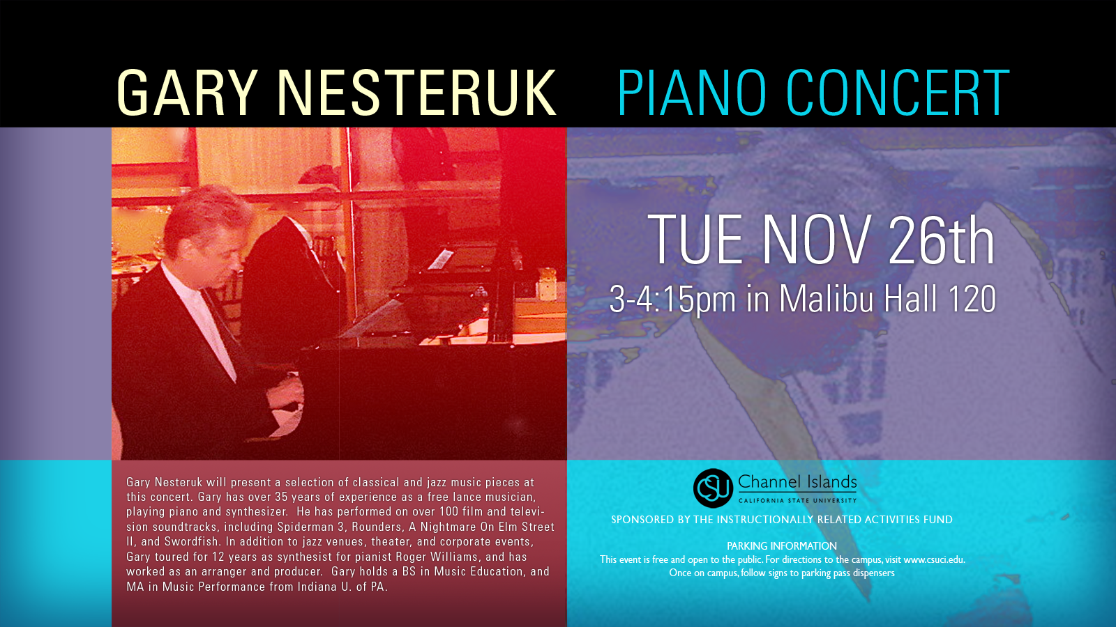

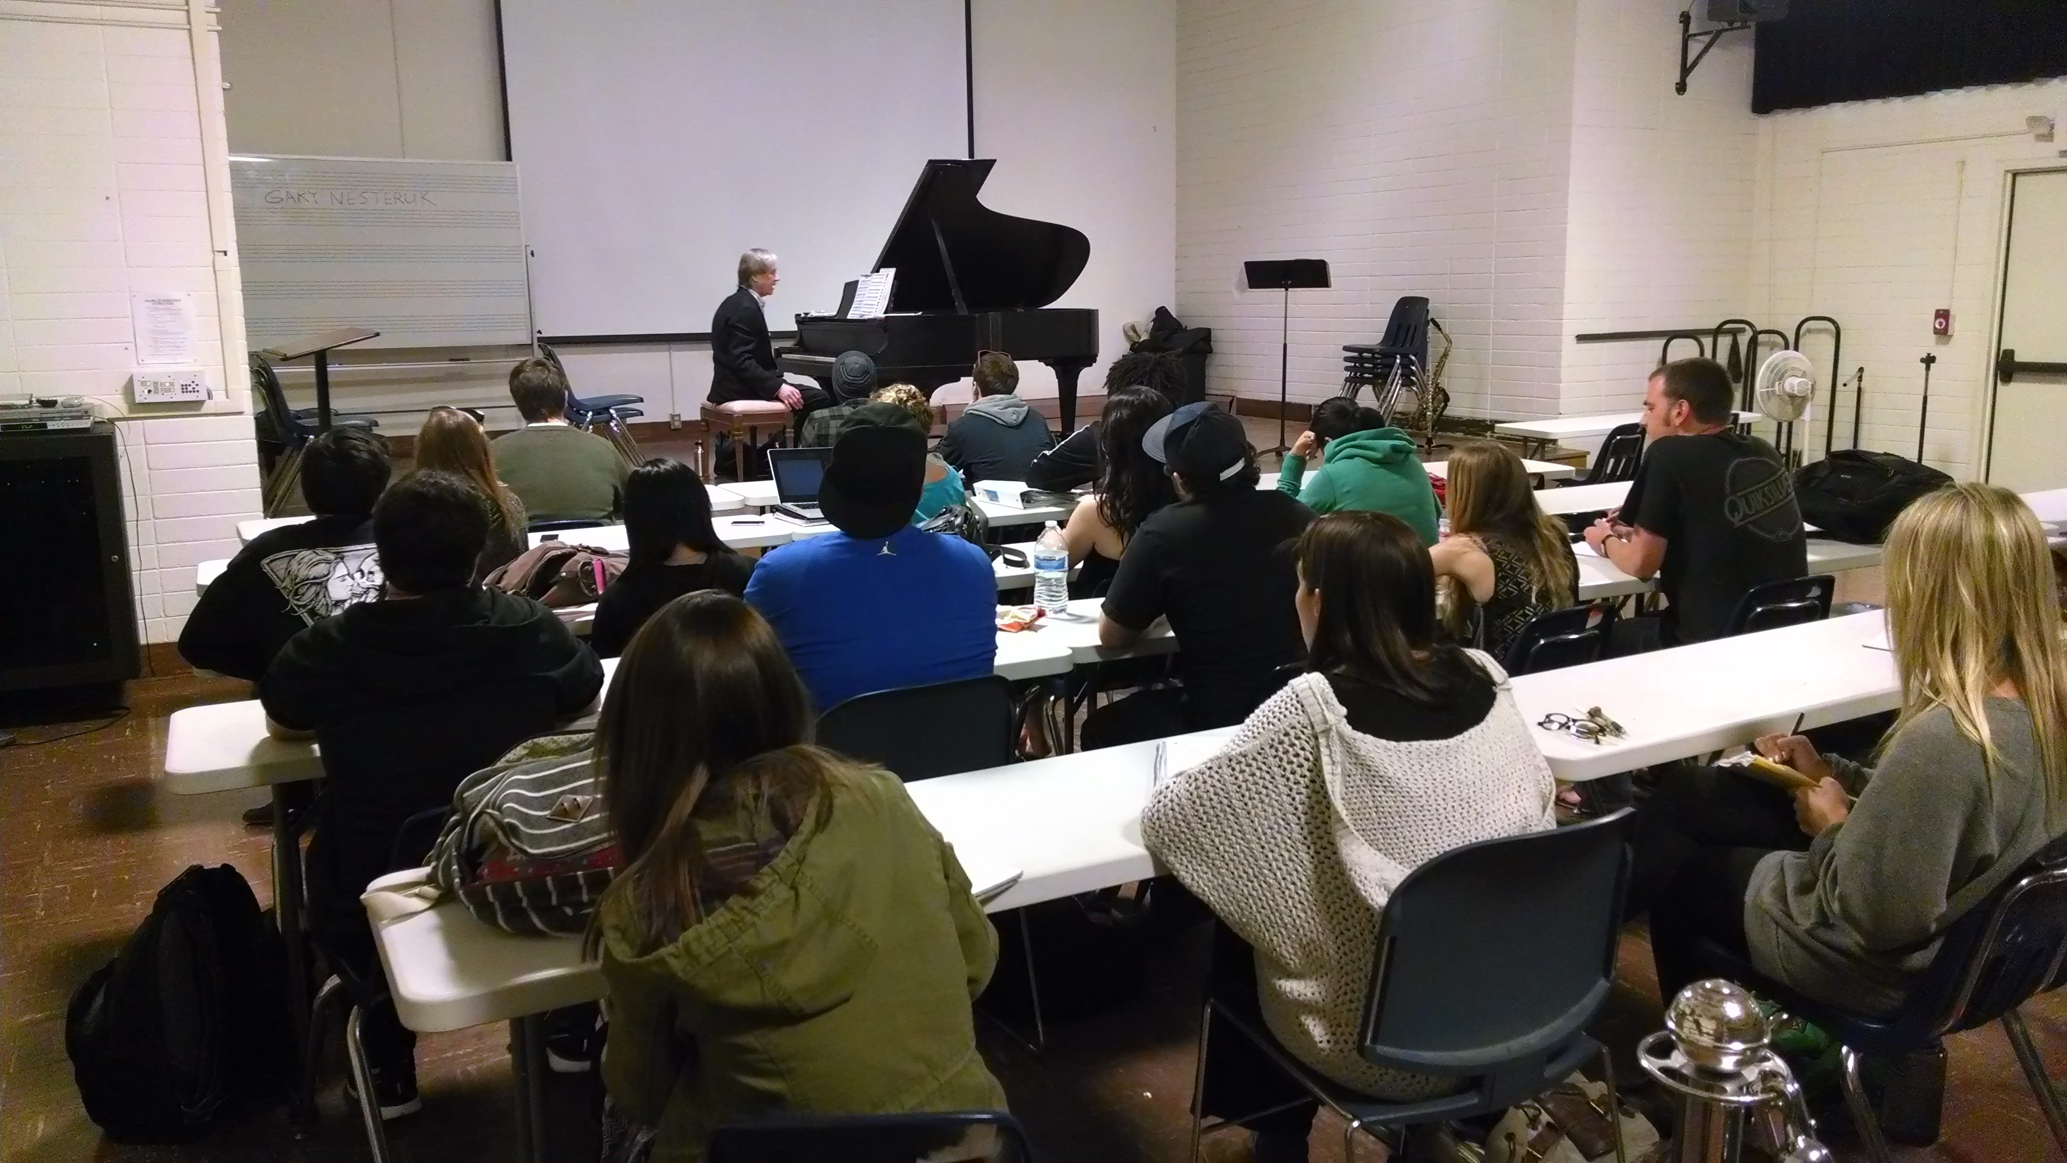

GO TO NEXT PAGE > > > >
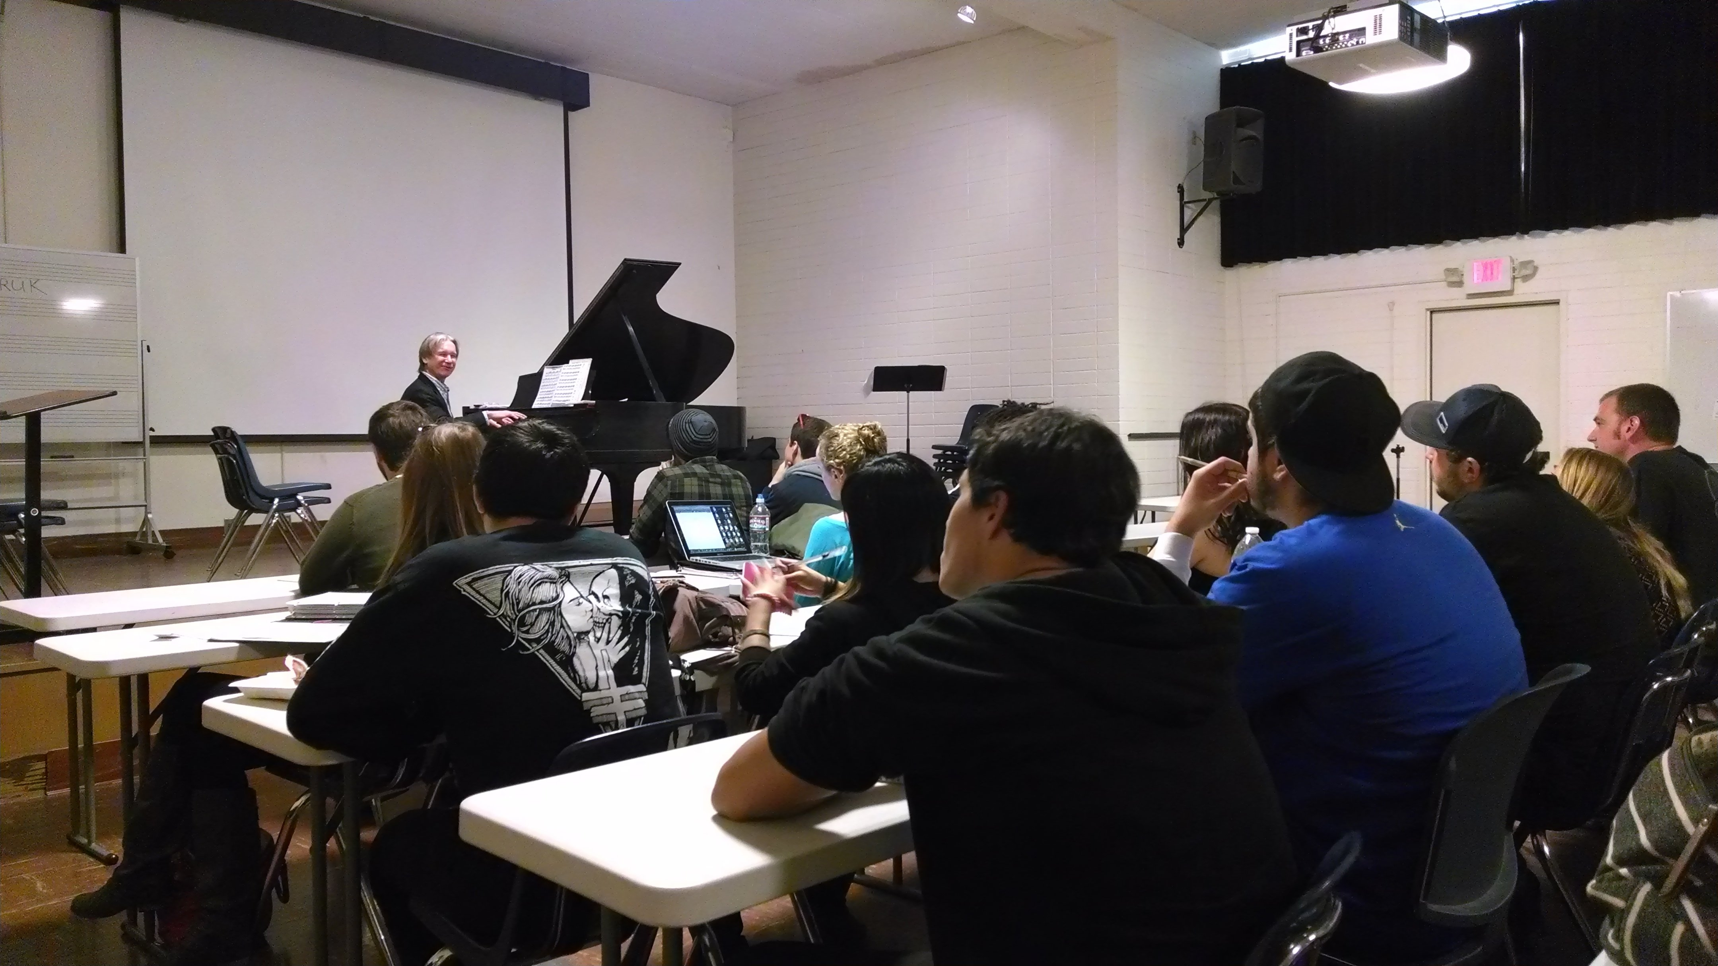

STUDENT COMMENTS – GARY NESTERUK Concert – 11/26/2013

Overall I found this concert experience enjoyable and a pleasant contribution to the experiences I have had throughout the semester. Seeing the influences of other eras and how they can translate into modern music is something that I find valuable to music literacy. Having the understanding of the previous eras and styles that directly influenced the music I grew up loving only strengthens my appreciation for its history.
________________________________________________________
When Nesteruk introduced the piano to our class you could see the passion and respect he had for the instrument. Gary Nesteruk’s performance was soothing, exciting, entertaining, and interesting. When he talked about each piece, and the piano itself, you could see his respect and passion for them. He was a phenomenal performer and extremely humble. Performances like this have proved to be crucial for classes like this one, because they allow students to appreciate the instruments and the worked written on them in all of their glory.
__________________________________________________________
It was so nice to see such an incredible musician at work this last Tuesday. Gary Nesteruk is a true professional. The knowledge he had of the piano was mind blowing, and I really appreciated his willingness to teach us more about how a piano works. His passion for piano made the experience even more enjoyable and inspiring. I loved hearing Gary Nesteruk play the piano. He is sensational, It was a treat to watch and listen to such an incredibly talented artist. He was such a wealth of knowledge and I felt I learned a lot about the piano in such a short period of time. I could listen to him play the piano all day.
Mr. Nesteruk first played the first preludes from Bach’s “Well-Tempered Clavier”. He mentioned how much he admired Bach’s work and that Bach is his favorite composer.
Our teacher then accompanied him on flute for Bach’s flute sonata No. 2 E flat major. This one of my favorite performances from the concert, the flute playing was marvelous and it was good to see 2 musicians perform with each other. It was a joyous and chirpy piece. The flute played embellishments of the piano’s melody.
It was an amazing performance and helped me appreciate this class even more.
_________________________________________________________
Gary Nesteruk was a great choice for the in-class concert because it was easy to communicate and ask questions about him, his job in the entertainment industry, and the music. The in-class concert as a whole was a great cultural experience and I am pleased that I was a witness to it.
___________________________________________________________
Towards the end of the performance, Gary Nesteruk talked about some of the experiences he had in the music recording industry. It was interesting to hear some of his stories and his comments on the music and film industry. Overall this in-class performance was a wonderful experience. I got a taste of live classical, baroque and romantic piano music. Not to mention a taste of soothing flute paying, thanks to our Professor. Overall, an educational and fun experience.
__________________________________________________________________
As a performer Mr. Nesteruk not only provided insightful information and details on his areas of expertise, but he drew the class in and got them excited about what he is passionate about.
During this concert I found that knowing the performer, character, background, and a "snapshot" of their personality makes listening to them play significantly more enjoyable.
__________________________________________________________________
The overall experience of the concert was mesmerizing. Nesteruk played many wonderful pieces that contained variety with regard to tempo and emotion. It was a well put together set list. To witness a professor piano player and composer in a live setting is truly rewarding.
_________________________________________________________
I enjoyed the Gary Nesteruk performance. I enjoy listening to the piano and find it impressive that a person can play it so well because it doesn't seem to be an easy instrument to play. I enjoyed the fact that he showed us the piano and the technicalities of it. He didn't just play but showed how it all works. He played each of the pieces beautifully.
__________________________________________________________
On Tuesday we were privileged to have an in-class concert with Gary Nesteruk who not only played some very famous piano pieces, but also educated us all on the mechanics of a piano. Gary was incredible at not just playing the notes, but putting himself into them by exerting emotional and feelings into each and every phrase he played. Bach is not an easy composer to mimic in playing, but I feel that Gary did it better than I had every seen before.
____________________________________________________________
Gary Nesteruk’s classical piano concert was exquisite. The way he began his performance by letting us come up to the stage to demonstrate to our class how the piano works, and explaining in detail the importance of the sound of each note was very intriguing and refreshing. The way Gary pointed out key effects to look for throughout each piece made it a more knowledgeable experience for myself, which was very delightful. Lastly, learning about his personal experience in the career path chose in making music for movies and television series gave me a whole new outlook, and appreciation for music performers and producers.

________________________________________________________________

Initial Report
Last Modified: 11/21/2013

Statistic | Value
Total Responses | 13

3. Event Name
Text Response
Gary Nesteruk Piano Performance
In class concert demonstration
Gary Nesturuk
Gary Nesteruk
Classical Pianist (Gary Nesteruk) In-Class-Concert for Steven Marsh
Gary Nesteruk Piano concert
Gary Nesturk
Gary Nesteruk
Gary Nesteruck Concert
Gary Nesteruk Concert
In-class concert
Gary Nesteruk
Gart Nesteruk Piano Concert

Statistic | Value
Total Responses | 13

4. Event Date
Text Response
11/26/13
11/26/2013
November 26, 2013
11/26/13
11-26-13
11-26
November 11-26-13
11-26-2013
November 26, 2013
11/28/2013
11/29/13
11/26/2013
Nov. 26, 2013

Statistic | Value
Total Responses | 13

5. How did your hear about this activity?
# | Answer |  | Response | %
1 | Instructor |  | 13 | 100%
2 | Word of mouth |  | 0 | 0%
3 | Facebook announcement or posting |  | 0 | 0%
4 | csuci.edu website |  | 0 | 0%
5 | Flyer/ Poster |  | 0 | 0%
6 | CI newsletter or publication- if so, which one? |  | 0 | 0%
 | Total |  | 13 | 100%

CI newsletter or publication- if so, which one?

Statistic | Value
Min Value | 1
Max Value | 1
Mean | 1.00
Variance | 0.00
Standard Deviation | 0.00
Total Responses | 13

6. Rate your overall satisfaction with this activity- 1 being lowest, and 10 being the highest score.
# | Answer |  | Response | %
1 | 1 |  | 0 | 0%
2 | 2 |  | 0 | 0%
3 | 3 |  | 0 | 0%
4 | 4 |  | 0 | 0%
5 | 5 |  | 0 | 0%
6 | 6 |  | 1 | 8%
7 | 7 |  | 0 | 0%
8 | 8 |  | 2 | 15%
9 | 9 |  | 3 | 23%
10 | 10 |  | 7 | 54%
 | Total |  | 13 | 100%

Statistic | Value
Min Value | 6
Max Value | 10
Mean | 9.15
Variance | 1.47
Standard Deviation | 1.21
Total Responses | 13

7. What do you consider the positives/ strengths of this activity?
Text Response
I think that it is important that we have actual music experiences in this class and it keeps things fresh. Allows us to break up the monotony of lectures with something that is very relevant to the class.
I enjoyed learning more about the piano and hearing this incredible music live.
It brings the music to life, we were able to ask questions to better understand the music, and if he was trying to explain something, he was able to demonstrate it right then on the piano.
Classical music is new to me, so it's opening new doors.
It allowed us to see a classical performance aswell as see the music we learned about being played live.
He began by showing us the Piano and in depth on how it works. As well as giving us information about each song and composer before he began playing.
The musicality and professionalism of the music played.
Hearing music played live causes you to hear it in a different way. Hearing first hand experiences as a studio musician was very interesting and brought a sense of the world and real life into the class room.
Professional atmosphere and highly knowledgeable guest performer
The pieces were well played.
Gives students the ability to hear professional pianists and be able to have some Q&A with them as well.
Displaying quality music connected to the class subject matter and explaining it thoroughly.

Statistic | Value
Total Responses | 12

8. What were the weaknesses of this activity?
Text Response
I don't really see any down side to doing these activities in moderation.
We didnt have enough time to listen to all these wonderful peices.
Sometimes it was hard to follow.
No weaknesses
It focused a little too much on the classical pieces we learned about, and I wish Gary would of played more jazz, blues, and even pop.
none!
No weaknesses.
None! It was so great and enjoyable!
There was not enough campus-wide knowledge of event
The room we used.
N/A
None.

Statistic | Value
Total Responses | 12

9. Suggestions or comments for future activities?
Text Response
Keep them coming!
I think this should be more available in the future, it is a great way to learn the music
None I can think of.
None. The outline of the concert was excellent.
Provide better campus-wide knowledge of such events
N/A
Live music is useful in teaching music history if it is explained.

Statistic | Value
Total Responses | 7

10. Any other comments?
Text Response
no
Awesome experience and would really encourage to continue keeping this opportunity available for students.
The enrichment provided by Steven Marsh through this event was very impactful on the quality of the PAMU/HIST 337-01 course
N/A
None.

Statistic | Value
Total Responses | 5

11. Which course(s) that you are currently taking did this activity relate to?
Text Response
Music in History
Music In History PAMU337
Music History
hist 337
PAMU 337 Music History
Music in History
Music History 337
Music in History, Hist 337
Music in History 337
HIST/PAMU 337 Music in History - 01
Music in History
Hist 337
Music in History

Statistic | Value
Total Responses | 13

12. How did this activity relate to the content and/or learning outcomes of the courses that you are taking?
Text Response
We were able to see, first hand, the music that we discuss in class being performed.
It was a nice way for us to hear some of the composers music that we have been studying.
He played pieces that were composed by composers that we are learning about in class
Gary played classical music on the piano and were learning about the classical era. We also are learning about writing concert reports.
In my Music History course we were talking about the music of Beethoven and Bach, which Nesteruk played for us.
the pianist showed us different piano peices, and showed us a lot about the piano. it helped us learn how the music is made and how the piano works.
The music he performed were from composers we are studying in class
The musician played classical pieces that we learned and discussed in class.
He played music that we had learned about in class and explained the background, process and details of certain songs, the build of a piano and his occupation as a studio musician. It related to our class in every way! Having someone tangibly display and illustrate the things we had learned in the class session was incredibly effective.
It covered several musical periods studied in class and provided hands on education on how pianos work.
We had to write an in-class concert report.
We learned the music of the classical era and about many famous composers.
Gary played a myriad of pieces from composers we have studied in class. He discussed important elements regarding the details of the music and it's history.

Statistic | Value
Total Responses | 13

