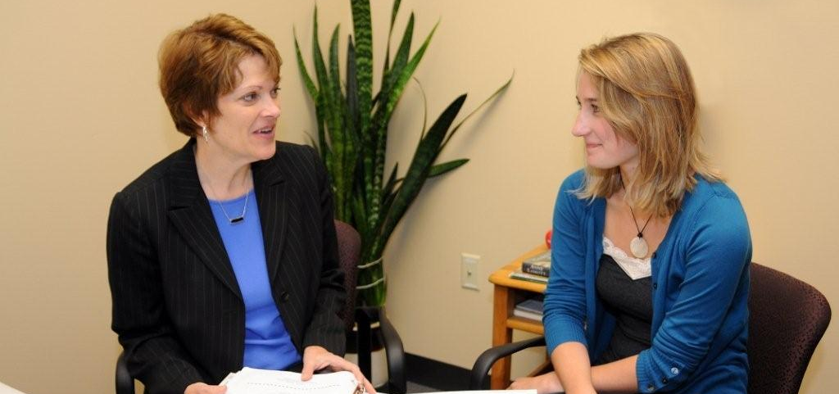
Informational Interview Assignment
Conduct an informational interview with a professional related to your own career interests. During this interview, you will try to learn what inspired her/him into this field. If you are not sure about your major or career interests visit Career Development Services prior to your informational interview to help you narrow down some options.

Steps:
- Review this document regarding informational interviews.
- Locate 3-5 prospective professionals to contact.
- Create a phone/email script on what you should say before contacting these professionals.
- Allow a minimum of 2-3 weeks to schedule your phone or in-person interview. (Please do not make last minute requests expecting these professionals to bend over backwards or alter their schedules because you did not plan in advance)
- After you scheduled your phone or in-person appointment, try to find out as much information you can about their career pathway (Use google and LinkedIn).
- Develop at least 10-15 questions regarding their career pathway, that you feel the information would be relevant to you.
- Make sure you arrive 15-minutes early if you are meeting in person. Whether you are on the phone or in-person, bring your questions, a pen and notepad to take detailed notes.
- After your interview, write a minimum 500 word paper covering the following:
  - What did you find most interesting?
  - How do you think you the information you learned can assist you with your career path?
  - What plans of action will you take based on what you learned from this interview?
FAQ
- Why are informational interviews important?
Please review the information regarding informational interviews on the second page of this document.
- I can’t find someone to interview, what should I do?
Ask friends and family for contacts in your field of interests. People you know well, (family, friends, and co-workers) are more likely to provide you good referrals. You can also utilize the LinkedIn Alumni Tool to find professionals that are connected to CI who might be willing to help.
- I’m not sure which questions I should ask?
These questions are an opportunity to provide you with insight about your career interests. Ask questions you really care about. What is most important to you? What information might help you the most, pursuing this career? You can also come to Drop-In Career Counseling if you need further assistance.
- I’m confused about what I need, to complete this assignment; can visit the Career Center for help?
Please make sure you ask your faculty or staff about the requirements to complete this assignment. The Career Center staff is knowledgeable about informational interviews, however assignment requirements are designated by your faculty or staff. We don’t have the ability to confirm the assignment’s requirements.
- I can’t visit the Career Center during Drop-In Career Counseling, can I make an appointment?
Students who are unable to make it during Drop-In Career Counseling will need to call the Career Center at 805-437-3270. We cannot schedule appointments via email. Please try to avoid making last minute appointments, as the average appointment requires approximately 3-5 business days. Appointments are not available during summer and winter breaks.

Career Development Services
1 University Drive, Bell Tower 1548 • Camarillo, CA 93012
Monday-Friday 9:00 am – 5:00 pm • (805)-437-3270 career.services@csuci.edu

What is an Informational Interview or Field Research?
An informational interview is a meeting that you schedule with someone who works in an industry that you may be considering for future employment. This can help provide some insight into whether or not you would enjoy a certain type of job. It is a learning experience but can lead to jobs and internships. Once someone knows you they are more likely to consider you for employment or refer you to other people who have openings. This is a way to make an acquaintance in your field. These meetings are a key way to obtain senior level jobs too, which are often found through word-of-mouth. During the meeting you will take notes on buzzwords and concepts discussed since you want to become a sponge for things related to your field.

What are other benefits of an Informational Interview?
- Help you decide if this field is right for you.
- It will improve your interview skills and get you ready for potential careers.
- Gain a contact for future employment.
- You can learn what skills you are lacking and how to improve your chances in obtaining a career.

Who do I talk to?
Ask around and do some research. Determine what kind of job and industry interests you most. Talk to multiple staff, friends, relatives, professors… any other people that could possibly give you a contact name.

How do I make an appointment?
- Most informational interviews are about 30 minutes long. Be prepared with dates and times that you are available to meet with this person before you call. Remember this is a favor, so be flexible. Be considerate that professionals are very busy, keep a 2 week period in mind. Don’t wait for the last few days before your assignment is due to request an interview.
- Make your motivation clear. Tell the person you are trying to learn more about different majors and potential career interests to determine what you may want to look for in the future.
- If your contact person is unable to meet you, ask them if they could refer you to someone else.

Script:
Hi, _______________ I am currently a student at CSU Channel Islands, pursuing a degree in ____________. I wanted to find out more about the field of ___________. I am in the process of researching information and completing an assignment for my ____________ class and I would really appreciate the opportunity to speak with you. Would it be possible to schedule a 20-30 minute phone or in-person appointment to ask you a few questions to help me narrow down my career options and complete my assignment?

How should I prepare for the interview?
Prepare for it like you would for a job interview, arriving on-time, professional and prepared with questions and a note pad and pen. You do not want to show up late poorly dressed and unprepared even though this is not a formal job interview. It is very possible that the person you are interviewing may ask you some questions about yourself and your goals, so be prepared to answer questions such as “Why did you want to interview me?” What interests you about my class? Do not just ask the questions that you bring with you, but let them serve as a guide. If they answer with something that strikes an interest, continue to asking additional questions. You could also utilize this opportunity to receive resume feed-back if you brought a draft of your resume.

Make sure you write down approximately 10-20 questions and keep in mind the time-frame you have during your appointment. You want to ask some icebreaker questions at the very beginning and a few follow-up advice questions at the end. You don’t want to end your interview too early or ask so many questions you make the person late for other appointments or other responsibilities.

Sample Questions

Icebreaker questions:
How are you today?
How long have you worked for __________?
Standard questions:
Could you tell me your career path?
What about this field/industry do you enjoy most?
What prepared you the most for this job?
What degrees or licenses did you have to get before being employed?
What got you interested in this type of work?
What type of person is best suited to this type of work?
What qualities would you look for hiring someone?
What is the best way to find out about job opportunities in this field?
Who makes the hiring decisions?
What do you like to see on a resume or what are the main skills needed?
How much has this industry grown since you have started this job?
Do you expect to be in demand for as long as you work?
How secure is employment in this industry?
What is the salary range for this profession?
Does the salary increase much with more education?*Do not ask what salary the person you are interviewing receives.
How much time do you spend with your co-workers in general?
What kinds of clothes are acceptable to wear here?
How do you spend your breaks from work during the day?
How much time do you spend working outside of office hours?
How much time can you take off for vacations?
Do you belong to any professional organizations?
How long is your average work day?
What tasks do you accomplish in a typical day?
Who do you came into contact with on a daily basis?
Do you consider this job rewarding?
What makes it worth it for you to come in every day?
Are some rewards monetary or promotional?
What are some of the drawbacks of this occupation?
What are improvements you would like to see in this field?
What is the biggest challenge you face in the course of your work?
Is there a similar industry that I may want to look into?
Can I contact you again if I have any other questions?
Can you recommend anyone else for me to speak with?
Can you suggest other resources w/valuable information? Newsletters?
Advice questions:
What advice would you give to someone now entering your field?
What advice did you wish you had before entering this field?

What do I do after I interview?
- Take note of what questions were answered and what you may still need to find out.
- Consider your next course of action. Based on what you learned from this interview, what do you need to do next? Did they suggest a type of skill you need to learn? What kind of positions can you get now to help you in this field? Is there someone else you should contact?
- Send a thank you note within one day. Email is fine.
- Take advantage of any referrals you received and make other informational interview appointments to get another person’s perspective.

