How to Join a Club or Organization on CI Sync

- Login to your MyCI Account.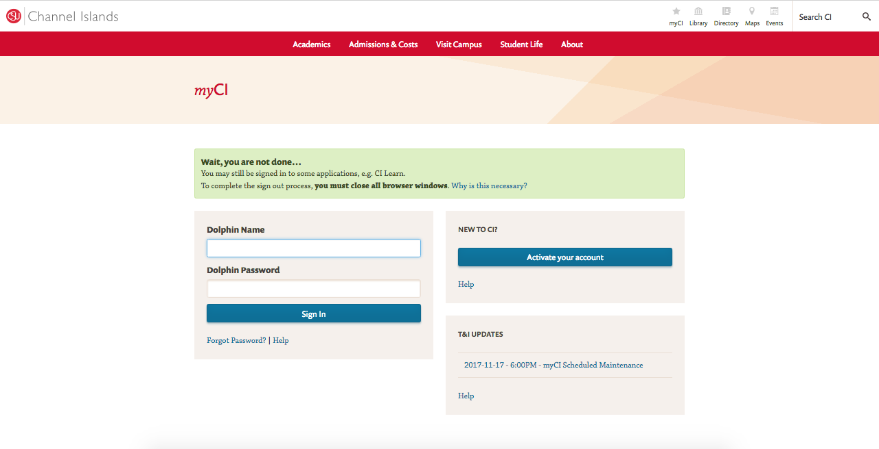
Figure 1 MyCI Login

- Find the My Links section.
- Click the CI Sync (Clubs and Orgs) link.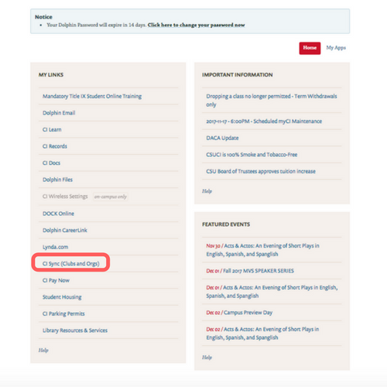
Figure 2 MyCI My LInks

- You’ll be taken to the CI Sync home page.
- On the top of the home page find the search box and type the name of any club or organization.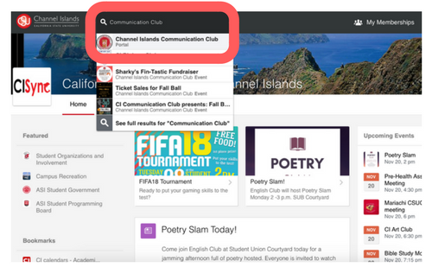
Figure 3 CI Sync Home Page
- You’ll be taken to the portal page for the club
- Click the “Join Now” button in top right corner
Figure 4 CI Sync Club Portal Page

