 | CI 8.9 Business Process Guide  CI Custom LCD Payroll Reports

Last Revised: | 8/29/2007

REVISION CONTROL
Document Title: | CI 8.9 Custom LCD Reports
Author: | CI CMS
File Reference: | CI_LCD_LCD with Recon Reports.doc

Date | By | Action | Pages
6/14/07 | L Lovejoy | Release of New Document | All
8/29/2007 | M Klep | Update Document | All

Review/Approval History
Date | By | Action | Pages

Table of Contents
Page
Introduction 1
Process Prerequisites/Assumptions 2
Processing Steps 2
Run Control Set Up 2
Single Department 4
Multiple Department 5
Run Report 5
Expected Output 7
Access to Previously Ran Reports 8

Introduction
The CI Custom LCD Payroll Reports Business Process Guide will guide the user through running the LCD Payroll Reports and how to access them at a later time. The primary goal of the LCD payroll reports is to balance to the financial reports and to assist in the data gathering for expenditure adjustments. This guide covers the following functionality:
- Run control setup
  - Single Department
  - Multiple Departments
- Run Report
- Expected output
- Access to report previously ran

Process Prerequisites/Assumptions

Prerequisite/Assumption | Detail
Assumption | LCD has been successful ran for pay period the user wants to see.

Processing Steps

Run Control Set Up
Navigation: Main Menu > CI Customizations / Interfaces > CI Human Resources > LCD Payroll Reports > Payroll Reports > LCD Payroll Reports > Add a New Value*

Processing Steps | Screen Shot
Create a run Control ID  - Can be named anything – this is specific to your login  - Cannot have spaces  - Once the run control is saved it may be used again and again by selecting the find an exisiting value. All the previously saved information will be populated and can be updated.  - Can create multiple Run controls for multiple departments or one run control to run all departments | 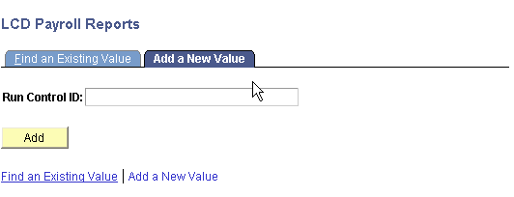

Processing Steps | Screen Shot
Once Run Control ID is created, you will have the option to select your criteria.  The fields with “*” are required:  - Fiscal Year  - Department  All other fields are optional and can limit the amount of information retrieved. | 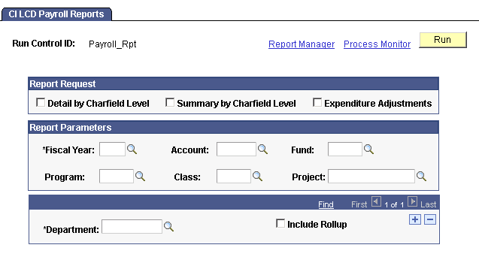

Explanation of Fields
- Detail by Chartfield Level : Report page that show all entries based upon the criteria selected in the Report Parameters by employee
- Summary by Chartfield Level : Report page that will show all entries summed by chartfield based upon the Report Parameters
- Expenditure Adjustment : Report page that will show all expenditure adjustments based upon the Report Parameter selected
  - These reports can all be selected to run in the same report request and will appear as different tabs in the excel worksheet
- Fiscal Year (Required Field): 4 digit fiscal year. Example 2006 is July 2006 to June 2007.
  - Reports must be ran for a particular fiscal year, but users have the ability to run prior fiscal year reports now
- Account : Input to view charges on a specific account code.
  - Example 602001 (FWS students)
- Fund : Input to view charges on a specific fund.
  - Example GD901 (CI ~ Operating)
- Program Input to view charges on a specific program.
  - Example 00102 (CMS)
- Class Input to view charges on a specific class.
  - Example 0039A (Trio Main)
- Project Input to view charges on a specific project.
  - Example G0039 (Trio)
- Department (Required Field) three digit department id
  - Example 110 (Office of the President)

- Include Rollup allows reports to be ran based off of the department tree. Entering UNIVERSITY (administrative use only) is the highest level of roll up. Example of the department tree:
  - Example
    - If department 210 is input in the Department field, only 210 will come back in the results (pending the user requesting this report has access to this department)
    - If department 210 is input in the Department field AND Include Rollup is selected 210, 220,225,230,240 will come back in the results (pending the user requesting this report has access to all these departments)

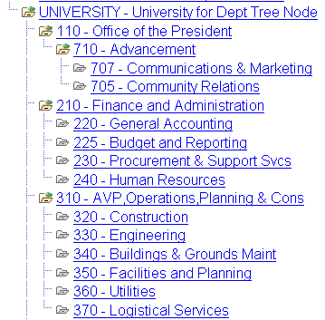

Single Department
Processing Steps | Screen Shot
Running all reports (report request section) and one department for fiscal year 2006 will appear similar to screen shot | 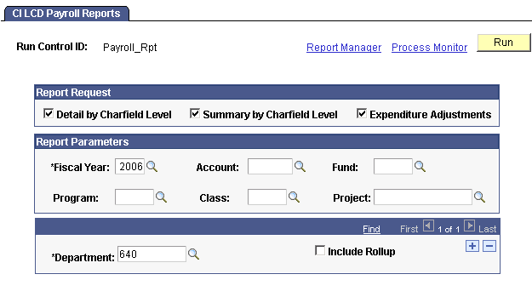

Multiple Department
Processing Steps | Screen Shot
Running all reports (report request section) and multiple departments for fiscal year 2006 will appear similar to screen shot  Click to add another department | 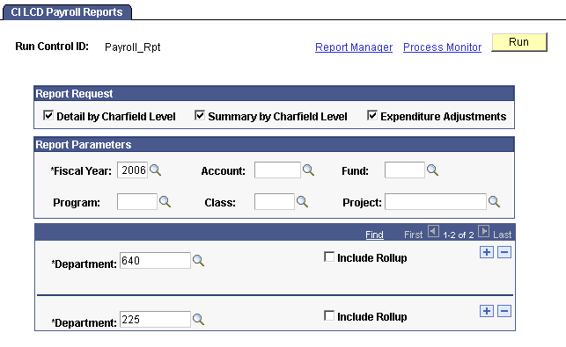
Output from Multiple Departments Payroll Report will be in one book.

Run Report
Processing Steps | Screen Shot
Click Run  Server Name: PSUNX  Click OK  Click Process Monitor | 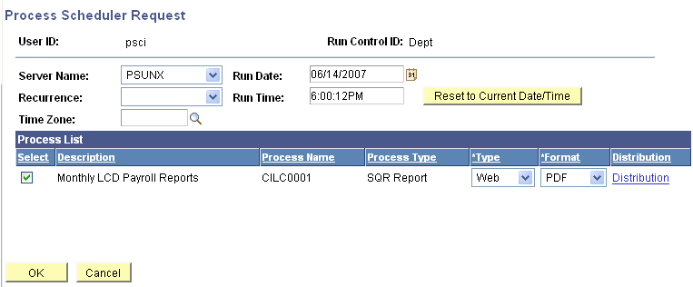
Click Details

Expected Output
 | Screen Shot
Click “View Log/Trace” | 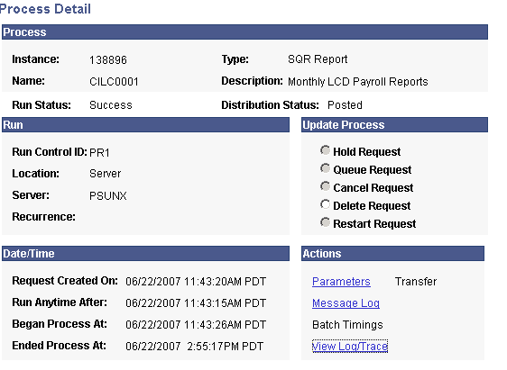
Open the .xls file | 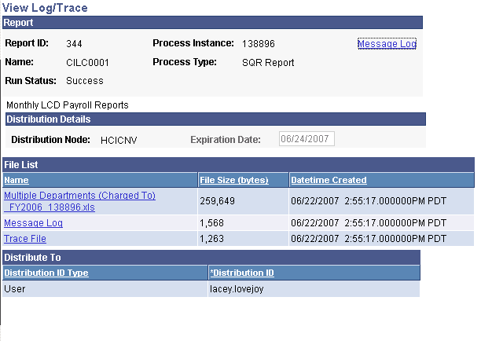
Example of output  - Notice each tab at the bottom of the screen. This will vary based upon what check boxes are selected  - Reports can be saved to users local drive for further review or see next tab for viewing previously ran reports | 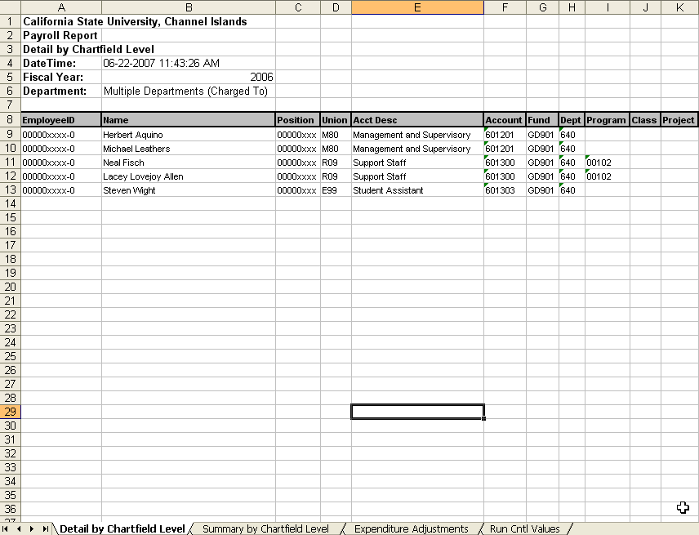

Access to Previously Ran Reports
Navigation: Main Menu > Reporting Tools > Report Manager > Administration Tab

Process Steps | Screen Shot
Reports that the user has ran will be listed there.  To see older reports change the “Last” to a larger number.  Reports will archive after 45 days | 