**Chart of Accounts**

**Chart of Accounts**



**MISCELLANEOUS**

**660915:** **License, Permits, Filing Fees.** Used to record payments for license and registration. *Not for software or training fees*

**660816:** **Memberships.** Costs associated with memberships to outside associations.

**660961:** **Recognition Expense.** In compliance with the ICSUAM 1301.00 Hospitality, Payment or Reimbursement of Expenses, something of value given or bestowed upon an individual, group or entity in recognition of service to the university or achievement benefiting the university; e.g. trophies, plaques.

**660851:** **Food and Beverage.** Costs associated with providing CO guests with food and beverages. Includes catering services and meals provided at CO hosted events.

**660090:** **Miscellaneous Expenses**. Used for expenses that are not otherwise described by other account ***Last resort.***

**ADVERTISING/MARKETING/PROMOTION**

**660017: Advertising and Promotional Expenses**. For the cost of any kind of advertising, including routine personnel vacancy announcements, and marketing and promotional expenses, including the cost of sponsoring a booth at a conference, the purpose of which is to promote educational services and programs of the CSU. *Marketing, sponsoring booths.*

**660844: Promotional Items.** Used only to record costs of promotional items such as logo imprinted tote bags, mugs, & pens

**660002: Printing.** Charges billed to you for printing services.

**REVENUE ACCOUNTS:**

**580094:** **Cost Recovery from CO.** Used for receiving admin fees or registration from another **CO** department.

**580194:** **Cost Recovery from Campus.** Used for receiving money from a **campus**.

**580090:** **Other Operating Revenue.** All sources of revenue from external parties for primary operations of department.

***Other revenue accounts are available. Contact General Accounting for unique requirements*.**

**TEMPORARY HELP**

**601302:** This account is for temporary ***employees***of the CSU. Should only use when processing through the payroll system. Should have an HR source.

**613001:** **Services.** Used for “temp” agencies such as *Apple One with a formal agreement in place.*

**RECRUITMENT**

**660017: Advertising/Promotional.** Job postings

**660042: Recruitment.** To record costs associated with employee recruitment, such as fees charged by recruiting firms and approved travel reimbursements for recruitment visits.

**603094: Employee Relocation.** Relocation expenditures and costs to relocate successful candidates, including new executives

**EQUIPMENT**

**619001:** Use for equipment expenditures that total over $5,000 **PER PROJECT**. *Copiers*

**619802:** Use for equipment expenditures that total under $5,000 PER PROJECT. *Refrigerators, calculators, voice recorders.*

***Total cost means the actual cost for the piece of equipment plus all costs associated with the acquisition, including taxes, shipping and handling, and installation charges****.*

**FURNITURE**

**619803:** Use for furniture expenditures that total over $5,000 **PER PROJECT**. *Work stations, desks, cabinets.* Includes storage, design, installation, and planning services provided by consultants. Vendors could include Tangram, PhaseSix, and Office Max.

**619804:** Use for furniture expenditures that total under $5,000 **PER PROJECT**. *Chairs, tables, bookcases.*

***Labor costs to design or install a workstation are part of the total overall furniture cost and is included in over/under $5,000.***

**SUBSCRIPTIONS**

**608800: Library Subscriptions**. Costs associated ONLY with institution’s library such as periodical subscriptions or electronic media.

**616805: Software as a Service (SaaS).** Software licenses on a subscription basis which is hosted by an external party.

**660970: Other Subscriptions.** Costs associated periodicals (paper or electronic) or other recurring subscriptions other than Software as a Service (SaaS).

**BOOKS**

**660825: Books** Used to record purchases of books for department use.

**Contractual Services & IT**

**Meetings/Conferences/Trainings**

**660851: Food and Beverage.** Costs associated with providing CO guests with food and beverages. Includes catering services and meals provided at CO hosted events.

**660041: Space Rental.** Meeting room expenses.

**616823: Info Tech Rental.** Audio/Visual-IT related fees paid to facility where event is held.

**660009:** **Professional Development &Training.** Used to record fees paid for staff to attend training, workshops, conferences and seminars. This account is used only for registration fees paid associated with these events and not for related travel expenses incurred by employees. *Registration fees, payments to trainers.*

**CONTRACTUAL**

**613001: Contractual Services.** Used to record expenditures made to external parties pursuant to a ***formal*** agreement. ***Should be used when there is no other account which more specifically describes the service being procured*.**

**61600X:** IT Related contracts, such as those for software and hardware maintenance, should be recorded using more detailed accounts.

***616001****-IT Communications,* ***616002****-IT Hardware over $5,000,* ***616003****-IT Software,* ***616004****-IT Infrastructure*.

**660061: R&M – Building Maintenance.** Used to record contractual services for facilities maintenance and repairs.

**660003:** All supplies including paper, office supplies, and things that are generally consumed. Services that are non-recurring, simple in nature and do not require a contract. Services requiring more complex contractual provisions should be charged to Contractual Services, object code 613001

**IT RELATED EXPENDITURES**

**616002: IT Hardware over $5,000.** *Servers*

**616822: IT Hardware under $5,000.** *Laptop computers, fax, printers, monitors, cables, routers, label makers.*

**616003**: **Software licenses and development**.

**616805: Software** as a Service (SaaS) or Software

**616806: IT Maintenance**

**616823: Info Tech Rental** Audio/visual*.*

**Criteria to Determine the Proper Account**

1. Account should describe the nature of the activity
2. Account should be based on purpose, instead of budget setup
3. Review online Chart of Accounts for account options and updates.

**Accounting Resources**

The Accounting department website is also the best place to reference up to date information. The Accounts page can be found [here](https://csyou.calstate.edu/Divisions-Orgs/bus-fin/Financial-Services/accounting/Pages/default.aspx), or by navigating to:

**Division & Organizations>Business & Finance>Financial Services>Accounting.**

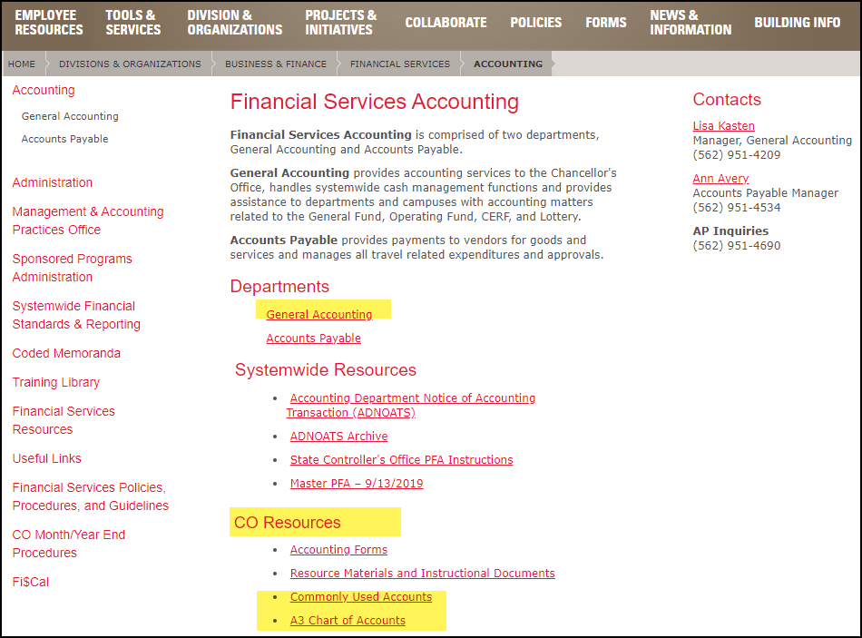

**For additional questions contact:**

Lisa Kasten: LKasten@calstate.edu

**Accounts for Travel Costs**

**TRAVEL COSTS DEPEND ON WHERE YOU TRAVEL:**

**606001: Travel In State.** Used for in-state travel expenses incurred by employees.

**606002: Travel Out of State.** Travel expenses incurred by employees outside of California.

Travel expense accounts should only be used for CSU employees (campus or CO) and students working for the CSU in some capacity outside of being a student. All other travel related expenses should go into the same account as the account used to pay the vendor/consultant services.

For example, if the services were charged to 613001 or 660009, then the associated travel costs would also go in those same accounts. For guest travel **(non CSU employee)** expenses where no services are being compensated, please use **660975: Office Guest Travel Reimbursement.**

|  |  |
| --- | --- |
| Approval Date: 1/16/2020 | Manager Approval: Lisa Kasten |
| Last Revised: 1/16/2020 | Revised by: Kerri Helfrick |

**Notes**

**How Chart of Accounts are Designed:**

**Assets:** A resource from which future benefits are expected.

*Example:**Cash, Accounts Receivable, Fixed Assets*

**Accounts beginning with a ‘1’ (101901-Cash)**

**Liability:** An obligation arising from past events that is owed to others.

*Example:**Accounts Payable and Use Tax Payable*

**Accounts beginning with a ‘2’ (201001-AP)**

**Equity:** The residual interest in the assets after deducting all liabilities.

*Example:**Fund Balance*

**Accounts beginning with a ‘3’ (305022-Fund Balance Clearing)**

**Revenue:** Increases in economic benefit during an accounting period in the form of inflows of an asset.

*Example: Student Fees, Contributions, and Investment Interest*

**Accounts beginning with a ‘5’ (508001-Investment Earnings)**

**Expenses:** Decrease in economic benefits during an accounting period in the form of outflows.

*Example: Salaries, Travel, Supplies and Services*

**Accounts beginning with a ‘6’ (606001-Travel)**

**PeopleSoft & Chart of Accounts**

**Accounting Concepts**

***In PeopleSoft (CFS) and the Data Warehouse (FDW)***

PeopleSoft is an accountng information system that collects and processes transaction data and then disseminates the financial information to interested parties.

**Accounting is a double entry system,**

**every transaction requires debits equal to credits.**

**Debits:** Debits are positive amounts

**Credits:** Credits are negative amounts

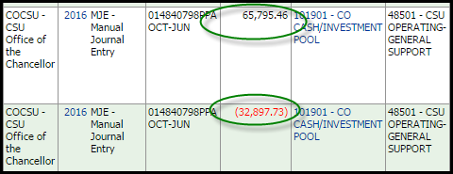

**Assets:** Normal balance is a debit (positive number)

**Liabilities:** Normal balance is a credit (negative number)

**Expenses**: Typically a debit (positive) when paying. Negative side is cash being reduced.

**Revenue**: Typically a credit (negative) when receiving. Positive side is cash being increased.

**Debits & Credits**

**PeopleSoft uses a Chart of Accounts (COA)**

A COA is designed to:

* + - * Comply with external financial reporting requirements (GAAP, State, Federal Government, etc.)
      * Allow for consistency and data integrity within the CO and CSU system.
      * Provide information needed for analysis, benchmarking and decision making (IPEDS, budget. Surveys, etc).
      * Provide a common language for classifying and grouping business transactions.
      * Required for accurate data collection and reporting when defined.

The Chart of Accounts (COA) provides info regarding the nature of the transaction to help segregate and categorize financial transactions. Each information field is called a **Chartfield**. Combining a series of Chartfields makes up a **Chartfield String**. ***A Chartfield String is used to define, identify, categorize, and sort transactions.***

**Account-Fund-Department-Program-Project-Class**

**606001 48501 1029 AA006 ITS00000 02901**

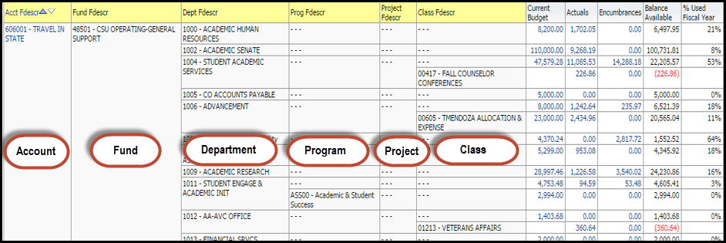

**Account:** Identifies “what” is the nature of the transaction. The account captures the detailed breakdown of a financial transaction that is entered into the system. Required on all transactions.

**Fund:** Identifies “where” of the transaction and its source and use of dollars being held. Required on all transactions. Maps to FNAT key, which is necessary for reporting. Tied to a specific purpose.

**Department:** Identifies “who” is impacted by the revenue/expenditure transaction. Represents the detailed breakdown of the Business Unit organization structures. Required for all revenue and expenditure accounts.

**Program:** Used to define a set of ongoing accounting activities for which revenues and/or expenditures need to be tracked. Identifying transactions for additional accounting treatments. Used on Revenue and Expense accounts. Required for accurate data collection and reporting when defined.

**Project:** Identifies a discrete set of activities that occur within a finite time period (a defined start and end date). Activities associated with project chartfield may span multiple funds, accounts and/or departments. Revenues and expense cross multiple years.

**Class:** Used for special reporting needs a department or other organizational unit may have. Activities associated with class may span multiple departments, funds and/or accounts.

**Contra Accounts**

To record reimbursements without losing track of the original expense.

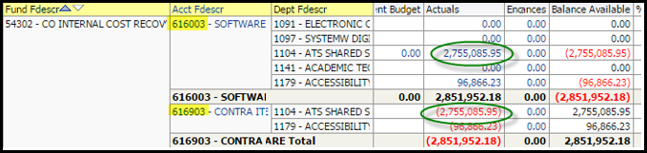

**608905:** Contra Library Subscriptions **616903:** Contra Software

**613901:** Contra Contractual Services **616905:** Contra Info Tech Maintenance

**616902:** Contra IT Hardware **660990:** Contra Expense-Other

**617901:** Contra Service from other Funds/Agencies-*Used instead of revenue when reimbursed by campuses or state agencies.*