Large Office Standard

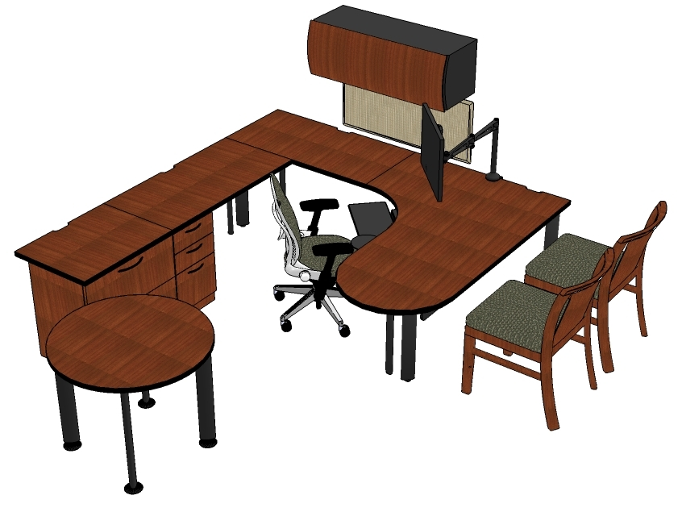
Quantity and Description
(1) Humanscale Keyboard Tray with Clip Mouse and Gel Wrist Rest
(1) Humanscale Monitor Arm for 19” Monitor
(1) Task Chair- Leap with Adjustable Seat, Fully Upholstered
(2) Guest Chair- Peek Armless Wood Chair
(1) Modesty Panel- 60” Long, Laminate
(1) Overhead Bin with Curved Wood Front- 42” Wide
(1) Fixed Box/Box/File Pedestal, Wood Front
(1) Lateral File/ 2 Drawer, Wood Front, 30” Wide
(2) Support Plate, 14” Deep
(1) Tackboard- 18”x42”
(2) Single Post Leg
(3) Double Post Leg
(1) Jetty Worksurface, Curved Corner, 72”x48”, Left Hand, Wood
(1) Straight Worksurface, 24”x30”, Wood Veneer
(2) Straight Worksurface, 24”x48”, Wood Veneer
(1) Wall Hanging Channel, 66” High
(1) Round Table Top, 36” Diameter, Wood Veneer
(4) Table Support Leg, Painted

Additional Seating
Think Task chair with adjustable arms and upholstered back
Think Task chiar with adjustable arms and knit back

