Medium Office Standard
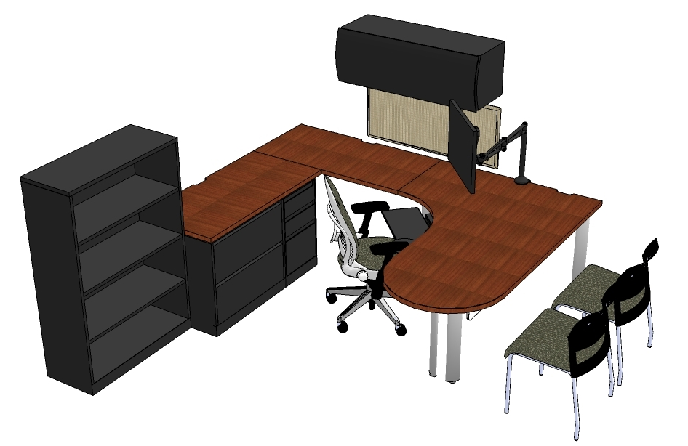
Quantity and Description
(1) Humanscale Keyboard Tray with Clip Mouse and Gel Wrist Rest
(1) Humanscale Monitor Arm for 19” Monitor
(1) Task Chair- Leap with Adjustable Seat, Fully Upholstered
(2) Guest Chair- Move, no Arms, Plastic Back
(1) Modesty Panel- 60” Long, Laminate
(1) Overhead Bin with Curved Front- 42” Wide, Painted
(1) Fixed Box/Box/File Pedestal, Flush Front
(1) Lateral File/ 2 Drawer, Flush Front, 30” Wide
(1) Support Plate, 14” Deep
(1) Tackboard- 18”x42”
(3) Single Post Leg
(2) Double Post Leg
(1) Jetty Worksurface, Curved Corner, 72”x48”, Left Hand, Laminate
(2) Straight Worksurface, 24”x48”, Laminate
(1) Wall Hanging Channel, 66” High
(1) Bookcase, 3 Adjustable Shelves, 36” Wide, 53-1/2” High

Additional Seating
Think Task chair with adjustable arms and upholstered back
Think Task chair with adjustable arms and knit back

