Small Office Standard
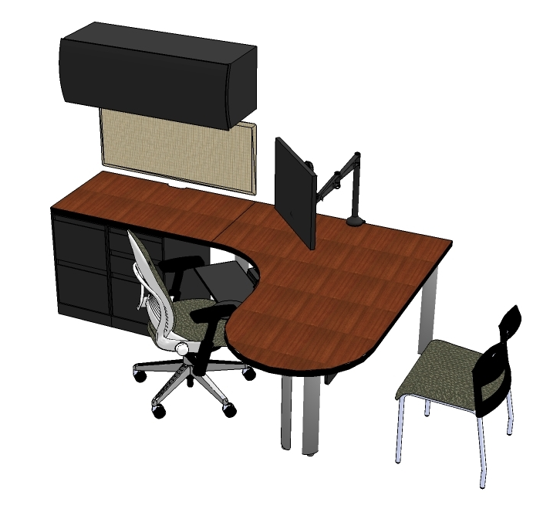
Quantity and Description
(1) Humanscale Keyboard Tray with Clip Mouse and Gel Wrist Rest
(1) Humanscale Monitor Arm for 19” Monitor
(1) Task Chair- Leap with Adjustable Seat, Fully Upholstered
(1) Guest Chair- Move, no Arms, Plastic Back
(1) Modesty Panel- 60” Long, Laminate
(1) Overhead Bin with Curved Front- 42” Wide, Painted
(1) Fixed Box/Box/File Pedestal, Flush Front
(1) Fixed File/File Pedestal, Flush Front
(1) Support Plate, 14” Deep
(1) Tackboard- 18”x42”
(1) Single Post Leg
(2) Double Post Leg
(1) Jetty Worksurface, Curved Corner, 66”x48”, Left Hand, Laminate
(1) Straight Worksurface, 24”x42”, Laminate
(1) Wall Hanging Channel, 66” High

Additional Seating
Think Task chair with adjustable arms and upholstered back
Think Task chair with adjustable arms and knit back

