

COMPLETING THE CI ALTERNATE SUMMER WORK SCHEDULE 2024 APPROVAL FORM
Effective Start Date: June 2, 2024 | Effective End Date: August 10, 2024

- Click this link or copy and paste this link into your browser: https://csuci1.na2.documents.adobe.com/account/customComposeJs?workflowid=CBJCHBCAABAAPa_s4yxjo66hz9GbN7TyEG11C1Nl0DEk

- If you are initiating the form for yourself, then submitting to your manager for approval, your email address will auto populate as the employee, add your manager’s email in the appropriate box. Be sure to update the Message or Document Name to include your name, as your manager may be receiving several of these requests.
- If requesting AWS option, cc payroll.services@csuci.edu.
- If requesting telecommuting option, cc hr.forms@csuci.edu & submit new telecommuting agreement to hr.forms@csuci.edu.
- Then click the “Send” button.

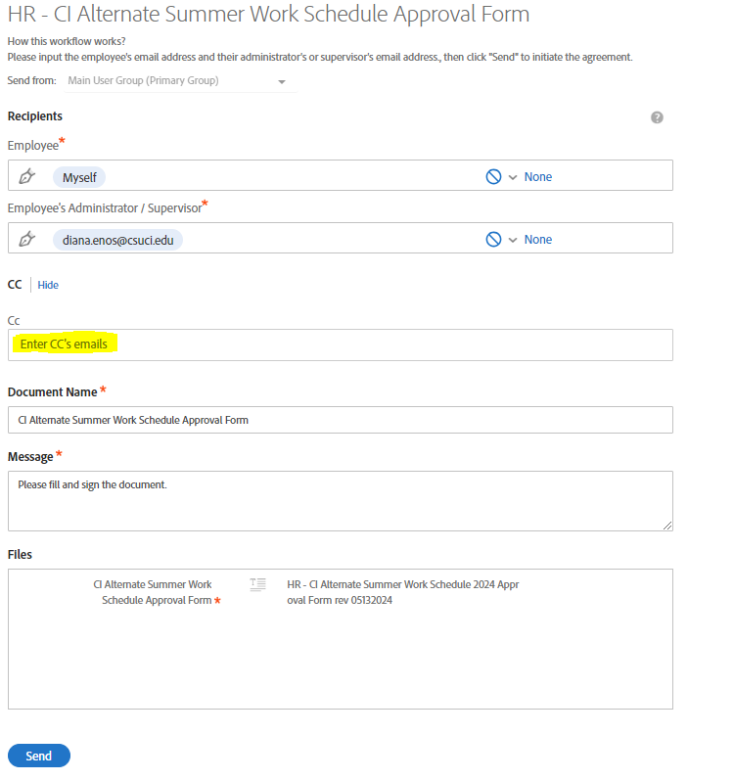

OR
If you are initiating the form for someone else, your email address will auto populate as the employee, you will need to change this to the email address of the employee you for whom you are requesting this change, then add their manager in the appropriate box. Be sure to update the Message or Document Name to include the employee’s name, as their manager may be receiving several of these requests.
- If requesting AWS option, cc payroll.services@csuci.edu.
- If requesting telecommuting option, cc hr.forms@csuci.edu & submit new telecommuting agreement to hr.forms@csuci.edu.
- Then click the “send” button.

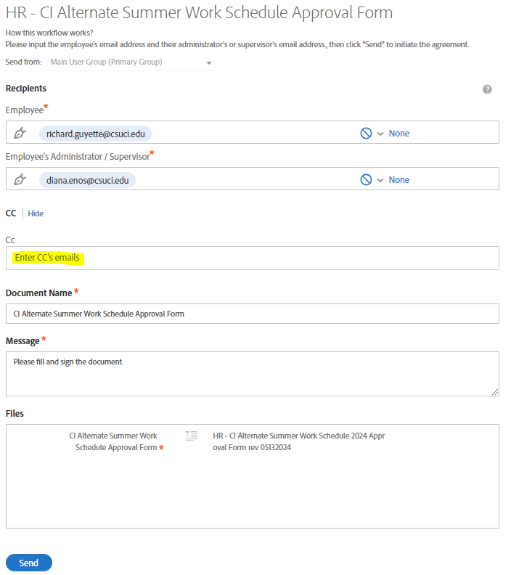

- The employee must complete Section I, filling in the required information for the alternate work schedule(s) being requested or the increased telework schedule. For Section II, the employee will need to type their name, enter their employee ID number, sign using one of Adobe’s signature methods, and date. Adobe will route the form to the manager indicated at the start of the process so the manager can fill out Section III.

