|  |  |  |  |
| --- | --- | --- | --- |
| National Park Service  U.S. Department of the Interior |  |  | Channel Islands National Park  1901 Spinnaker Drive  Ventura, CA 93001  805-658-5700 phone  www.nps.gov/chis |

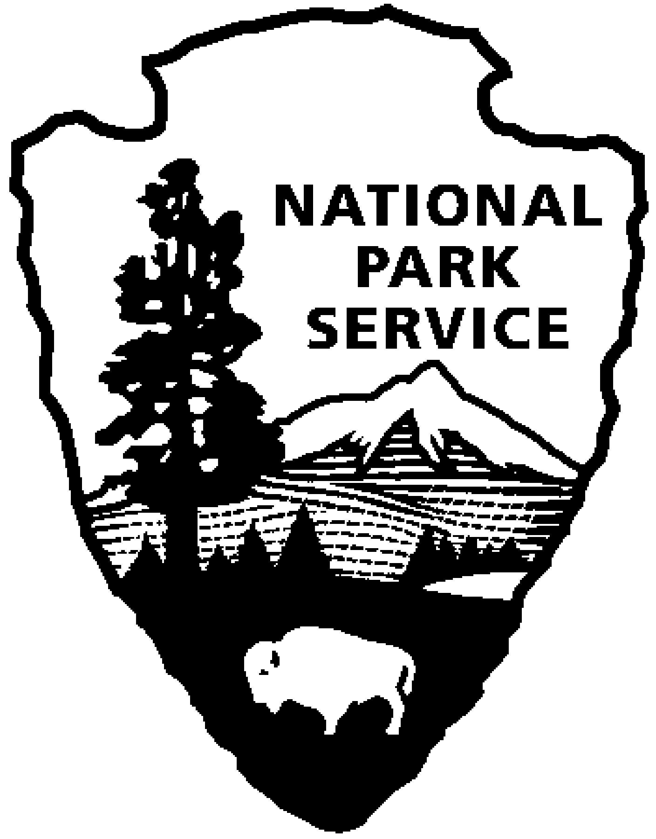

**Channel Islands National Park** News Release

|  |
| --- |
|  |

Release Date: June 7, 2024

Press Contact: Jasmine Reinhardt, [jasmine_reinhardt@nps.gov](mailto:jasmine_reinhardt@nps.gov)

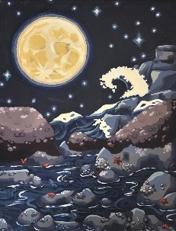

“Sleeping Tides” by Bren Barnes 12th Grade Winner

Channel Islands National Park Features Student Art from the California Coast and Celebrates World Oceans Day

VENTURA, Calif., - The 2024 California Coastal Art & Poetry Contest will be on exhibit through June 24, 2024, at the Channel Islands National Park Robert J. Lagomarsino Visitor Center in the Ventura Harbor. Ten winners (five in art, five in poetry) and 40 honorable mentions, including students from Goleta and Los Angeles, were selected out of more than 2,407 entries from California’s kindergarten through 12th grade students. Special events will be offered during the month of June at the Channel Islands National Park Visitor Center to celebrate the exhibit in conjunction with World Oceans Day.

**Beach Cleanup**- Saturday, June 8, 2024   
Show your love for marine life by joining us for a beach cleanup from 9:00 am to 12:00 pm. Individuals, families, and groups are welcome. Children under the age of 18 must be accompanied by a parent or legal guardian. Park near Channel Islands National Park Visitor Center and meet a ranger in front of the visitor center. Walk-ins are welcome. All volunteers must sign a volunteer waiver. Please wear closed toed shoes and sun protection. Volunteers are encouraged to BYOB; bring your own reusable bucket, gloves, and water bottle. Instructions, volunteer waivers, data cards, trash and recycling bags, gloves, and water will otherwise be provided.

**World Oceans Day Event**- Saturday, June 8, 2024  
Celebrate World Oceans Day from 12:00 to 4:30 pm and connect with the ocean during this family-friendly event at the Channel Islands National Park Visitor Center in Ventura Harbor. Activities include guest speakers, film screenings, and activities for children. This drop-in event is co-sponsored by Paso Pacifico.

**Poetry Workshop: Natural Words about the Natural World**- Sunday, June 9, 2024

Join a free interactive workshop from 1:00 to 3:00 pm for seasoned and budding poets of all ages, with Dr. Mary Adler, a California State University Channel Islands English professor, and James Corman, a 9th grader at Harvard-Westlake school who received an honorable mention for his poem in the contest. In this workshop, you will develop your poetic voice by examining the natural world through your memories and your senses. You will have an opportunity to compose and share two original poems on natural themes. Call the visitor center at 805-658-5730 to register. Limited to 30 participants. Materials are provided.

The California Coastal Commission has held this contest for creative students to celebrate the coast and ocean since 2002. The contest is held annually to encourage youth to reflect on the beauty and spirit of California's beaches and ocean. Through this effort the California Coastal Commission hopes to inspire a greater sense of appreciation and stewardship for these natural places.

Channel Islands National Park is part of a year-long traveling exhibit that also includes the Muth Interpretive Center at Upper Newport Bay in Orange County, the Ford House Museum in Mendocino, and the Bear Valley Visitor Center at Point Reyes National Seashore. The winning poetry is featured in the May issue of Chapman University’s TAB: A Journal of Poetry & Poetics.

Winners and honorable mentions of the California Coastal Art & Poetry contest can also be viewed online at www.coastal.ca.gov/art-poetry. The deadline for the 2025 contest will be January 30.

This publication is available at: [www.nps.gov/chis/learn/news/newsreleases.htm](http://www.nps.gov/chis/learn/news/newsreleases.htm)

-NPS-

*About the National Park Service. More than 20,000 National Park Service employees care for America’s 429 national parks and work with communities across the nation to help preserve local history and create close-to-home recreational opportunities. Learn more at* *www.nps.gov**, and on* [*Facebook*](https://www.facebook.com/nationalparkservice)*,* [*Instagram*](https://www.instagram.com/nationalparkservice/)*,* [*Twitter*](https://twitter.com/i/flow/login?redirect_after_login=%2Fnatlparkservice)*, and* [*YouTube*](https://www.youtube.com/nationalparkservice)*.*